########################------- ANGULAR -------####################

## Angular is a strong typing language.

Every property has a type , every method has a return type. Every method parameter has a type.

**Question: What is Angular?**

**Answer:** Angular is a TypeScript-based open-source web application framework, developed and maintained by Google. It offers an easy and powerful way of building front end web-based applications.

Angular integrates a range of features like declarative templates, dependency injection, end-to-end tooling, etc. that facilitates web application development.

## [*https://www.fullstack.cafe/blog/angular-7-interview-questions-to-crack-in-2019*](https://www.fullstack.cafe/blog/angular-7-interview-questions-to-crack-in-2019)

## *Q1*: What are pipes? Give me an example.

Topic: Angular

Difficulty: ⭐

A pipe takes in data as input and transforms it to a desired output. You can chain pipes together in potentially useful combinations. You can write your own custom pipes. Angular comes with a stock of pipes such as DatePipe, UpperCasePipe, LowerCasePipe, CurrencyPipe, and PercentPipe.

Consider:

<p>The hero's birthday is {{ birthday | date }}</p>

In this page, you'll use pipes to transform a component's birthday property into a human-friendly date.

## *Q2*: What is the definition of components.

>>Components are like the basic building block in an Angular application. Components are defined using the @component decorator. A component has a selector, template, style and other properties, using which it specifies the metadata required to process the component.

From the official docs:

*Components are the most basic building block of an UI in an Angular application. An Angular application is a tree of Angular components. Angular components are a subset of directives. Unlike directives, components always have a template and only one component can be instantiated per an element in a template.*

## *Q3*: What's the difference between an Angular component and module?

Topic: Angular

Difficulty: ⭐⭐

*Components* control views (html). They also communicate with other components and services to bring functionality to your app.

*Modules* consist of one or more components. They do not control any html. Your modules declare which components can be used by components belonging to other modules, which classes will be injected by the dependency injector and which component gets bootstrapped. Modules allow you to manage your components to bring modularity to your app.

## *Q4*: How can I select an element in a component template?

Topic: Angular

Difficulty: ⭐⭐

You can get a handle to the DOM element via ElementRef by injecting it into your component's constructor:

constructor(myElement: ElementRef) { ... }

## *Q5*: What is an observer?

Topic: Angular

Difficulty: ⭐⭐

Observer is an interface for a consumer of push-based notifications delivered by an Observable. It has below structure,

interface Observer<T> {

closed?: boolean;

next: (value: T) => void;

error: (err: any) => void;

complete: () => void;

}

A handler that implements the Observer interface for receiving observable notifications will be passed as a parameter for observable as below,

myObservable.subscribe(myObserver);

Note: If you don't supply a handler for a notification type, the observer ignores notifications of that type.

## *Q6*: What is an observable?

Topic: Angular

Difficulty: ⭐⭐

An Observable is a unique Object similar to a Promise that can help manage async code. Observables are not part of the JavaScript language so we need to rely on a popular Observable library called RxJS. The observables are created using new keyword. Let see the simple example of observable,

import { Observable } from 'rxjs';

const observable = new Observable(observer => {

setTimeout(() => {

observer.next('Hello from a Observable!');

}, 2000);

});`

## *Q7*: What is TestBed?

Topic: Angular

Difficulty: ⭐⭐⭐

The Angular Test Bed (ATB) is a higher level *Angular Only* testing framework that allows us to easily test behaviours that depend on the Angular Framework.

We still write our tests in Jasmine and run using Karma but we now have a slightly easier way to create components, handle injection, test asynchronous behaviour and interact with our application.

The TestBed creates a dynamically-constructed Angular test module that emulates an Angular @NgModule.

## *Q8*: What is Redux and how does it relate to an Angular app?

Topic: Angular

Difficulty: ⭐⭐⭐

Redux is a way to manage application state and improve maintainability of asynchronicity in your application by providing a single source of truth for the application state, and a unidirectional flow of data change in the application. ngrx/store is one implementation of Redux principles.

## *Q9*: What are the Core Dependencies of Angular 7?

Topic: Angular

Difficulty: ⭐⭐⭐

There are two types of core dependencies, RxJS and TypeScript.

* RxJS 6.3 - RxJS version 6.3 is used by Angular 7. It has no changes in the version from Angular 6
* TypeScript 3.1 - TypeScript version 3.1 is used by Angular 7. It is the upgrade from the version 2.9 of Angular 6.

## *Q10*: Why Incremental DOM Has Low Memory Footprint?

Topic: Angular

Difficulty: ⭐⭐⭐

Virtual DOM creates a whole tree from scratch every time you rerender.

Incremental DOM, on the other hand, doesn’t need any memory to rerender the view if it doesn’t change the DOM. We only have to allocate the memory when the DOM nodes are added or removed. And the size of the allocation is proportional to the size of the DOM change.

## *Q11*: What are the ways to control AOT compilation?

**Angular AoT** (for *Ahead-of-Time*) compilation is the new feature added to Angular to significantly boost performance. It is a way to improve performance by doing most of the heavy lifting at build time.

Topic: Angular

Difficulty: ⭐⭐⭐

You can control your app compilation in two ways

1. By providing template compiler options in the tsconfig.json file
2. By configuring Angular metadata with decorators

## *Q12*: What is activated route?

Topic: Angular

Difficulty: ⭐⭐⭐

ActivatedRoute contains the information about a route associated with a component loaded in an outlet. It can also be used to traverse the router state tree. The ActivatedRoute will be injected as a router service to access the information. In the below example, you can access route path and parameters,

@Component({

...

})

class MyComponent {

constructor(route: ActivatedRoute) {

const id: Observable < string > = route.params.pipe(map(p => p.id));

const url: Observable < string > = route.url.pipe(map(segments => segments.join('')));

// route.data includes both `data` and `resolve`

const user = route.data.pipe(map(d => d.user));

}

}

## *Q13*: What is router outlet?

Topic: Angular

Difficulty: ⭐⭐⭐

The RouterOutlet is a directive from the router library and it acts as a placeholder that marks the spot in the template where the router should display the components for that outlet. Router outlet is used as a component,

<router-outlet></router-outlet>

<!-- Routed components go here -->

## *Q14*: What are the utility functions provided by RxJS?

Topic: Angular

Difficulty: ⭐⭐⭐

The RxJS library also provides below utility functions for creating and working with observables.

1. Converting existing code for async operations into observables
2. Iterating through the values in a stream
3. Mapping values to different types
4. Filtering streams
5. Composing multiple streams

## *Q15*: What is multicasting?

Topic: Angular

Difficulty: ⭐⭐⭐

Multi-casting is the practice of broadcasting to a list of multiple subscribers in a single execution. Let's demonstrate the multi-casting feature,

var source = Rx.Observable.from([1, 2, 3]);

var subject = new Rx.Subject();

var multicasted = source.multicast(subject);

// These are, under the hood, `subject.subscribe({...})`:

multicasted.subscribe({

next: (v) => console.log('observerA: ' + v)

});

multicasted.subscribe({

next: (v) => console.log('observerB: ' + v)

});

// This is, under the hood, `s

## Q16: What is subscribing?

An Observable instance begins publishing values only when someone subscribes to it. So you need to subscribe by calling the subscribe() method of the instance, passing an observer object to receive the notifications.

Let's take an example of creating and subscribing to a simple observable, with an observer that logs the received message to the console.

Creates an observable sequence of 5 integers, starting from 1

const source = range(1, 5);

// Create observer object

const myObserver = {

next: x => console.log('Observer got a next value: ' + x),

error: err => console.error('Observer got an error: ' + err),

complete: () => console.log('Observer got a complete notification'),

};

// Execute with the observer object and Prints out each item

myObservable.subscribe(myObserver);

// => Observer got a next value: 1

// => Observer got a next value: 2

// => Observer got a next value: 3

// => Observer got a next value: 4

// => Observer got a next value: 5

// => Observer got a complete notification

## *Q17*: How to set headers for every request in Angular?

Topic: Angular

Difficulty: ⭐⭐⭐⭐

You could provide a service that wraps the original Http object from Angular.

import { Injectable } from '@angular/core';

import { Http, Headers } from '@angular/http';

@Injectable() export class HttpClient {

constructor(private http: Http) {}

createAuthorizationHeader(headers: Headers) {

headers.append('Authorization', 'Basic ' + btoa('username:password'));

}

get(url) {

let headers = new Headers();

this.createAuthorizationHeader(headers);

return this.http.get(url, {

headers: headers

});

}

post(url, data) {

let headers = new Headers();

this.createAuthorizationHeader(headers);f

return this.http.post(url, data, {

headers: headers

});

}

}

And instead of injecting the Http object you could inject this one (HttpClient).

import { HttpClient } from './http-client';

## *Q18*: Why would you use renderer methods instead of using native element methods?

Topic: Angular

Difficulty: ⭐⭐⭐⭐

Angular is a platform, and the browser is just one option for where we can render our app. When we access the native element directly we are giving up on Angular’s DOM abstraction and miss out on the opportunity to be able to execute also in none-DOM environments such as:

* native mobile,
* native desktop,
* web worker
* server side rendering.

The Renderer2 class is an abstraction provided by Angular in the form of a service that allows to manipulate elements of your app without having to touch the DOM directly. This is the recommended approach because it then makes it easier to develop apps that can be rendered in environments that don’t have DOM access, like on the server, in a web worker or on native mobile.

## *Q19*: What is Zone in Angular?

Topic: Angular

Difficulty: ⭐⭐⭐⭐

NgZone is a wrapper around Zone.js which is a library that creates a context around asynchronous functions in order to to make them trackable. Angular's change detection is heavily dependent on Zones.

## *Q20*: What does a just-in-time (JIT) compiler do (in general)?

Topic: Angular

Difficulty: ⭐⭐⭐⭐

A JIT compiler runs after the program has started and compiles the code (usually bytecode or some kind of VM instructions) on the fly (or just-in-time, as it's called) into a form that's usually faster, typically the host CPU's native instruction set. A JIT has access to dynamic runtime information whereas a standard compiler doesn't and can make better optimizations like inlining functions that are used frequently.

This is in contrast to a traditional compiler that compiles all the code to machine language before the program is first run.

## *Q21*: What is ngUpgrage?

Topic: Angular

Difficulty: ⭐⭐⭐⭐

NgUpgrade is a library put together by the Angular team, which we can use in our applications to mix and match AngularJS and Angular components and bridge the AngularJS and Angular dependency injection systems.

## *Q22*: Why would you use lazy loading modules in Angular app?

Topic: Angular

Difficulty: ⭐⭐⭐⭐

To load a feature module lazily we need to load it using loadChildren property in route configuration and that feature module must not be imported in application module. Lazy loading is useful when the application size is growing. In lazy loading, feature module will be loaded on demand and hence application start will be faster.

const routes: Routes = [

{

path: 'customers',

loadChildren: 'app/customers/customers.module#CustomersModule'

},

{

path: 'orders',

loadChildren: 'app/orders/orders.module#OrdersModule'

},

{

path: '',

redirectTo: '',

pathMatch: 'full'

}

];

## 

## 

## *Q23*: What is Ivy Renderer? Is it supported by Angular 7?

Topic: Angular

Difficulty: ⭐⭐⭐⭐

The purpose of Angular view engine is to translate the templates and components that we have written into the regular HTML and JavaScript so it is easy for the browser to read it comfortably. Ivy is the next generation of Angular Renderer. It is third in line after the original compiler (for Angular 2) and Renderer2 (for Angular 4 and above).

Angular Ivy is a new Angular renderer, which is radically different from anything we have seen in mainstream frameworks, because it uses incremental DOM. No, it is not yet released.

## *Q24*: What is incremental DOM? How is it different from virtual DOM?

Topic: Angular

Difficulty: ⭐⭐⭐⭐

Incremental DOM is used internally at Google, and it is defined by this key idea:

*Every component gets compiled into a series of instructions. These instructions create DOM trees and update them in-place when the data changes.*

React was the first mainstream framework to use virtual DOM, which is defined by this key idea:

*Every component creates a new virtual DOM tree every time it gets rerendered. React compares the new virtual DOM tree with the old one and then applies a series of transformations to the browser DOM to match the new virtual DOM tree.*

## *Q25*: What are the advantages with AOT?

Topic: Angular

Difficulty: ⭐⭐⭐⭐

Below are the list of AOT benefits,

1. Faster rendering: The browser downloads a pre-compiled version of the application. So it can render the application immediately without compiling the app.
2. Fewer asynchronous requests: It inlines external HTML templates and CSS style sheets within the application javascript which eliminates separate ajax requests.
3. Smaller Angular framework download size: Doesn't require downloading the Angular compiler. Hence it dramatically reduces the application payload.
4. Detect template errors earlier: Detects and reports template binding errors during the build step itself
5. Better security: It compiles HTML templates and components into JavaScript. So there won't be any injection attacks.

## *Q26*: Do I need to bootstrap custom elements?

Topic: Angular

Difficulty: ⭐⭐⭐⭐

No, custom elements bootstrap (or start) automatically when they are added to the DOM, and are automatically destroyed when removed from the DOM. Once a custom element is added to the DOM for any page, it looks and behaves like any other HTML element, and does not require any special knowledge of Angular.

## *Q27*: What is the difference between pure and impure pipe?

Topic: Angular

Difficulty: ⭐⭐⭐⭐

* A pure pipe is only called when Angular detects a change in the value or the parameters passed to a pipe. For example, any changes to a primitive input value (String, Number, Boolean, Symbol) or a changed object reference (Date, Array, Function, Object).
* An impure pipe is called for every change detection cycle no matter whether the value or parameters changes. i.e, An impure pipe is called often, as often as every keystroke or mouse-move.

## *Q31*: Just-in-Time (JiT) vs Ahead-of-Time (AoT) compilation. Explain the difference.

>> At the end fo the day, AOT(Ahead-of-Time) and JIT(Just-in-Time) do the same things. They both compile your Angular code so it can run in a native environment (aka the browser). The key difference is when the compilation happens. With AOT, your code is compiled before App downloaded in Browser. With JIT, your code is compiled at runtime in the browser.

Here is comparison: 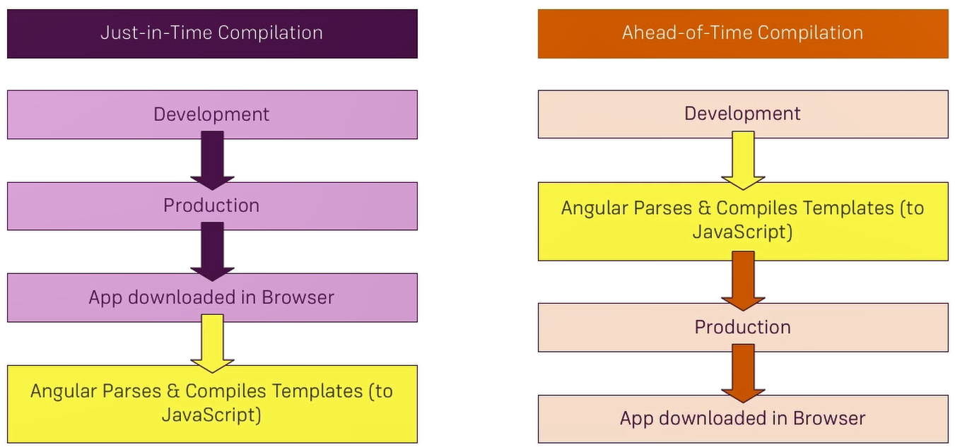

Benefits of AOT:

* **Faster startup** as Parsing and Compilation doesn’t happen in the Browser.
* **Templates gets checked** during development(which means all the errors which we see in the javascript console in the running apps otherwise will then be thrown in our build process).
* **Smaller File Size** as unused Features can be stripped out and the Compiler itself isn’t shipped.

## *Q32*: Why angular uses url segment?

**UrlSegment Interface -** UrlSegment interface represents a single URL segment and the constructor, properties, and methods look like below UrlSegment class i.e.

classUrlSegment {

constructor(path: string, parameters: {...})

path: string

parameters: {...}

toString(): string

}

The UrlSegment is a part of a URL between the two slashes and it contains a path and matrix parameters associated with the segment.

Stayed In formed - [Angular 7 Interview Questions](https://www.code-sample.com/2018/04/angular-7-interview-questions-and.html)

Example:

@Component({

templateUrl:'./user.component.html',

styleUrls: ['./user.component.css']

})

classUserComponent {

constructor(router: Router) {

consturlTree: UrlTree = router.parseUrl('/user;id=101');

consturlSGroup: UrlSegmentGroup = urlTree.root.children[PRIMARY_OUTLET];

consturlSegment: UrlSegment[] = urlSGroup.segments;

urlSegment[0].path; // It will returns 'user'

urlSegment[0].parameters; //It will returns {id: 101}

}

}

## *Q33*: Why did the Google team go with incremental DOM instead of virtual DOM?

While they are in many ways similar, the largest difference between Virtual DOM and Incremental DOM is their chief tradeoff:

* Virtual DOM stores the canonical representation of the DOM in memory; this allows for extremely fast updates to this canonical representation which means you can get to re-rendering much faster
* Incremental DOM stores the canonical representation of the DOM in… well… the DOM itself; this means no additional memory is consumed in the process which has implications for memory-constrained devices

Thus, applications that perform *fewer* DOM updates will benefit from the reduced memory consumption of Incremental DOM while those that perform a *large* number of DOM updates will benefit more from Virtual DOM’s greater performance.

read this for more some interesting facts →<https://www.quora.com/Why-did-the-Google-team-go-with-incremental-DOM-in-Angular-instead-of-virtual-DOM>

## *Q35*: What's new in Angular 7?

## Angular 7 highlights

Though there are not a lot of new updates & features launched in this release, but there are certainly some useful upgrades for Angular [front-end developers](https://www.peerbits.com/frontend-development.html) including improvements to Angular Material and the core framework, CLI with synchronized major versions, and upgrades to the toolchain.

The Angular JS 7 version is primarily focused on the Ivy project, which has been going on since past release.

The Ivy project is basically rewriting the Angular compiler and runtime code to make it better, faster, and smaller.

While the Ivy is still not ready for the prime time yet, but back in April, there were a lot of rumors & fake news about Ivy as well as many other Angular features, which are now nowhere to be seen.

-----------------------------------------------------------------

CTS interview

What is lamba expression?

how is it helpful

how do we make memory utilisation better?

datatype used for amount in bank?

Difference btn decimal and long? What is big decimal? can we use it here? how to compare 2 bigdecimals?

Hash table vs hash map

Benifit of IOC

1) What are the tools have you used so far for quality

>> Jenkins , Sonar quebs,Eclima ,PMD

2) Have you configured jenkins and sonarqube? <RT>

>> Steps to cnfigure sonarqube in mac.

i) Go to sonarqube bin folder start the soanarquebe server

ii) Go to build.gradle and add 2/3 line of plugin like host name & project ect.

Iii) Go to terminal run “Gradle.clean” then --> “gradle.build” then --> “gradle sonar cube”

3)What are the error you are getting in sonar quebe

>> different types of error in sonarqube --

|  |  |
| --- | --- |
| **Blocker** | Operational/security *risk*: This issue might make the whole application unstable in production. Ex: calling garbage collector, not closing a socket, etc. |
| **Critical** | Operational/security *risk*: This issue might lead to an unexpected behavior in production without impacting the integrity of the whole application. Ex: NullPointerException, badly caught exceptions, lack of unit tests, etc. |
| **Major** | This issue might have a substantial impact on *productivity*. Ex: too complex methods, package cycles, etc. |
| **Minor** | This issue might have a potential and minor impact on *productivity*. Ex: naming conventions, Finalizer does nothing but call superclass finalizer, etc. |
| **Info** | Not known or yet well defined security risk or impact on productivity. |

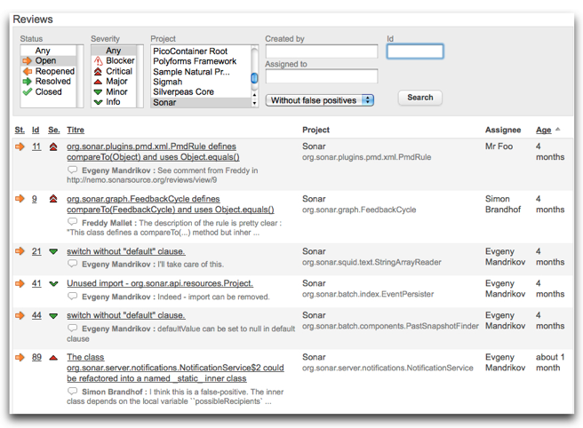 **Trics ti avoid sonar**

1. Do not throw Raw Exception Types

     Instead of throwing raw exception types such as *Exception, Throwable* or *Error*, throw specific exceptions.

1. Do not use deprecated methods.

Do not use == or != operators for string comparison

     The operators == and != are used for comparing java.lang.String objects for reference equality.  Unless both strings are constants or have been interned using the *String.intern()* method, use equals(Object) method instead.

4. Do not throw exception in *finally* block

Sonar treat this violation as very severe one.

5. Do not have empty *catch* block

       Empty *catch* block nullify the effect of throwing exception. Log the exception properly or do some relevant operations in the *catch* block.

6. Do not have empty *finally* Block

     Empty *finally* blocks are useless.

7. Use braces in *If-else* and *for* statements.

     Braces make the code highly readable.

8. Do not catch java.lang.Exception, java.lang.Error or java.lang.RuntimeException.

     Catch the specific exceptions.

9. Do not declare *Throws Exception*  in method signature

     Throw specific exceptions.

10. Do not write System.out.print

     Log the information instead of using System.out.print or System.out.println statement.

11. Follow naming conventions

     Class names should always begin with an upper case letter and method name should begin with lower case letter.

12. Do not rethrow exception in catch block

     Catch blocks that merely rethrow a caught exception only increase the code size and run-time complexity.

13. Avoid empty if blocks.

**Example:**

      if (dialog.open() == Dialog.OK) {

      }

15. Do not use fall through in switch-case statements especially when the case is not empty.

4) are u in agile ? what are the difference btn waterfall and agile?

5) Name 5-7 terms of agile.

## All Terms

**--**[**Burndown Chart**](http://www.telerik.com/teampulse/agile-vocabulary#8a9dc416-0e10-4ecb-af55-f36e7e53dff4)**, --**[**Daily Standup/Scrum**](http://www.telerik.com/teampulse/agile-vocabulary#561981b9-dc20-4278-9214-b748698dd12d)**, --**[**Done**](http://www.telerik.com/teampulse/agile-vocabulary#3c8a474a-af7f-430d-ac82-425abca95cea)**, --**[**Epic**](http://www.telerik.com/teampulse/agile-vocabulary#88a009fe-d575-4887-9f39-569f1cc72c1f)**, --**[**Estimation**](http://www.telerik.com/teampulse/agile-vocabulary#7e7f4c7c-6d6b-4922-bece-4574815661c4), --[Feature creep](http://www.telerik.com/teampulse/agile-vocabulary#cd5625c9-0dce-439f-a9dc-c900c864a9df), --[Acceptance criteria](http://www.telerik.com/teampulse/agile-vocabulary#a7b1ff9b-3384-41b9-81db-ede7bb28082b), -- [Acceptance testing](http://www.telerik.com/teampulse/agile-vocabulary#6b7f475a-da01-4ff6-ae59-d67a795ec3ba), --[Agile](http://www.telerik.com/teampulse/agile-vocabulary#895a46d1-1c46-448e-8c75-aaa15e22af5f), --[Behavior Driven Development](http://www.telerik.com/teampulse/agile-vocabulary#778ce003-7c4e-48ce-a4b9-219c9458d8b6), --[Bottleneck](http://www.telerik.com/teampulse/agile-vocabulary#f5186217-16c6-41da-9fa3-615ac1d1ecd2), --[Bugs](http://www.telerik.com/teampulse/agile-vocabulary#0924e4bf-2edd-4a87-b12e-34cb7396c732),

**--**[**Kanban**](http://www.telerik.com/teampulse/agile-vocabulary#76343aec-3d16-458d-a593-ab9298001852)**, --**[**Lean**](http://www.telerik.com/teampulse/agile-vocabulary#517faa48-df19-479c-9365-d944a9d3e6fb)**, --**[**Pair Programming**](http://www.telerik.com/teampulse/agile-vocabulary#eed6c120-de80-47fb-ab7d-6a2538a4e263)**, --**[**Planning Poker**](http://www.telerik.com/teampulse/agile-vocabulary#10262111-ec1b-42c4-a89b-e65c0b14ea7c)**, --**[**Product Backlog**](http://www.telerik.com/teampulse/agile-vocabulary#3aba4ac6-ab02-4ba7-914c-b3ea573df376)**, --**[**Product Owner**](http://www.telerik.com/teampulse/agile-vocabulary#7ada20d8-e26d-4acb-9274-e02a0b570d60)**, --**[**Retrospective**](http://www.telerik.com/teampulse/agile-vocabulary#845dbea8-cbbd-438e-9bae-3705785fbf7e)**, --**[**Scrum**](http://www.telerik.com/teampulse/agile-vocabulary#e1afdee8-196f-45da-bb44-4f20fb9c8f8d)**, --**[**Scrumban**](http://www.telerik.com/teampulse/agile-vocabulary#529ce5ea-a93f-497e-87e9-81f0189c0447)**, --**[**Scrum Master**](http://www.telerik.com/teampulse/agile-vocabulary#66d921f2-126e-4e81-844b-69d75f5d4576)**, --**[**Spike**](http://www.telerik.com/teampulse/agile-vocabulary#a760e1e8-4c56-4098-a023-45647cedf30f)**, --**[**Sprint / Iteration**](http://www.telerik.com/teampulse/agile-vocabulary#54358f19-3be2-48e0-b3b8-4d906f9c77af)**, --**[**Sprint Backlog**](http://www.telerik.com/teampulse/agile-vocabulary#febd2508-13ad-4177-86f1-b32defbe54fa)**, --**[**Sprint Planning**](http://www.telerik.com/teampulse/agile-vocabulary#2bedf426-bae3-4793-8ab0-fd84b3cc1ebd)**, --**[**Sprint Review**](http://www.telerik.com/teampulse/agile-vocabulary#42d29e18-2b3f-470a-ab29-ff9574c66db4)**, --**[**Story Points**](http://www.telerik.com/teampulse/agile-vocabulary#f1461668-6ab6-422f-af16-a4956ed773b5)**, --**[**Task**](http://www.telerik.com/teampulse/agile-vocabulary#75748f2c-fca7-4df8-a3a3-2a2603ed98e3)**,--**[**Taskboard /** Storyborad](http://www.telerik.com/teampulse/agile-vocabulary#ec1f8f61-4b12-4004-affb-b2d2a08256ba), --[Team](http://www.telerik.com/teampulse/agile-vocabulary#024a6ffd-a99e-4881-b36c-6c4f6b0ea823), --[Test Driven, --Development](http://www.telerik.com/teampulse/agile-vocabulary#f88aa106-2577-4623-998a-112f8cabb64e), --[Timeboxing](http://www.telerik.com/teampulse/agile-vocabulary#509cec31-6a12-4382-858d-0cd8a4c2e8ae), --[User Persona](http://www.telerik.com/teampulse/agile-vocabulary#d6716bc0-6487-4c85-8fb1-0908ad3302a8), --[User Story](http://www.telerik.com/teampulse/agile-vocabulary#3cbaec4e-70ac-4ebc-a3fb-4f6edb014f77), --[Velocity](http://www.telerik.com/teampulse/agile-vocabulary#5e1db616-fbc5-4cc4-9a75-4914db3efb6f), --[Vertical Slice](http://www.telerik.com/teampulse/agile-vocabulary#6b74a100-d6c2-44fa-81c7-9a9581439fe4), --[WIP](http://www.telerik.com/teampulse/agile-vocabulary#272cc6a1-c7f1-4970-bb73-04fbb6db466b).

6) What is the role of scrum master.

1. >>Facilitating (not participating in) the daily standup
2. **Helping the team maintain their burndown chart**
3. **Setting up retrospectives, sprint reviews or sprint planning sessions**
4. **Shielding the team from interruptions during the sprint**
5. **Removing obstacles that affect the team**
6. **Walking the product owner through more technical user stories**
7. Encouraging collaboration between the Scrum team and product owner

**GIT Commands**

**Patching**

* [apply](https://git-scm.com/docs/git-apply)
* [cherry-pick](https://git-scm.com/docs/git-cherry-pick) - git-cherry-pick - Apply the changes introduced by some existing commits
* [diff](https://git-scm.com/docs/git-diff)
* [rebase](https://git-scm.com/docs/git-rebase) - Reapply commits on top of another base tip
* [revert](https://git-scm.com/docs/git-revert)

**Debugging**

* [bisect](https://git-scm.com/docs/git-bisect) - Use binary search to find the commit that introduced a bug
* [blame](https://git-scm.com/docs/git-blame) - Show what revision and author last modified each line of a file
* [grep](https://git-scm.com/docs/git-grep) - Look for specified patterns in the tracked files in the work tree,

git-rebase - Reapply commits on top of another base tip

DESCRIPTION

If <branch> is specified, *git rebase* will perform an automatic git checkout <branch> before doing anything else. Otherwise it remains on the current branch.

If <upstream> is not specified, the upstream configured in branch.<name>.remote and branch.<name>.merge options will be used (see [git-config[1]](https://git-scm.com/docs/git-config) for details) and the --fork-point option is assumed. If you are currently not on any branch or if the current branch does not have a configured upstream, the rebase will abort.

--------------Spring----------------

############### Spring boot ###########

Spring Boot provides a quick (and opinionated) way to create a production-ready Spring-based application

## Features

* Create stand-alone Spring applications
* Embed Tomcat, Jetty or Undertow directly (no need to deploy WAR files)
* Provide opinionated 'starter' POMs to simplify your Maven configuration
* Automatically configure Spring whenever possible
* Provide production-ready features such as metrics, health checks and externalized configuration
* Absolutely **no code generation** and **no requirement for XML** configuration

Min maven version 3.0

* Use JDK and not JRE
* Pom : project object model. Its nothing but the configuration of your maven project. Here mainly we define all the dependency of our project.
* Why Maven :: it gives us the flexibility to manage the dependency and we don’t need to download and configure the dependency explicitly.

For example if you want to include spring core jar. Just search for the spring core dependency and add it in pom. As soon as you save your dependency jar will be added in mavenDependencies folder/library.

* 5 key point of SpringBoot:

1. **SpringBoot Starter parent** (if you use this you don’t need to use the version number of everything) And it also provides the default plugin.

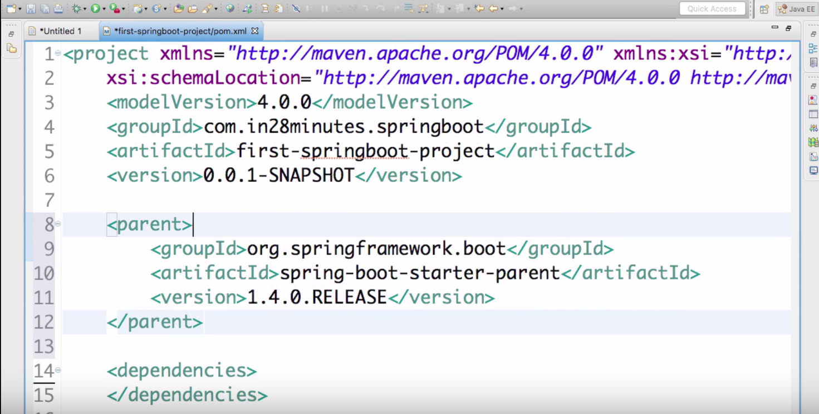

**ii. SpringBoot Starter Web** (If you use spring MVC, you really need to add lots of dependency to make things work. But if you use SpringBoot Starter then all the necessary things will be added)

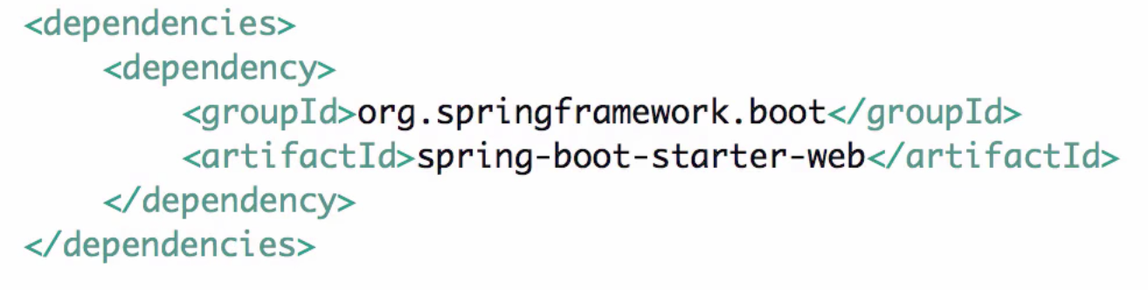

This dependency will add all the below necessary jar incl. spring boot, web, aop ect.

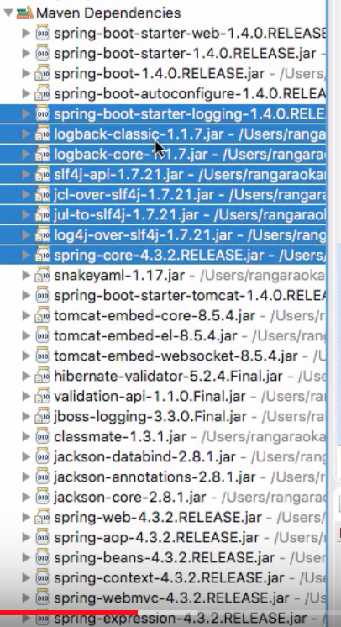

**iii. Java version 8.**

In the parent pom the java version might be different but declare a property in your current pom and override the java version to 1.8. Now if you rightclck and update the project it will automatically update the java version to 1.8.

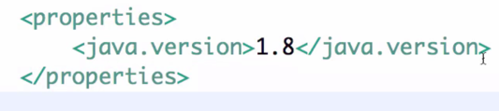

**iv. Spring boot plugin (it help us to launch the application)**

We need to add build plugin to run the application.

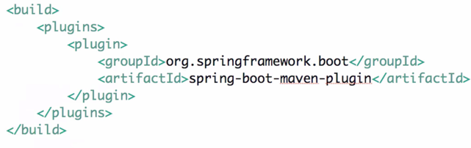

**v. Spring boot application launcher (it’s a java file that launch the application)**

The java file looks like this.

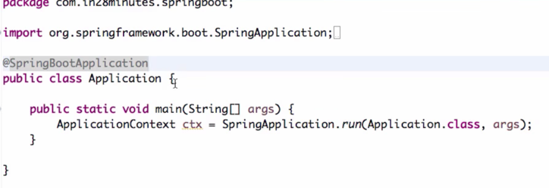

* RestController annotation needs to be used to crate controller.

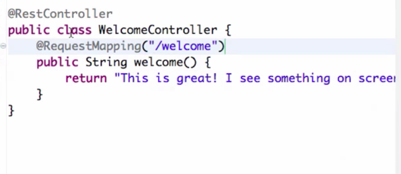

* Autowiring : It’s a special technique of Spring framework where spring create the beans and injects / wired them where ever they are needed.

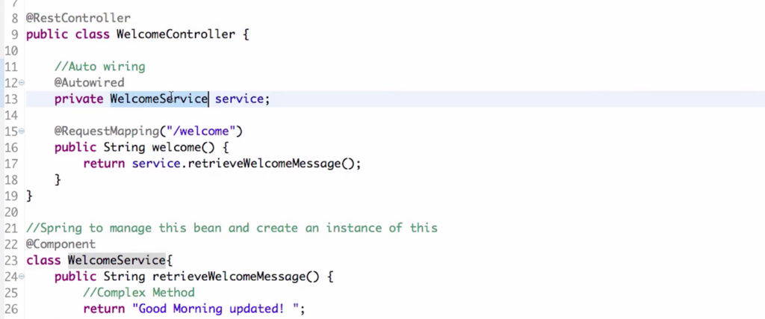

* For @**SpringBootApplication** annotation spring will by default will do the component scan for this class but not for all other class.
* **Component Scan :** It should tell the spring where should spring look for componenets. (eg. some components @Component ,@Service, @Controller, @RestController, @Repository )

**What is auto configuration in Spring boot.**

>> No Manual configuration is required. It means before springboot if you need to work on webapp or spring MVC you need to configure servlet Dispatcher manually. But in spring boot because of autometially this configuration will be taken care. As we have added the dependency **“spring-boot-starter-web”**

**How to make the debug mode.**

>> SpringFramework:Debug in “Application.properties” file.

**spring-boot-starter-web-services :: it is required to work with soap services.**

**spring-boot-starter-web-test :: It will give you the dependency to work with junit like Mokito.**

**spring-boot-starter-web-jdbc :: It will give you the dependency to work with Database.**

**###########-----Spring-----##############**

**\*\*\* @ Autowiring finds the automatic finding of dependencies. Which ever the class you are autoowiring make sure it’s a bean meaning that is having @Component /@Service annotation.\*\*\*\***

Spring makes it easy to create Java enterprise applications. It provides everything you need to embrace the Java language in an enterprise environment, with support for Groovy and Kotlin as alternative languages on the JVM, and with the flexibility to create many kinds of architectures depending on an application’s needs. As of Spring Framework 5.0, Spring requires JDK 8+ (Java SE 8+) and provides out-of-the-box support (e.g. Servlet 4.0, JSON Binding API and This keeps Spring fully compatible with e.g. Tomcat 8 and 9, WebSphere 9, and JBoss EAP 7.) for JDK 9 already.

The Spring Framework is divided into modules. Applications can choose which modules they need. At the heart are the modules of the **core container, including a configuration model and a dependency injection mechanism**. Beyond that, the Spring Framework **provides foundational support** for **different application architectures, including messaging, transactional data and persistence, and web**. It also includes the **Servlet-based Spring MVC** web framework and, in parallel, the Spring WebFlux reactive web framework.

Spring continues to innovate and to evolve. Beyond the Spring Framework, there are other projects, such as Spring Boot, Spring Security, Spring Data, Spring Cloud, Spring Batch, among others. It’s important to remember that each project has its own source code repository, issue tracker, and release cadence

**Some of the features of spring framework are:**

1. Lightweight and very little overhead of using framework for our development.
2. Dependency Injection or Inversion of Control to write components that are independent of each other, spring container takes care of wiring them together to achieve our work.
3. Spring IoC container manages [Spring Bean life cycle](https://www.journaldev.com/2637/spring-bean-life-cycle) and project specific configurations such as JNDI lookup.
4. Spring **MVC** framework can be used to **create web applications** as well as ***restful* web services capable of returning XML as well as JSON response.**
5. Support for **transaction management, JDBC operations**, File uploading, Exception Handling etc with very little configurations, either by using annotations or by spring bean configuration file.

### What do you understand by Dependency Injection?

Dependency Injection design pattern allows us to remove the hard-coded dependencies and make our application loosely coupled, extendable and maintainable. We can implement dependency injection pattern to move the dependency resolution from compile-time to runtime.

**Some of the benefits of using Dependency Injection are:**

* **Separation of Concerns,**
* **Code reduction,**
* **Configurable components and**
* **easy unit testing**.

We can also use [Google Guice for Dependency Injection](https://www.journaldev.com/2403/google-guice-dependency-injection-example-tutorial) to automate the process of dependency injection. But in most of the cases we are looking for more than just dependency injection and that’s why Spring is the top choice for this.

**How do we implement DI in Spring Framework?**

We can use Spring ***XML based* as well as *Annotation based*** configuration to implement DI in spring applications.

### Name some of the important Spring Modules?

Some of the important Spring Framework modules are:

1. **Spring Context** – for dependency injection (IOC).
2. **Spring AOP** – for aspect oriented programming.
3. **Spring DAO** – for database operations using DAO pattern
4. **Spring JDBC** – for JDBC and DataSource support.
5. **Spring ORM** – for ORM tools support such as Hibernate
6. **Spring Web Module** – for creating web applications.
7. **Spring MVC** – Model-View-Controller implementation for creating web applications, web services etc.

### What do you understand by Aspect Oriented Programming?

AOP separates application business logic from system services, Spring Framework supports Aspect Oriented Programming and enables cohesive development.

Enterprise applications have some common cross-cutting concerns that is applicable for different types of Objects and application modules, such as logging, transaction management, data validation, authentication etc. In **Object Oriented Programming, modularity of application is achieved by Classes whereas in AOP application modularity is achieved by Aspects and they are configured to cut across different classes methods.**

AOP takes out the direct dependency of cross-cutting tasks from classes that is not possible in normal object oriented programming. For example, we can have a separate class for logging but again the classes will have to call these methods for logging the data.

### What is Aspect, Advice, Pointcut, JointPoint and Advice Arguments in AOP?

**Aspect**: Aspect is a class that implements cross-cutting concerns, such as transaction management. Aspects can be a normal class configured and then configured in Spring Bean configuration file or we can use Spring AspectJ support to declare a class as Aspect using @Aspect annotation.

**Advice**: Advice is the action taken for a particular join point. In terms of programming, they are methods that gets executed when a specific join point with matching pointcut is reached in the application. You can think of Advices as [Spring interceptors](https://www.journaldev.com/2676/spring-mvc-interceptor-example-handlerinterceptor-handlerinterceptoradapter) or [Servlet Filters](https://www.journaldev.com/1933/java-servlet-filter-example-tutorial).

**Pointcut**: **Pointcut are regular expressions that is matched with join points to determine whether advice needs to be executed or not.** Pointcut uses different kinds of expressions that are matched with the join points. **Spring framework uses the AspectJ pointcut expression language for determining the join points where advice methods will be applied.**

**Join Point**: A join point is the specific point in the application such as method execution, exception handling, changing object variable values etc. In Spring AOP a join points is always the execution of a method.

**Advice Arguments**: We can pass arguments in the advice methods. We can use args() expression in the pointcut to be applied to any method that matches the argument pattern. If we use this, then we need to use the same name in the advice method from where argument type is determined.

## Why do we have Servlet Filter?

**Servlet Filters are** pluggable **java components that we can use to intercept and process requests *before* they are sent to servlets and response *after* servlet code is finished and before container sends the response back to the client.**

Some common tasks that we can do with servlet filters are:

* Logging request parameters to log files.
* Authentication and autherization of request for resources.
* Formatting of request body or header before sending it to servlet.
* Compressing the response data sent to the client.
* Alter response by adding some cookies, header information etc.

As I mentioned earlier, **servlet filters are pluggable** and configured in deployment descriptor (web.xml) file. Servlets and filters both are unaware of each other and we can add or remove a servlet filter just by editing web.xml.

We can have **multiple filters for a single resource** and we can create a chain of filters for a single resource in web.xml. We can create a Servlet Filter by implementing javax.servlet.Filterinterface.

### What is the difference between Spring AOP and AspectJ AOP?

AspectJ is the industry-standard implementation for Aspect Oriented Programming whereas Spring implements AOP for some cases. Main differences between Spring AOP and AspectJ are:

* Spring AOP is simpler to use than AspectJ because we don’t need to worry about the weaving process.
* Spring AOP supports AspectJ annotations, so if you are familiar with AspectJ then working with Spring AOP is easier.
* **Spring AOP supports only proxy-based AOP, so it can be applied only to method execution join points. AspectJ support all kinds of pointcuts.**
* One of the shortcoming of Spring AOP is that it can be applied only to the beans created through Spring Context.

### What is Spring IoC Container?

**Inversion of Control (IoC) is the mechanism to achieve loose-coupling between Objects dependencies**. To achieve loose coupling and dynamic binding of the objects at runtime, **the objects define their dependencies** that are being injected by other assembler objects. **Spring IoC container is the program that injects dependencies into an object and make it ready for our use.**

Spring Framework IoC container classes are part of org.springframework.beans and org.springframework.context packages and provides us different ways to decouple the object dependencies.

Some of the useful ApplicationContext implementations that we use are;

* AnnotationConfigApplicationContext: For standalone java applications using annotations based configuration.
* ClassPathXmlApplicationContext: For standalone java applications using XML based configuration.
* FileSystemXmlApplicationContext: Similar to ClassPathXmlApplicationContext except that the xml configuration file can be loaded from anywhere in the file system.
* AnnotationConfigWebApplicationContext and XmlWebApplicationContext for web applications.

### What is a Spring Bean?

**Any normal java class that is initialized by Spring IoC container is called Spring Bean. We use Spring ApplicationContext to get the Spring Bean instance.**

**Spring IoC container manages the life cycle of Spring Bean, bean scopes and injecting any required dependencies in the bean.**

### What is the importance of Spring bean configuration file?

**We use Spring Bean configuration file to define all the beans that will be initialized by Spring Context. When we create the instance of Spring ApplicationContext, it reads the spring bean xml file and initialize all of them. Once the context is initialized, we can use it to get different bean instances.**

Apart from Spring Bean configuration, **this file also contains spring MVC interceptors, view resolvers and other elements to support annotations based configurations.**

### What are different ways to configure a class as Spring Bean?

There are three different ways to configure Spring Bean.

* 1. **XML Configuration**: This is the most popular configuration and we can use bean element in context file to configure a Spring Bean. For example:

<bean name="myBean" class="com.journaldev.spring.beans.MyBean"></bean>

* 1. **Java Based Configuration**: If you are using only annotations, you can configure a Spring bean using @Bean annotation. This annotation is used with @Configuration classes to configure a spring bean. Sample configuration is:
  2. @Configuration
  3. @ComponentScan(value="com.journaldev.spring.main")
  4. public class MyConfiguration {
  5. @Bean
  6. public MyService getService(){
  7. return new MyService();
  8. }

}

To get this bean from spring context, we need to use following code snippet:

AnnotationConfigApplicationContext ctx = new AnnotationConfigApplicationContext(

MyConfiguration.class);

MyService service = ctx.getBean(MyService.class);

1. **Annotation Based Configuration**: We can also use @Component, @Service, @Repository and @Controller annotations with classes to configure them to be as spring bean. For these, we would need to provide base package location to scan for these classes. For example:

<context:component-scan base-package="com.journaldev.spring" />

### What are different scopes of Spring Bean? Interview**

There are five scopes defined for Spring Beans.

1. **singleton**: Only one instance of the bean will be created for each container. This is the default scope for the spring beans. While using this scope, make sure spring bean doesn’t have shared instance variables otherwise it might lead to data inconsistency issues because it’s not thread-safe.
2. **prototype**: A new instance will be created every time the bean is requested.
3. **request**: A new instance of the bean will be created for each HTTP request.
4. **session**: A new bean will be created for each HTTP session by the container.
5. **global-session**: This is used to create global session beans for Portlet applications.

Spring Framework is extendable and we can create our own scopes too, however most of the times we are good with the scopes provided by the framework.

### What is Spring Bean life cycle?

**Spring Beans are initialized by Spring Container and all the dependencies are also injected. When context is destroyed, it also destroys all the initialized beans.**

We can do this by two ways – by implementing InitializingBean and DisposableBean interfaces or using **init-method** and **destroy-method** attribute in spring bean configurations. For more details, please read [Spring Bean Life Cycle Methods](https://www.journaldev.com/2637/spring-bean-life-cycle).

### How to get ServletContext and ServletConfig object in a Spring Bean?

There are two ways to get Container specific objects in the spring bean.

1. Implementing Spring *Aware interfaces, for these ServletContextAware and ServletConfigAware interfaces, for complete example of these aware interfaces, please read [Spring Aware Interfaces](https://www.journaldev.com/2637/spring-bean-life-cycle)
2. Using @Autowired annotation with bean variable of type ServletContext and ServletConfig. They will work only in servlet container specific environment only though.
3. @Autowired

ServletContext servletContext;

### What is Bean wiring and @Autowired annotation?

**Autowiring** feature of **spring** framework enables you to inject the object dependency implicitly.

The process of injection spring bean dependencies while initializing it called Spring Bean Wiring.

Usually it’s best practice to do the explicit wiring of all the bean dependencies, but spring framework also supports autowiring. We can use @Autowired annotation with fields or methods for **autowiring byType**. For this annotation to work, we also need to enable annotation based configuration in spring bean configuration file. This can be done by **context:annotation-config** element.

### What are different types of Spring Bean autowiring?

There are four types of autowiring in Spring framework.

1. **autowire byName**
2. **autowire byType**
3. **autowire by constructor**
4. autowiring by **@Autowired** and **@Qualifier** annotations

Prior to Spring 3.1, **autowire by autodetect** was also supported that was similar to autowire by constructor or byType.

### Does Spring Bean provide thread safety?

The default scope of Spring bean is singleton, so there will be only one instance per context. That means that all the having a class level variable that any thread can update will lead to inconsistent data. Hence in **default mode spring beans are not thread-safe.**

However we can change spring bean scope to request, prototype or session to achieve thread-safety at the cost of performance. It’s a design decision and based on the project requirements.

### What is a Controller in Spring MVC?

**Just like MVC design pattern, Controller is the class that takes care of all the client requests and send them to the configured resources to handle** it. In Spring MVC, org.springframework.web.servlet.DispatcherServlet is the front controller class that initializes the context based on the spring beans configurations.

A Controller class is responsible to handle different kind of client requests based on the request mappings. We can create a controller class by using @Controller annotation. Usually it’s used with @RequestMapping annotation to define handler methods for specific URI mapping.

### What’s the difference between @Component, @Controller, @Repository & @Service annotations in Spring?

**@Component** is used to indicate that a class is a component. These classes are used for auto detection and configured as bean, when annotation based configurations are used.

**@Controller** is a specific type of component, used in MVC applications and mostly used with RequestMapping annotation.

**@Repository** annotation is used to indicate that a component is used as repository and a mechanism to store/retrieve/search data. We can apply this annotation with DAO pattern implementation classes.

**@Service** is used to indicate that a class is a Service. Usually the business facade classes that provide some services are annotated with this.

### What is DispatcherServlet and ContextLoaderListener?

DispatcherServlet is the front controller in the Spring MVC application and it loads the spring bean configuration file and initialize all the beans that are configured. If annotations are enabled, it also scans the packages and configure any bean annotated with @Component, @Controller, @Repository or @Service annotations.

**ContextLoaderListener is the listener to start up and shut down Spring’s root WebApplicationContext.** It’s important functions are to tie up the lifecycle of ApplicationContext to the lifecycle of the ServletContext and to automate the creation of ApplicationContext. We can use it to define shared beans that can be used across different spring contexts.

### What is ViewResolver in Spring?

ViewResolver implementations are used to resolve the view pages by name. Usually we configure it in the spring bean configuration file. For example:

<!-- Resolves views selected for rendering by @Controllers to .jsp resources in the /WEB-INF/views directory -->

<beans:bean class="org.springframework.web.servlet.view.InternalResourceViewResolver">

<beans:property name="prefix" value="/WEB-INF/views/" />

<beans:property name="suffix" value=".jsp" />

</beans:bean>

### How to handle exceptions in Spring MVC Framework?

Spring MVC Framework provides following ways to help us achieving robust exception handling.

1. **Controller Based** – We can define exception handler methods in our controller classes. All we need is to annotate these methods with **@ExceptionHandler** annotation.
2. **Global Exception Handler** – Exception Handling is **a cross-cutting concern** and Spring provides **@ControllerAdvice annotation that we can use with any class to define our global exception handler**.
3. **HandlerExceptionResolver implementation** – For generic exceptions, most of the times we serve static pages. Spring Framework provides HandlerExceptionResolver interface that we can implement to create global exception handler. The reason behind this additional way to define global exception handler is that Spring framework also provides default implementation classes that we can define in our spring bean configuration file to get spring framework exception handling benefits.

### How to create ApplicationContext in a Java Program?

There are following ways to create spring context in a standalone java program.

1. **AnnotationConfigApplicationContext**: If we are using Spring in standalone java applications and using annotations for Configuration, then we can use this to initialize the container and get the bean objects.
2. **ClassPathXmlApplicationContext**: If we have spring bean configuration xml file in standalone application, then we can use this class to load the file and get the container object.
3. **FileSystemXmlApplicationContext**: This is similar to ClassPathXmlApplicationContext except that the xml configuration file can be loaded from anywhere in the file system.

### Can we have multiple Spring configuration files?

For Spring MVC applications, we can define multiple spring context configuration files through contextConfigLocation. This location string can consist of multiple locations separated by any number of commas and spaces. For example;

<servlet>

<servlet-name>appServlet</servlet-name>

<servlet-class>org.springframework.web.servlet.DispatcherServlet</servlet-class>

<init-param>

<param-name>contextConfigLocation</param-name>

<param-value>/WEB-INF/spring/appServlet/servlet-context.xml,/WEB-INF/spring/appServlet/servlet-jdbc.xml</param-value>

</init-param>

<load-on-startup>1</load-on-startup>

</servlet>

We can also define multiple root level spring configurations and load it through context-param. For example;

<context-param>

<param-name>contextConfigLocation</param-name>

<param-value>/WEB-INF/spring/root-context.xml /WEB-INF/spring/root-security.xml</param-value>

</context-param>

Another option is to use import element in the context configuration file to import other configurations, for example:

<beans:import resource="spring-jdbc.xml"/>

### What are the minimum configurations needed to create Spring MVC application?

For creating a simple Spring MVC application, we would need to do following tasks.

* + Add spring-context and spring-webmvc dependencies in the project.
  + Configure DispatcherServlet in the web.xml file to handle requests through spring container.
  + Spring bean configuration file to define beans, if using annotations then it has to be configured here. Also we need to configure view resolver for view pages.
  + Controller class with request mappings defined to handle the client requests.

Above steps should be enough to create a simple Spring MVC Hello World application.

### ****How would you relate Spring MVC Framework to MVC architecture?

As the name suggests Spring MVC is built on top of **Model-View-Controller** architecture. DispatcherServlet is the Front Controller in the Spring MVC application that takes care of all the incoming requests and delegate it to different controller handler methods.

Model can be any Java Bean in the Spring Framework, just like any other MVC framework Spring provides automatic binding of form data to java beans. We can set model beans as attributes to be used in the view pages.

View Pages can be JSP, static HTMLs etc. and **view resolvers** are responsible for finding the correct view page. Once the view page is identified, control is given back to the DispatcherServlet controller. **DispatcherServlet is responsible for rendering the view and returning the final response to the client**.

### How can we use Spring to create Restful Web Service returning JSON response?

We can use Spring Framework to create Restful web services that returns JSON data. Spring provides integration with [Jackson JSON](https://www.journaldev.com/2324/jackson-json-java-parser-api-example-tutorial) API that we can use to send JSON response in restful web service.

We would need to do following steps to configure our Spring MVC application to send JSON response:

* 1. Adding Jackson JSON dependencies, if you are using Maven it can be done with following code:
  2. <!-- Jackson -->
  3. <dependency>
  4. <groupId>com.fasterxml.jackson.core</groupId>
  5. <artifactId>jackson-databind</artifactId>
  6. <version>${jackson.databind-version}</version>

</dependency>

* 1. Configure RequestMappingHandlerAdapter bean in the spring bean configuration file and set the messageConverters property to MappingJackson2HttpMessageConverter bean. Sample configuration will be:
  2. <!-- Configure to plugin JSON as request and response in method handler -->
  3. <beans:bean class="org.springframework.web.servlet.mvc.method.annotation.RequestMappingHandlerAdapter">
  4. <beans:property name="messageConverters">
  5. <beans:list>
  6. <beans:ref bean="jsonMessageConverter"/>
  7. </beans:list>
  8. </beans:property>
  9. </beans:bean>
  11. <!-- Configure bean to convert JSON to POJO and vice versa -->
  12. <beans:bean id="jsonMessageConverter" class="org.springframework.http.converter.json.MappingJackson2HttpMessageConverter">

</beans:bean>

In the controller handler methods, return the Object as response using @ResponseBodyannotation. Sample code:

* 1. @RequestMapping(value = EmpRestURIConstants.GET_EMP, method = RequestMethod.GET)
  2. public @ResponseBody Employee getEmployee(@PathVariable("id") int empId) {
  3. logger.info("Start getEmployee. ID="+empId);
  5. return empData.get(empId);

}

* 1. You can invoke the rest service through any API, but if you want to use Spring then we can easily do it using RestTemplate class.

For a complete example, please read [Spring Restful Webservice Example](https://www.journaldev.com/2552/spring-rest-example-tutorial-spring-restful-web-services).

### What are some of the important Spring annotations you have used?

Some of the Spring annotations that I have used in my project are:

* 1. **@Controller** – for controller classes in Spring MVC project.
  2. **@RequestMapping** – for configuring URI mapping in controller handler methods. This is a very important annotation, so you should go through [Spring MVC RequestMapping Annotation Examples](https://www.journaldev.com/3358/spring-requestmapping-requestparam-pathvariable-example)
  3. **@ResponseBody** – for sending Object as response, usually for sending XML or JSON data as response.
  4. **@PathVariable** – for mapping dynamic values from the URI to handler method arguments.
  5. **@Autowired** – for autowiring dependencies in spring beans.
  6. **@Qualifier** – with @Autowired annotation to avoid confusion when multiple instances of bean type is present.
  7. **@Service** – for service classes.
  8. **@Scope** – for configuring scope of the spring bean.
  9. **@Configuration**, **@ComponentScan** and **@Bean** – for java based configurations.
  10. AspectJ annotations for configuring aspects and advices, **@Aspect**, **@Before**, **@After**, **@Around**, **@Pointcut** etc.

### Can we send an Object as the response of Controller handler method?

Yes we can, using **@ResponseBody** annotation. This is how we send JSON or XML based response in restful web services.

### How to upload file in Spring MVC Application?

Spring provides built-in support for uploading files through **MultipartResolver** interface implementations.

### How to validate form data in Spring Web MVC Framework?

Spring supports **JSR-303** annotation based validations as well as **provide Validator interface** that we can implement to create our own custom validator. For using JSR-303 based validation, we need to annotate bean variables with the required validations.

For custom validator implementation, we need to configure it in the controller class. For a complete example, please read [Spring MVC Form Validation Example](https://www.journaldev.com/2668/spring-validation-example-mvc-validator).

@Size(min=2, max=30)

private String name;

@NotEmpty @Email

private String email;

@NotNull @Min(18) @Max(100)

private Integer age;

@NotNull

private Gender gender;

@DateTimeFormat(pattern="MM/dd/yyyy")

@NotNull @Past

private Date birthday;

@Phone

private String phone;

### What is Spring MVC Interceptor and how to use it?

Spring MVC Interceptors are like Servlet Filters and allow us to intercept client request and process it. We can intercept client request at three places – **preHandle**, **postHandle** and **afterCompletion**.

We can create spring interceptor by implementing HandlerInterceptor interface or by extending abstract class **HandlerInterceptorAdapter**.

We need to configure interceptors in the spring bean configuration file. We can define an interceptor to intercept all the client requests or we can configure it for specific URI mapping too.

### What is Spring JdbcTemplate class and how to use it?

Spring Framework provides excellent integration with JDBC API and provides JdbcTemplate utility class that we can use to avoid bolier-plate code from our database operations logic such as Opening/Closing Connection, ResultSet, PreparedStatement etc.

### What is Spring DAO?

Spring DAO support is provided to work with data access technologies like JDBC, Hibernate in a consistent and easy way. For example we have JdbcDaoSupport, HibernateDaoSupport, JdoDaoSupport and JpaDaoSupport for respective technologies.

Spring DAO also provides consistency in exception hierarchy and we don’t need to catch specific exceptions.

### How to integrate Spring and Hibernate Frameworks?

We can use Spring ORM module to integrate Spring and Hibernate frameworks, if you are using Hibernate 3+ where SessionFactory provides current session, then you should avoid using HibernateTemplate or HibernateDaoSupport classes and better to use DAO pattern with dependency injection for the integration.

### What is Spring Security?

Spring security framework focuses on providing both authentication and authorization in java applications. It also takes care of most of the common security vulnerabilities such as CSRF attack.

It’s very beneficial and easy to use Spring security in web applications, through the use of annotations such as @EnableWebSecurity.

### Name some of the design patterns used in Spring Framework?

Spring Framework is using a lot of design patterns, some of the common ones are:

1. Singleton Pattern: Creating beans with default scope.
2. [Factory Pattern](https://www.journaldev.com/1392/factory-design-pattern-in-java): Bean Factory classes
3. [**Prototype Pattern**](https://www.journaldev.com/1440/prototype-design-pattern-in-java)**: Bean scopes - interview*** KBC**
4. [Adapter Pattern](https://www.journaldev.com/1487/adapter-design-pattern-java): Spring Web and Spring MVC
5. [Proxy Pattern](https://www.journaldev.com/1572/proxy-design-pattern): Spring Aspect Oriented Programming support
6. [Template Method Pattern](https://www.journaldev.com/1763/template-method-design-pattern-in-java): JdbcTemplate, HibernateTemplate etc
7. Front Controller: Spring MVC DispatcherServlet
8. Data Access Object: Spring DAO support
9. Dependency Injection and Aspect Oriented Programming

### What are some of the best practices for Spring Framework?

Some of the best practices for Spring Framework are:

1. **Avoid version numbers in schema reference, to make sure we have the latest configs.**
2. **Divide spring bean configurations based on their concerns such as spring-jdbc.xml, spring-security.xml.**
3. For spring beans that are used in multiple contexts in Spring MVC, create them in the root context and initialize with listener.
4. Configure bean dependencies as much as possible, try to avoid autowiring as much as possible.
5. For application level properties, best approach is to create a property file and read it in the spring bean configuration file.
6. **For smaller applications, annotations are useful but for larger applications annotations can become a pain. If we have all the configuration in xml files, maintaining it will be easier.**
7. Use correct annotations for components for understanding the purpose easily. For services use @Service and for DAO beans use @Repository.
8. Spring framework has a lot of modules, use what you need. Remove all the extra dependencies that gets usually added when you create projects through Spring Tool Suite templates.
9. If you are using Aspects, make sure to keep the join pint as narrow as possible to avoid advice on unwanted methods. Consider custom annotations that are easier to use and avoid any issues.
10. **Use dependency injection when there is actual benefit, just for the sake of loose-coupling don’t use it because it’s harder to maintain.**

**One of the major goal of Spring framework is to make the application testable.**

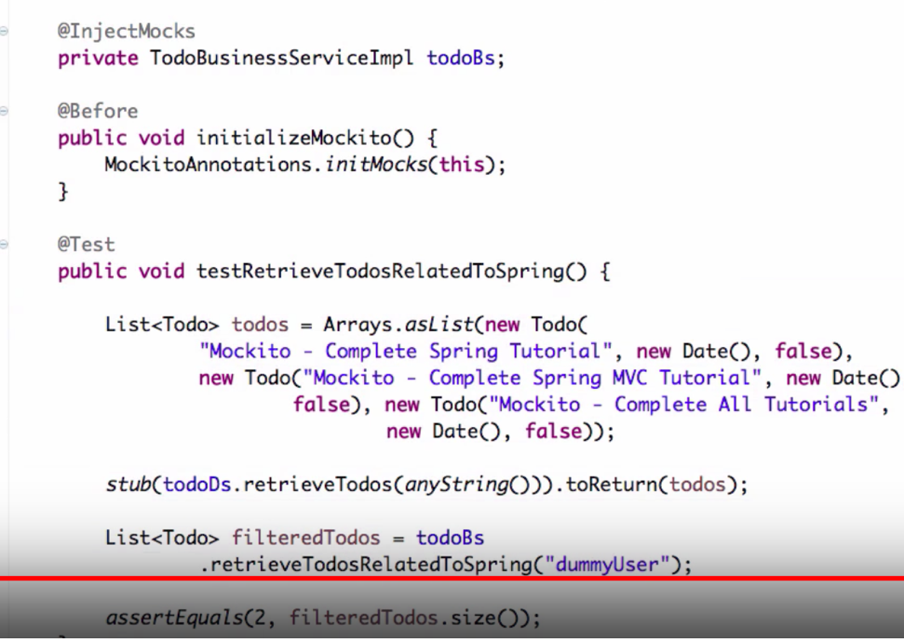

* With Spring JDBC connectivity become very simple with JDBC template. No need to

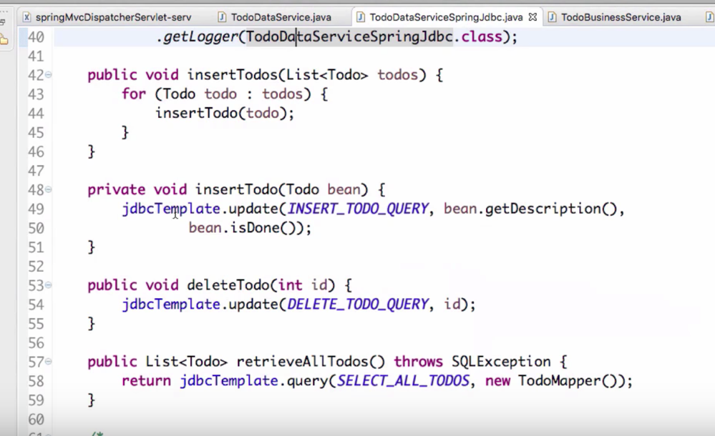

**Context Configuration Annotations**

These annotations are used by Spring to guide creation and injection of beans.

|  |  |  |
| --- | --- | --- |
| **ANNOTATION** | **USE** | **DESCRIPTION** |
| @Autowired | Constructor, Field, Method | Declares a constructor, field, setter method, or configuration method to be autowired by type. Items annotated with @Autowired do not have to be public. |
| @Configurable | Type | Used with <context:springconfigured> to declare types whose properties should be injected, even if they are not instantiated by Spring. Typically used to inject the properties of domain objects. |
| @Order | Type, Method, Field | Defines ordering, as an alternative to implementing the org. springframework.core.Ordered interface. |
| @Qualifier | Field, Parameter, Type, Annotation Type | Guides autowiring to be performed by means other than by type. |
| @Required | Method (setters) | Specifies that a particular property must be injected or else the configuration will fail. |
| @Scope | Type | Specifies the scope of a bean, either singleton, prototype, request, session, or some custom scope. |

### Stereotyping Annotations

These annotations are used to stereotype classes with regard to the application tier that they belong to

|  |  |  |
| --- | --- | --- |
| **ANNOTATION** | **USE** | **DESCRIPTION** |
| @Component | Type | Generic stereotype annotation for any Spring-managed component. |
| @Controller | Type | Stereotypes a component as a Spring MVC controller. |
| @Repository | Type | Stereotypes a component as a repository. Also indicates that SQLExceptions thrown from the component's methods should be translated into Spring DataAccessExceptions. |
| @Service | Type | Stereotypes a component as a service. |

### Spring MVC Annotations

|  |  |  |
| --- | --- | --- |
| **ANNOTATION** | **USE** | **DESCRIPTION** |
| @Controller | Type | Stereotypes a component as a Spring MVC controller. |
| @InitBinder | Method | Annotates a method that customizes data binding. |
| @ModelAttribute | Parameter, Method | When applied to a method, used to preload the model with the value returned from the method. When applied to a parameter, binds a model attribute to the parameter. table |
| @RequestMapping | Method, Type | Maps a URL pattern and/or HTTP method to a method or controller type. |
| @RequestParam | Parameter | Binds a request parameter to a method parameter. |
| @SessionAttributes | Type | Specifies that a model attribute should be stored in the session. |

These annotations were introduced in Spring 2.5 to make it easier to create Spring MVC applications with minimal XML configuration and without extending one of the many implementations of the Controller interface.

## Aspect Annotations

For defining aspects, Spring leverages the set of annotations provided by AspectJ.

|  |  |  |
| --- | --- | --- |
| **ANNOTATION** | **USE** | **DESCRIPTION** |
| @Aspect | Type | Declares a class to be an aspect. |
| @After | Method | Declares a method to be called after a pointcut completes. |
| @AfterReturning | Method | Declares a method to be called after a pointcut returns successfully. |
| @AfterThrowing | Method | Declares a method to be called after a pointcut throws an exception. |
| @Around | Method | Declares a method that will wrap the pointcut. |
| @Before | Method | Declares a method to be called before proceeding to the pointcut. |
| @DeclareParents | Static Field | Declares that matching types should be given new parents,that is, it introduces new functionality into matching types. |
| @Pointcut | Method | Declares an empty method as a pointcut placeholder method. |

What's important to note, however, is that while you can use AspectJ annotations to define Spring aspects, those aspects will be defined in the context of Spring AOP and will not be handled by the AspectJ runtime. This is significant because Spring AOP is limited to proxying method invocations and does not provide for the more exotic pointcuts (constructor interception, field interception, etc.) offered by AspectJ.

**Spring vs Springboot?**

cross cutting concerns @ it is the concern that’s **not restricted to any layer** like logging soming or user is spending how long in which module.

**Defination of AOP**

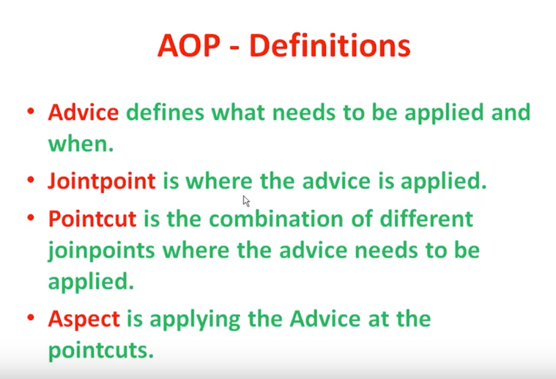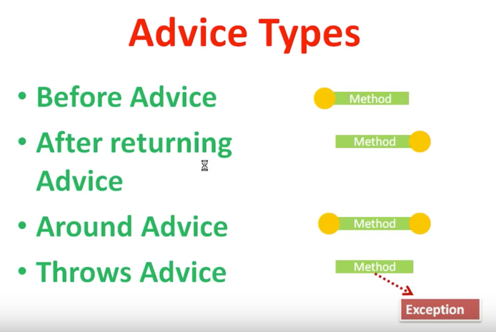

**Why we should use AOP.**

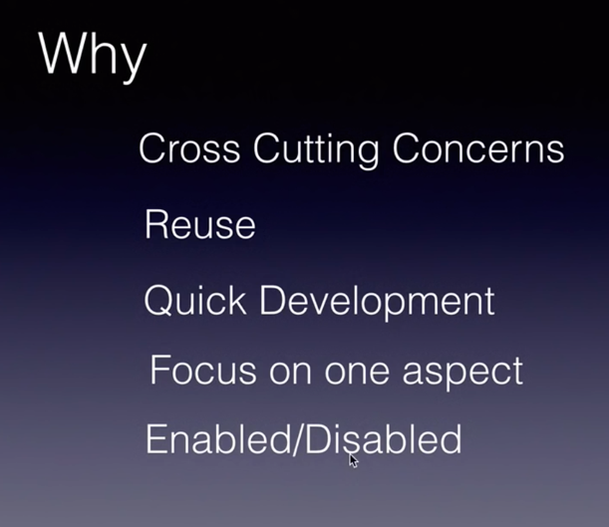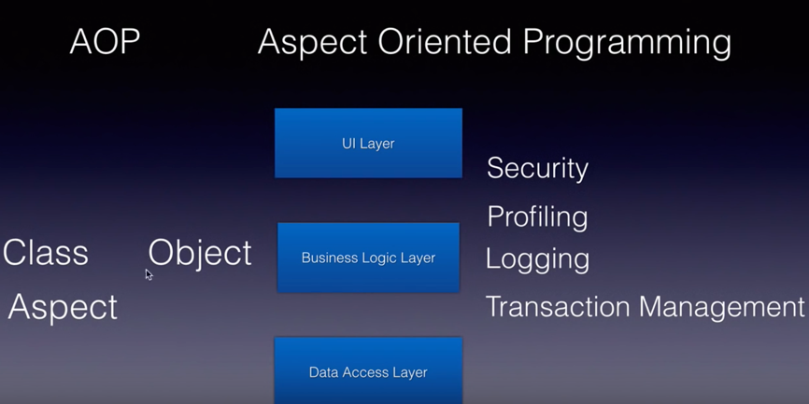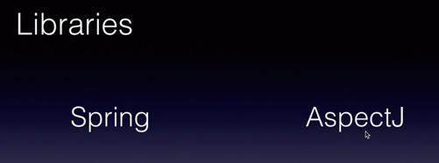

**What is the alternative of Spring Framework?**

This is difficult to find alternative for whole spring framework. Instead of that you have to replace every Spring module with different frameworks…

1. **Spring MVC with Struts, JSF like frameworks…**
2. **Spring HibernateTemplate with Hibernate, JBatis like frameworks…**
3. **Spring AOP with AspectJ kind of libraries…**
4. **and finally Spring IOC with Guice….**

There is a constant innovation happening in spring frameworks. Maintenance and configuration being so difficult for spring applications, people tend to look at alternatives.

You can have a look at spring Boot which eases all the initial steps of booting up an application.

It aims at zero configuration and comes with an Embedded tomcat [Embedded tomcat servlet container in spring boot](https://youtu.be/WdX0v8hPxcw)

**Below are the benefits of Spring:**

1. **Lightweight:**Spring Framework is lightweight with respect to size and transparency.
2. **Inversion Of Control (IOC):** In Spring Framework, loose coupling is achieved using Inversion of Control. The objects give their own dependencies instead of creating or looking for dependent objects.
3. **Aspect Oriented Programming (AOP):** By separating application business logic from system services, Spring Framework supports Aspect Oriented Programming and enables cohesive development.
4. **Container:** Spring Framework creates and manages the life cycle and configuration of application objects.
5. **MVC Framework:** Spring Framework is a MVC web application framework. This framework is configurable via interfaces and accommodates multiple view technologies.
6. **Transaction Management:** For transaction management,Spring framework provides a generic abstraction layer. It is not tied to J2EE environments and it can be used in container-less environments.
7. **JDBC Exception Handling:** The JDBC abstraction layer of the Spring Framework offers an exception hierarchy, which simplifies the error handling strategy.

**When ever we come from browser to web app first it goes to dispatcher servlet (which stays in webapp.xml) and from there it goes to controller.**

**----------------Java 1.8----------------**

**Java - 8 features.**

1. **Lamda expression. (**IT is an anonymous function. ( no name, no modifiers, no return type)

----inside java.util.function package-----

1. **Functional interface. (**if a interface contain only one abstract method that interface is called functional interface. It is used to invoke lamda expression.**)**
2. ***Predicate*** - (a single argument function that returns a boolean value. #test(); abstract method)

## *Composing predicates ( with and , or method)*

* 1. ***The negate() method ( get the opposite values)***

1. ***Function*** - ( accept 2 params( i/p , return type) #abstract method apply();and other default methods are **andThen()** & **compose()**. )
2. ***Consumer*** - ( accept generic type args <T> and return nothing. # abstract method accept(T t);)
3. ***Supplier*** - ( accept no argument but produces generic type return type <T>; # abstract method get();)

--------------------

1. **Method and constructor reference by using Double colon ::**
2. **Stream API**
3. Default method inside interface
4. Static method inside interface.
5. Date time api (joda api).

# ***1) Java Lambda Expressions ::***

|  |
| --- |
| Lambda expression is a new and important feature of Java which was included in Java SE 8. It **provides a clear and concise way to represent one method interface using an expression. It is very useful in collection library. It helps to iterate, filter and extract data from collection.**  The Lambda expression is used to **provide the implementation of an interface which has functional interface**. It saves a lot of code. **In case of lambda expression, we don't need to define the method again for providing the implementation. Here, we just write the implementation code.**  Java lambda expression is treated as a function, so compiler does not create .class file. Why use Lambda Expression  1. To provide the implementation of Functional interface. 2. Less coding.  Java Lambda Expression Syntax **(argument-list) -> {body}**  Java lambda expression is consisted of three components.  **1) Argument-list:** It can be empty or non-empty as well.  **2) Arrow-token:** It is used to link arguments-list and body of expression.  **3) Body:** It contains expressions and statements for lambda expression.  **No Parameter Syntax**   1. () -> { 2. //Body of no parameter lambda 3. }   **One Parameter Syntax**   1. (p1) -> { 2. //Body of single parameter lambda 3. }   **Two Parameter Syntax**   1. (p1,p2) -> { 2. //Body of multiple parameter lambda 3. }  Example Without Lambda Expression  1. **interface** Drawable{ 2. **public** **void** draw(); 3. } 4. **public** **class** LambdaExpressionExample { 5. **public** **static** **void** main(String[] args) { 6. **int** width=10; 8. //without lambda, Drawable implementation using anonymous class 9. Drawable d=**new** Drawable(){ 10. **public** **void** draw(){System.out.println("Drawing "+width);} 11. }; 12. d.draw(); 13. } 14. }   [**Test it Now**](https://compiler.javatpoint.com/opr/test.jsp?filename=LambdaExpressionExample)  Output:  Drawing 10 Example with Lambda Expression Now, we are going to implement the above example with the help of Java lambda expression.   1. @FunctionalInterface //It is optional 2. **interface** Drawable{ 3. **public** **void** draw(); 4. } 6. **public** **class** LambdaExpressionExample2 { 7. **public** **static** **void** main(String[] args) { 8. **int** width=10; 10. //with lambda 11. Drawable d2=()->{ 12. System.out.println("Drawing "+width); 13. }; 14. d2.draw(); 15. } 16. }  ava Lambda Expression Example: No Parameter  1. **interface** Sayable{ 2. **public** String say(); 3. } 4. **public** **class** LambdaExpressionExample3{ 5. **public** **static** **void** main(String[] args) { 6. Sayable s=()->{ 7. **return** "I have nothing to say."; 8. }; 9. System.out.println(s.say()); 10. } 11. }   [**Test it Now**](https://compiler.javatpoint.com/opr/test.jsp?filename=LambdaExpressionExample3)  Output:  I have nothing to say. Java Lambda Expression Example: Single Parameter  1. **interface** Sayable{ 2. **public** String say(String name); 3. } 5. **public** **class** LambdaExpressionExample4{ 6. **public** **static** **void** main(String[] args) { 8. // Lambda expression with single parameter. 9. Sayable s1=(name)->{ 10. **return** "Hello, "+name; 11. }; 12. System.out.println(s1.say("Sonoo")); 14. // You can omit function parentheses 15. Sayable s2= name ->{ 16. **return** "Hello, "+name; 17. }; 18. System.out.println(s2.say("Sonoo")); 19. } 20. }   [**Test it Now**](https://compiler.javatpoint.com/opr/test.jsp?filename=LambdaExpressionExample4)  Output:  Hello, Sonoo  Hello, Sonoo Java Lambda Expression Example: Multiple Parameters  1. **interface** Addable{ 2. **int** add(**int** a,**int** b); 3. } 5. **public** **class** LambdaExpressionExample5{ 6. **public** **static** **void** main(String[] args) { 8. // Multiple parameters in lambda expression 9. Addable ad1=(a,b)->(a+b); 10. System.out.println(ad1.add(10,20)); 12. // Multiple parameters with data type in lambda expression 13. Addable ad2=(**int** a,**int** b)->(a+b); 14. System.out.println(ad2.add(100,200)); 15. } 16. }   [**Test it Now**](https://compiler.javatpoint.com/opr/test.jsp?filename=LambdaExpressionExample5) Java Lambda Expression Example: with or without return keyword In Java lambda expression, if there is only one statement, you may or may not use return keyword. ***You must use return keyword when lambda expression contains multiple statements.***   1. **interface** Addable{ 2. **int** add(**int** a,**int** b); 3. } 5. **public** **class** LambdaExpressionExample6 { 6. **public** **static** **void** main(String[] args) { 8. // Lambda expression without return keyword. 9. Addable ad1=(a,b)->(a+b); 10. System.out.println(ad1.add(10,20)); 12. // Lambda expression with return keyword. 13. Addable ad2=(**int** a,**int** b)->{ 14. **return** (a+b); 15. }; 16. System.out.println(ad2.add(100,200)); 17. } 18. }  *Java Lambda Expression Example: Foreach Loop*  1. **import** java.util.*; 2. **public** **class** LambdaExpressionExample7{ 3. **public** **static** **void** main(String[] args) { 5. List<String> list=**new** ArrayList<String>(); 6. list.add("ankit"); 7. list.add("mayank"); 8. list.add("irfan"); 9. list.add("jai"); 11. list.forEach( 12. (n)->System.out.println(n) 13. ); 14. } 15. }  Java Lambda Expression Example: Creating Thread You can use lambda expression to run thread. In the following example, we are implementing run method by using lambda expression.   1. **public** **class** LambdaExpressionExample9{ 2. **public** **static** **void** main(String[] args) { 4. //Thread Example without lambda 5. Runnable r1=**new** Runnable(){ 6. **public** **void** run(){ 7. System.out.println("Thread1 is running..."); 8. } 9. }; 10. Thread t1=**new** Thread(r1); 11. t1.start(); 12. //Thread Example with lambda 13. Runnable r2=()->{ 14. System.out.println("Thread2 is running..."); 15. }; 16. Thread t2=**new** Thread(r2); 17. t2.start(); 18. } 19. }   [**Test it Now**](https://compiler.javatpoint.com/opr/test.jsp?filename=LambdaExpressionExample9) *Java Lambda Expression Example: Comparator (it is used for sorting)*  1. **import** java.util.ArrayList; 2. **import** java.util.Collections; 3. **import** java.util.List; 4. **class** Product{ 5. **int** id; 6. String name; 7. **float** price; 8. **public** Product(**int** id, String name, **float** price) { 9. **super**(); 10. **this**.id = id; 11. **this**.name = name; 12. **this**.price = price; 13. } 14. } 15. **public** **class** LambdaExpressionExample10{ 16. **public** **static** **void** main(String[] args) { 17. List<Product> list=**new** ArrayList<Product>(); 19. //Adding Products 20. list.add(**new** Product(1,"HP Laptop",25000f)); 21. list.add(**new** Product(3,"Keyboard",300f)); 22. list.add(**new** Product(2,"Dell Mouse",150f)); 24. System.out.println("Sorting on the basis of name..."); 26. // implementing lambda expression 27. Collections.sort(list,(p1,p2)->{ 28. **return** p1.name.compareTo(p2.name); 29. }); 30. **for**(Product p:list){ 31. System.out.println(p.id+" "+p.name+" "+p.price); 32. } 34. } 35. }   [**Tes**](https://compiler.javatpoint.com/opr/test.jsp?filename=LambdaExpressionExample10) *Java Lambda Expression Example: Filter Collection Data* **import** java.util.ArrayList;  **import** java.util.List;  **import** java.util.stream.Stream;  **class** Product{  **int** id;  String name;  **float** price;  **public** Product(**int** id, String name, **float** price) {  **super**();  **this**.id = id;  **this**.name = name;  **this**.price = price;  }  }  **public** **class** LambdaExpressionExample11{  **public** **static** **void** main(String[] args) {  List<Product> list=**new** ArrayList<Product>();  list.add(**new** Product(1,"Samsung A5",17000f));  list.add(**new** Product(3,"Iphone 6S",65000f));  list.add(**new** Product(2,"Sony Xperia",25000f));  list.add(**new** Product(4,"Nokia Lumia",15000f));  list.add(**new** Product(5,"Redmi4 ",26000f));  list.add(**new** Product(6,"Lenevo Vibe",19000f));    // using lambda to filter data  Stream<Product> filtered_data = list.stream().filter(p -> p.price > 20000);    // using lambda to iterate through collection  filtered_data.forEach(  product -> System.out.println(product.name+": "+product.price)  );  }  }  Source :: <https://www.javatpoint.com/java-lambda-expressions>  **2) Functional Interface ::**  Lambda expression provides implementation of *functional interface*. **An interface which has only one abstract method is called functional interface**. Java **provides an annotation @*FunctionalInterface***, which is **used to declare an interface as functional interface**. |

Where ever in java you find functional interface there you can use lamda expression. For eg. comparator.

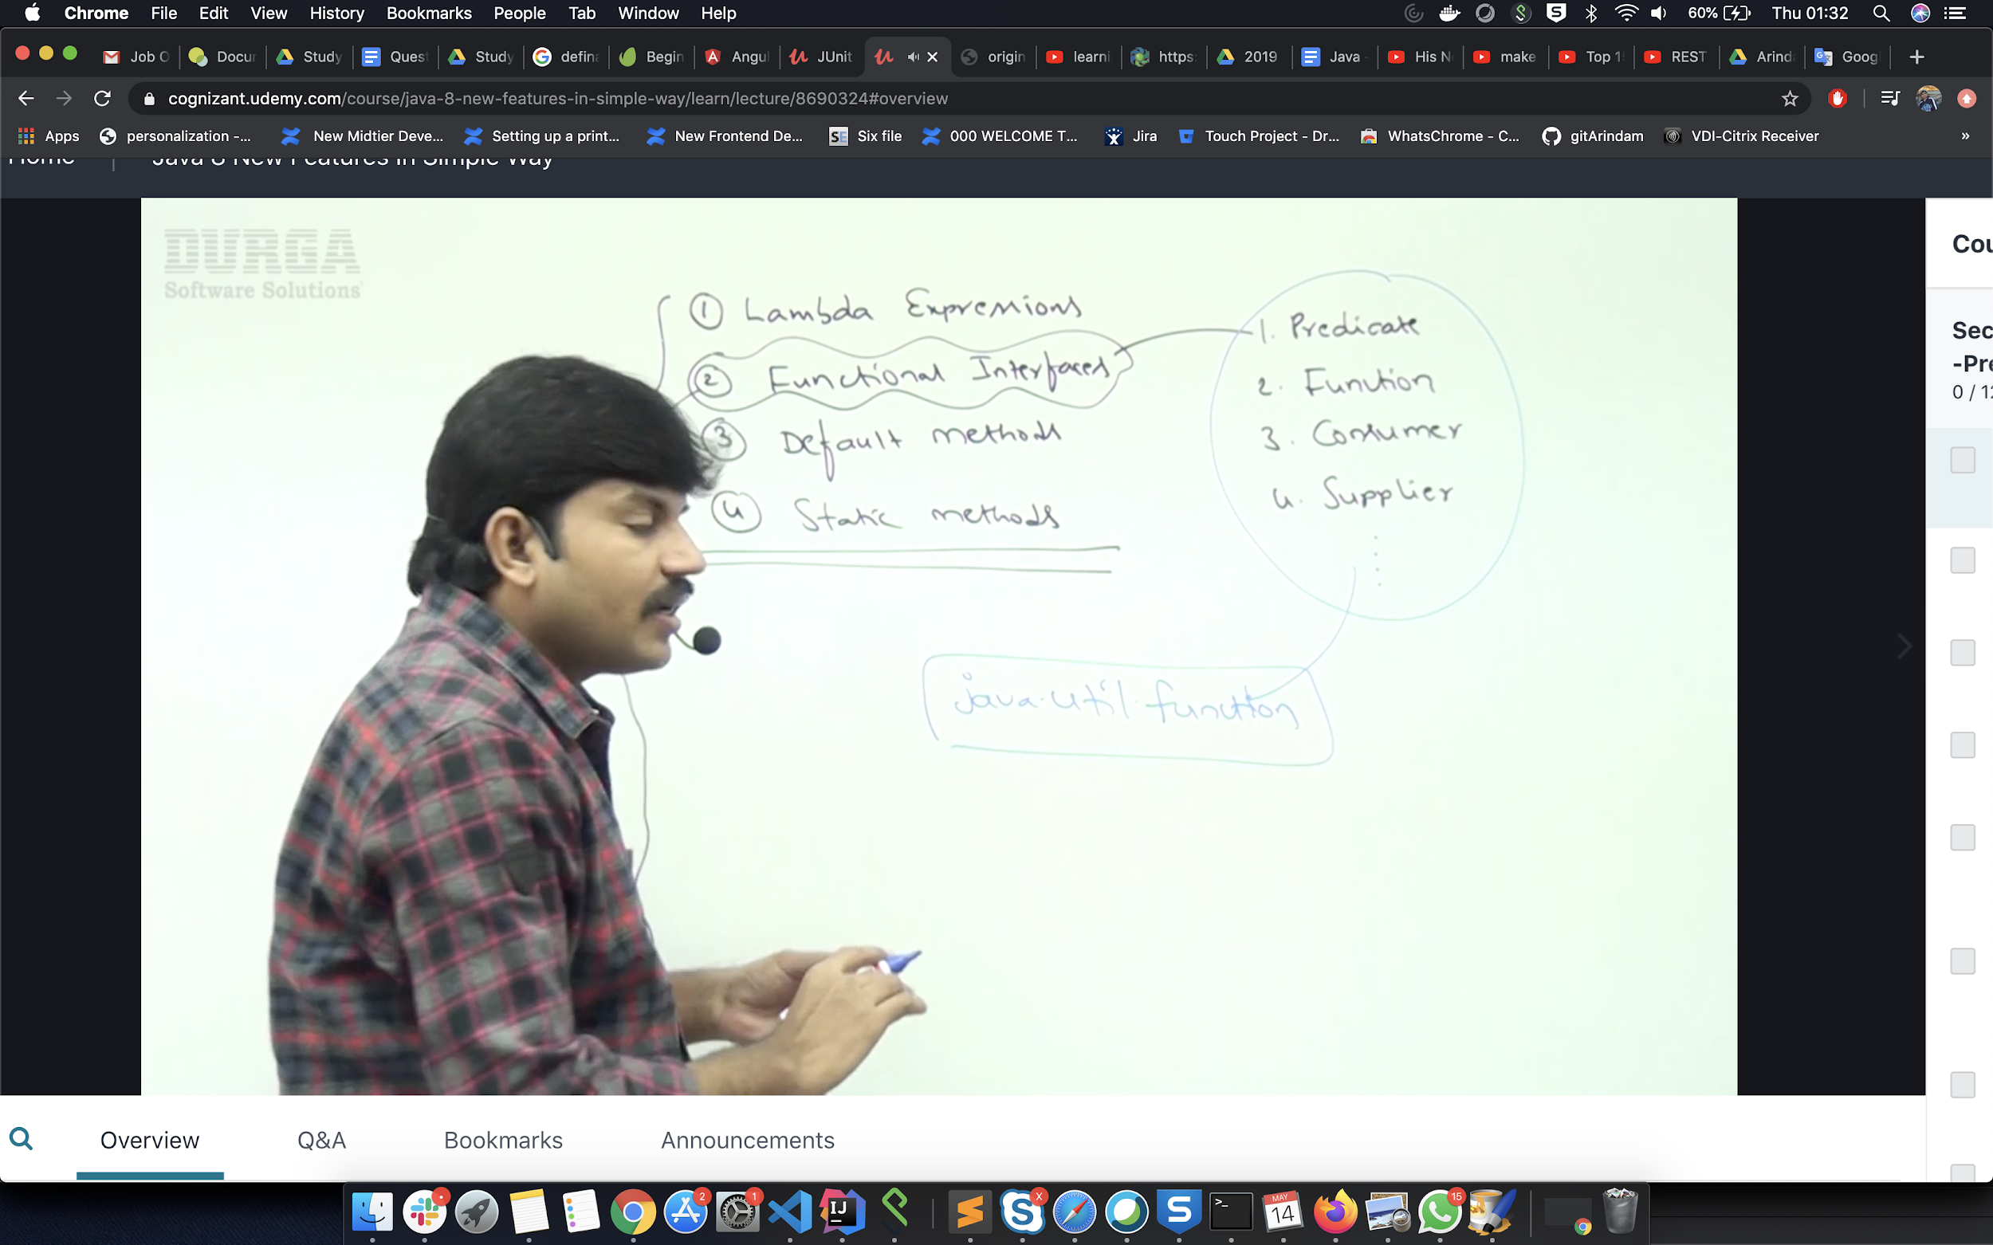

***3) Predicate ::***

Predicates represent single argument functions that return a boolean value.

Predicate<T> is a generic functional interface representing a single argument function that returns a boolean value. It is located in the java.util.function package. It contains a test(T t) method that evaluates the predicate on the given argument.

Eg

package com.zetcode;

import java.util.List;

import java.util.function.Predicate;

public class JavaPredicateEx2 {

public static void main(String[] args) {

List<Integer> nums = List.of(2, 3, 1, 5, 6, 7, 8, 9, 12);

Predicate<Integer> btf = n -> n > 5;

nums.stream().filter(btf).forEach(System.out::println);

}

}

The example filters integer values; this time we use Java lambda expression, which makes the code much shorter.

Predicate<Integer> btf = n -> n > 5;

## 

## *Composing predicates*

## With and() and or() methods we can compose predicates in Java.

com/zetcode/JavaPredicateCompose.java

package com.zetcode;

import java.util.Arrays;

import java.util.function.IntPredicate;

public class JavaPredicateCompose {

public static void main(String[] args) {

int[] nums = {2, 3, 1, 5, 6, 7, 8, 9, 12};

IntPredicate p1 = n -> n > 3;

IntPredicate p2 = n -> n < 9;

Arrays.stream(nums).filter(p1.and(p2)).forEach(System.out::println);

System.out.println("**********");

IntPredicate p3 = n -> n == 6;

IntPredicate p4 = n -> n == 9;

Arrays.stream(nums).filter(p3.or(p4)).forEach(System.out::println);

}

}

The example filters data using composition of IntPredicates.

IntPredicate p1 = n -> n > 3;

IntPredicate p2 = n -> n < 9;

Arrays.stream(nums).filter(p1.and(p2)).forEach(System.out::println);

We combine two predicates with the and() method; we get integers that are bigger than three and smaller than nine.

IntPredicate p3 = n -> n == 6;

IntPredicate p4 = n -> n == 9;

Arrays.stream(nums).filter(p3.or(p4)).forEach(System.out::println);

With the or() method, we get values that are equal either to six or nine.

5

6

7

8

**********

6

9

This is the output.

***The negate() method :: (***With the negate() method, we get the opposite)

The negate() method returns a predicate that represents the logical negation of the given predicate.

com/zetcode/JavaPredicateNegate.java

package com.zetcode;

import java.util.Arrays;

import java.util.function.IntPredicate;

public class JavaPredicateNegate {

public static void main(String[] args) {

int[] nums = {2, 3, 1, 5, 6, 7, 8, 9, 12};

IntPredicate p = n -> n > 5;

Arrays.stream(nums).filter(p).forEach(System.out::println);

System.out.println("**********");

Arrays.stream(nums).filter(p.negate()).forEach(System.out::println);

}

}

The example demonstrates the usage of the negate() method.

IntPredicate p = n -> n > 5;

We have a predicate that returns true for values bigger than five.

Arrays.stream(nums).filter(p).forEach(System.out::println);

We filter all integers that are bigger than five.

Arrays.stream(nums).filter(p.negate()).forEach(System.out::println);

With the negate() method, we get the opposite: values lower or equal to four.

6

7

8

9

12

**********

2

3

1

5

This is the output of the example.

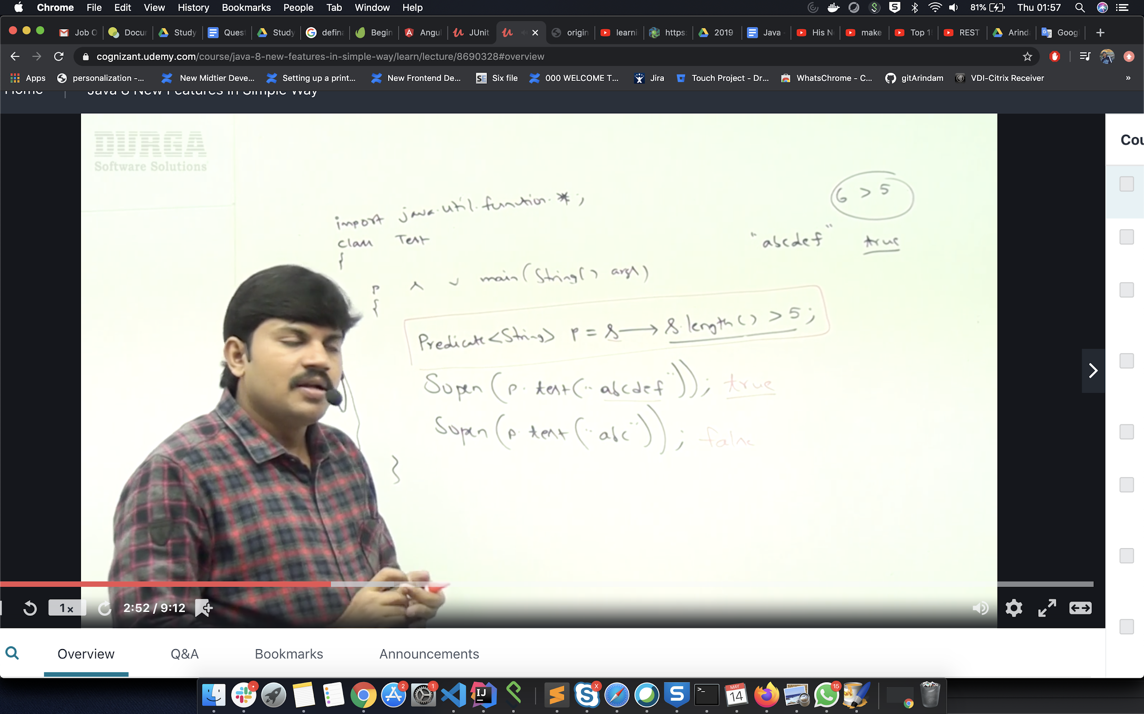

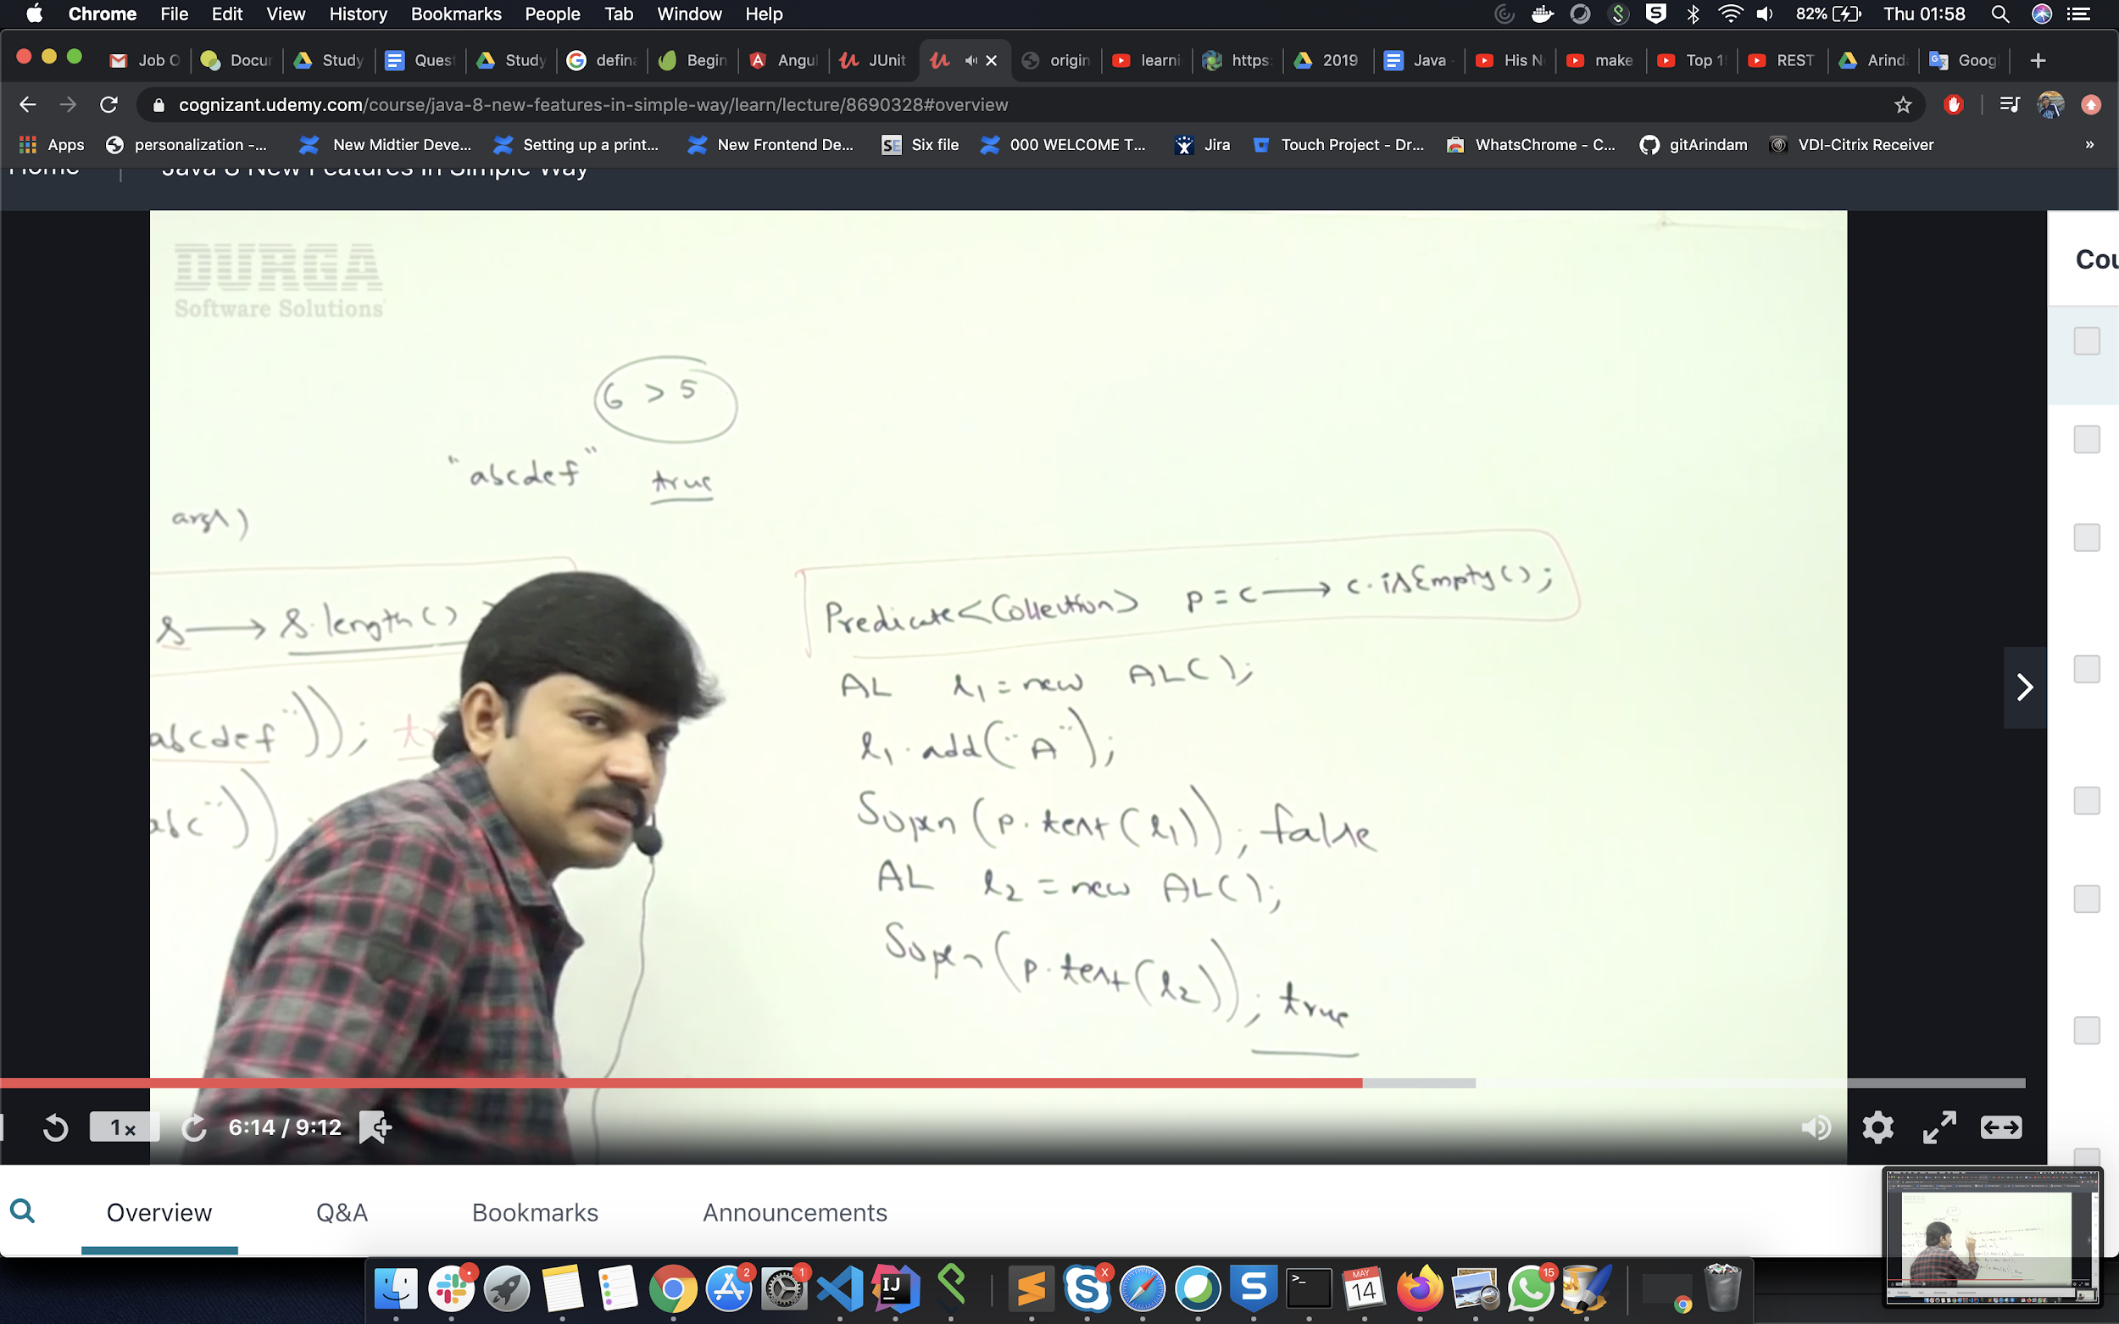

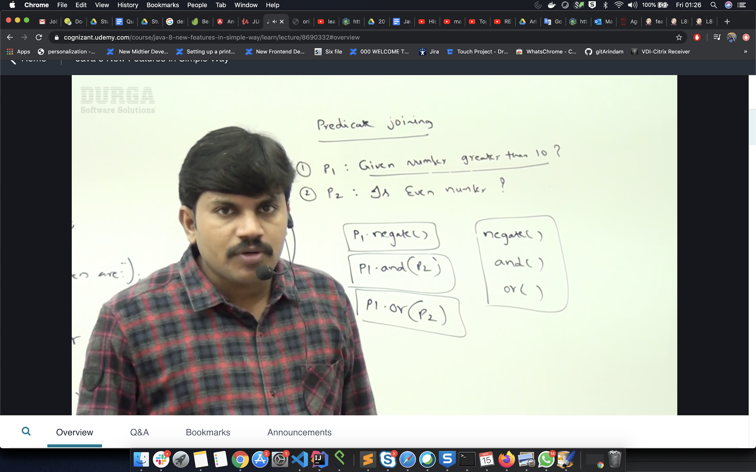

***4) Function ::***

It takes 2 parameters input and return type. The abstract methods is **apply();** and other default methods are andThen() and compose().

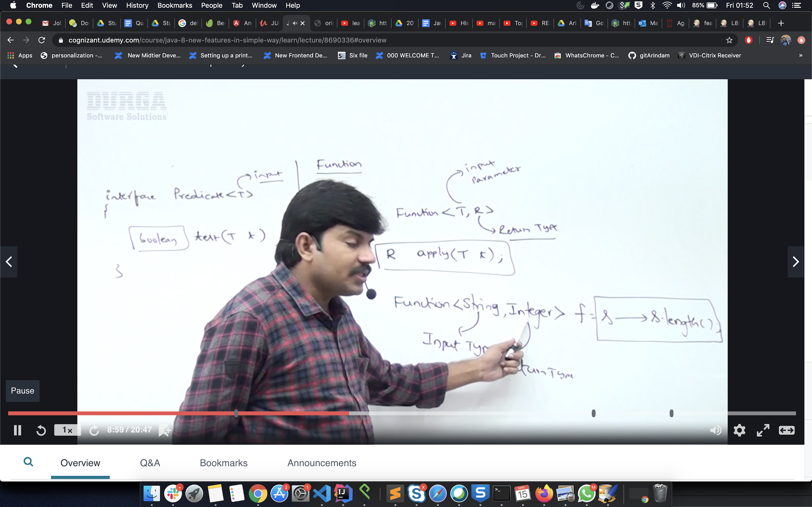

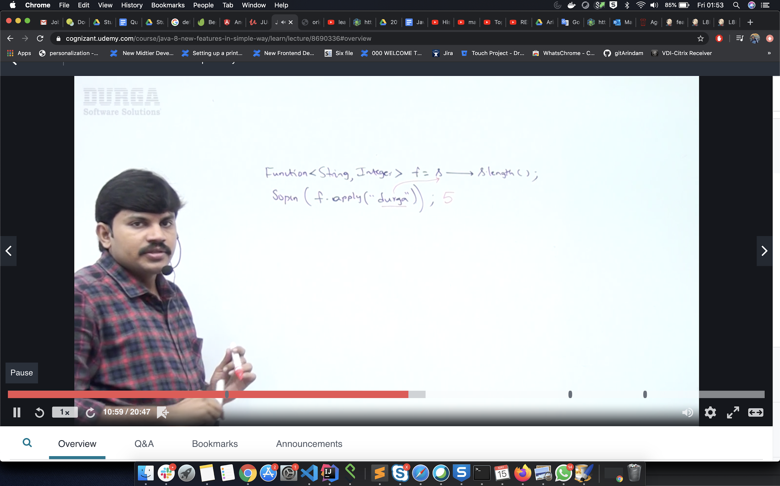

Difference btn predicate and function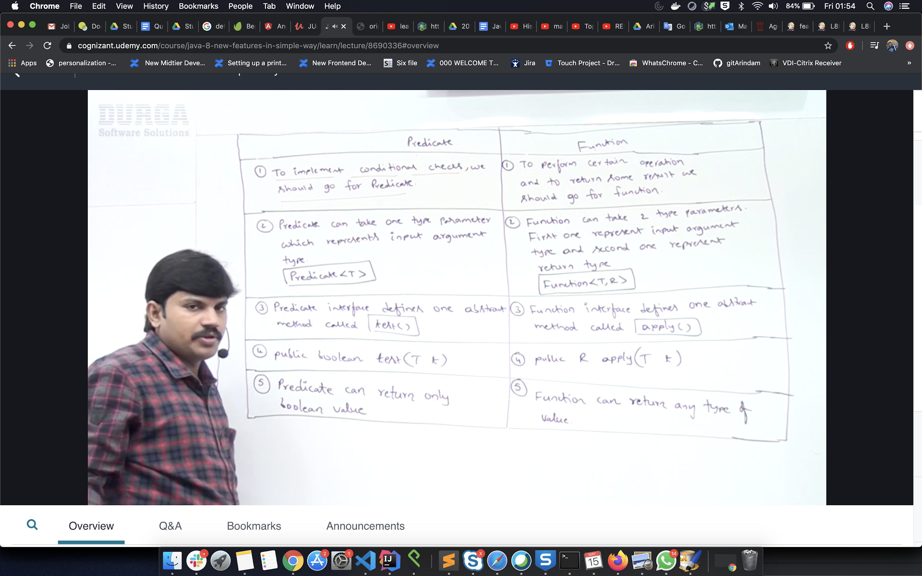

**FUNCTION CHAINING**

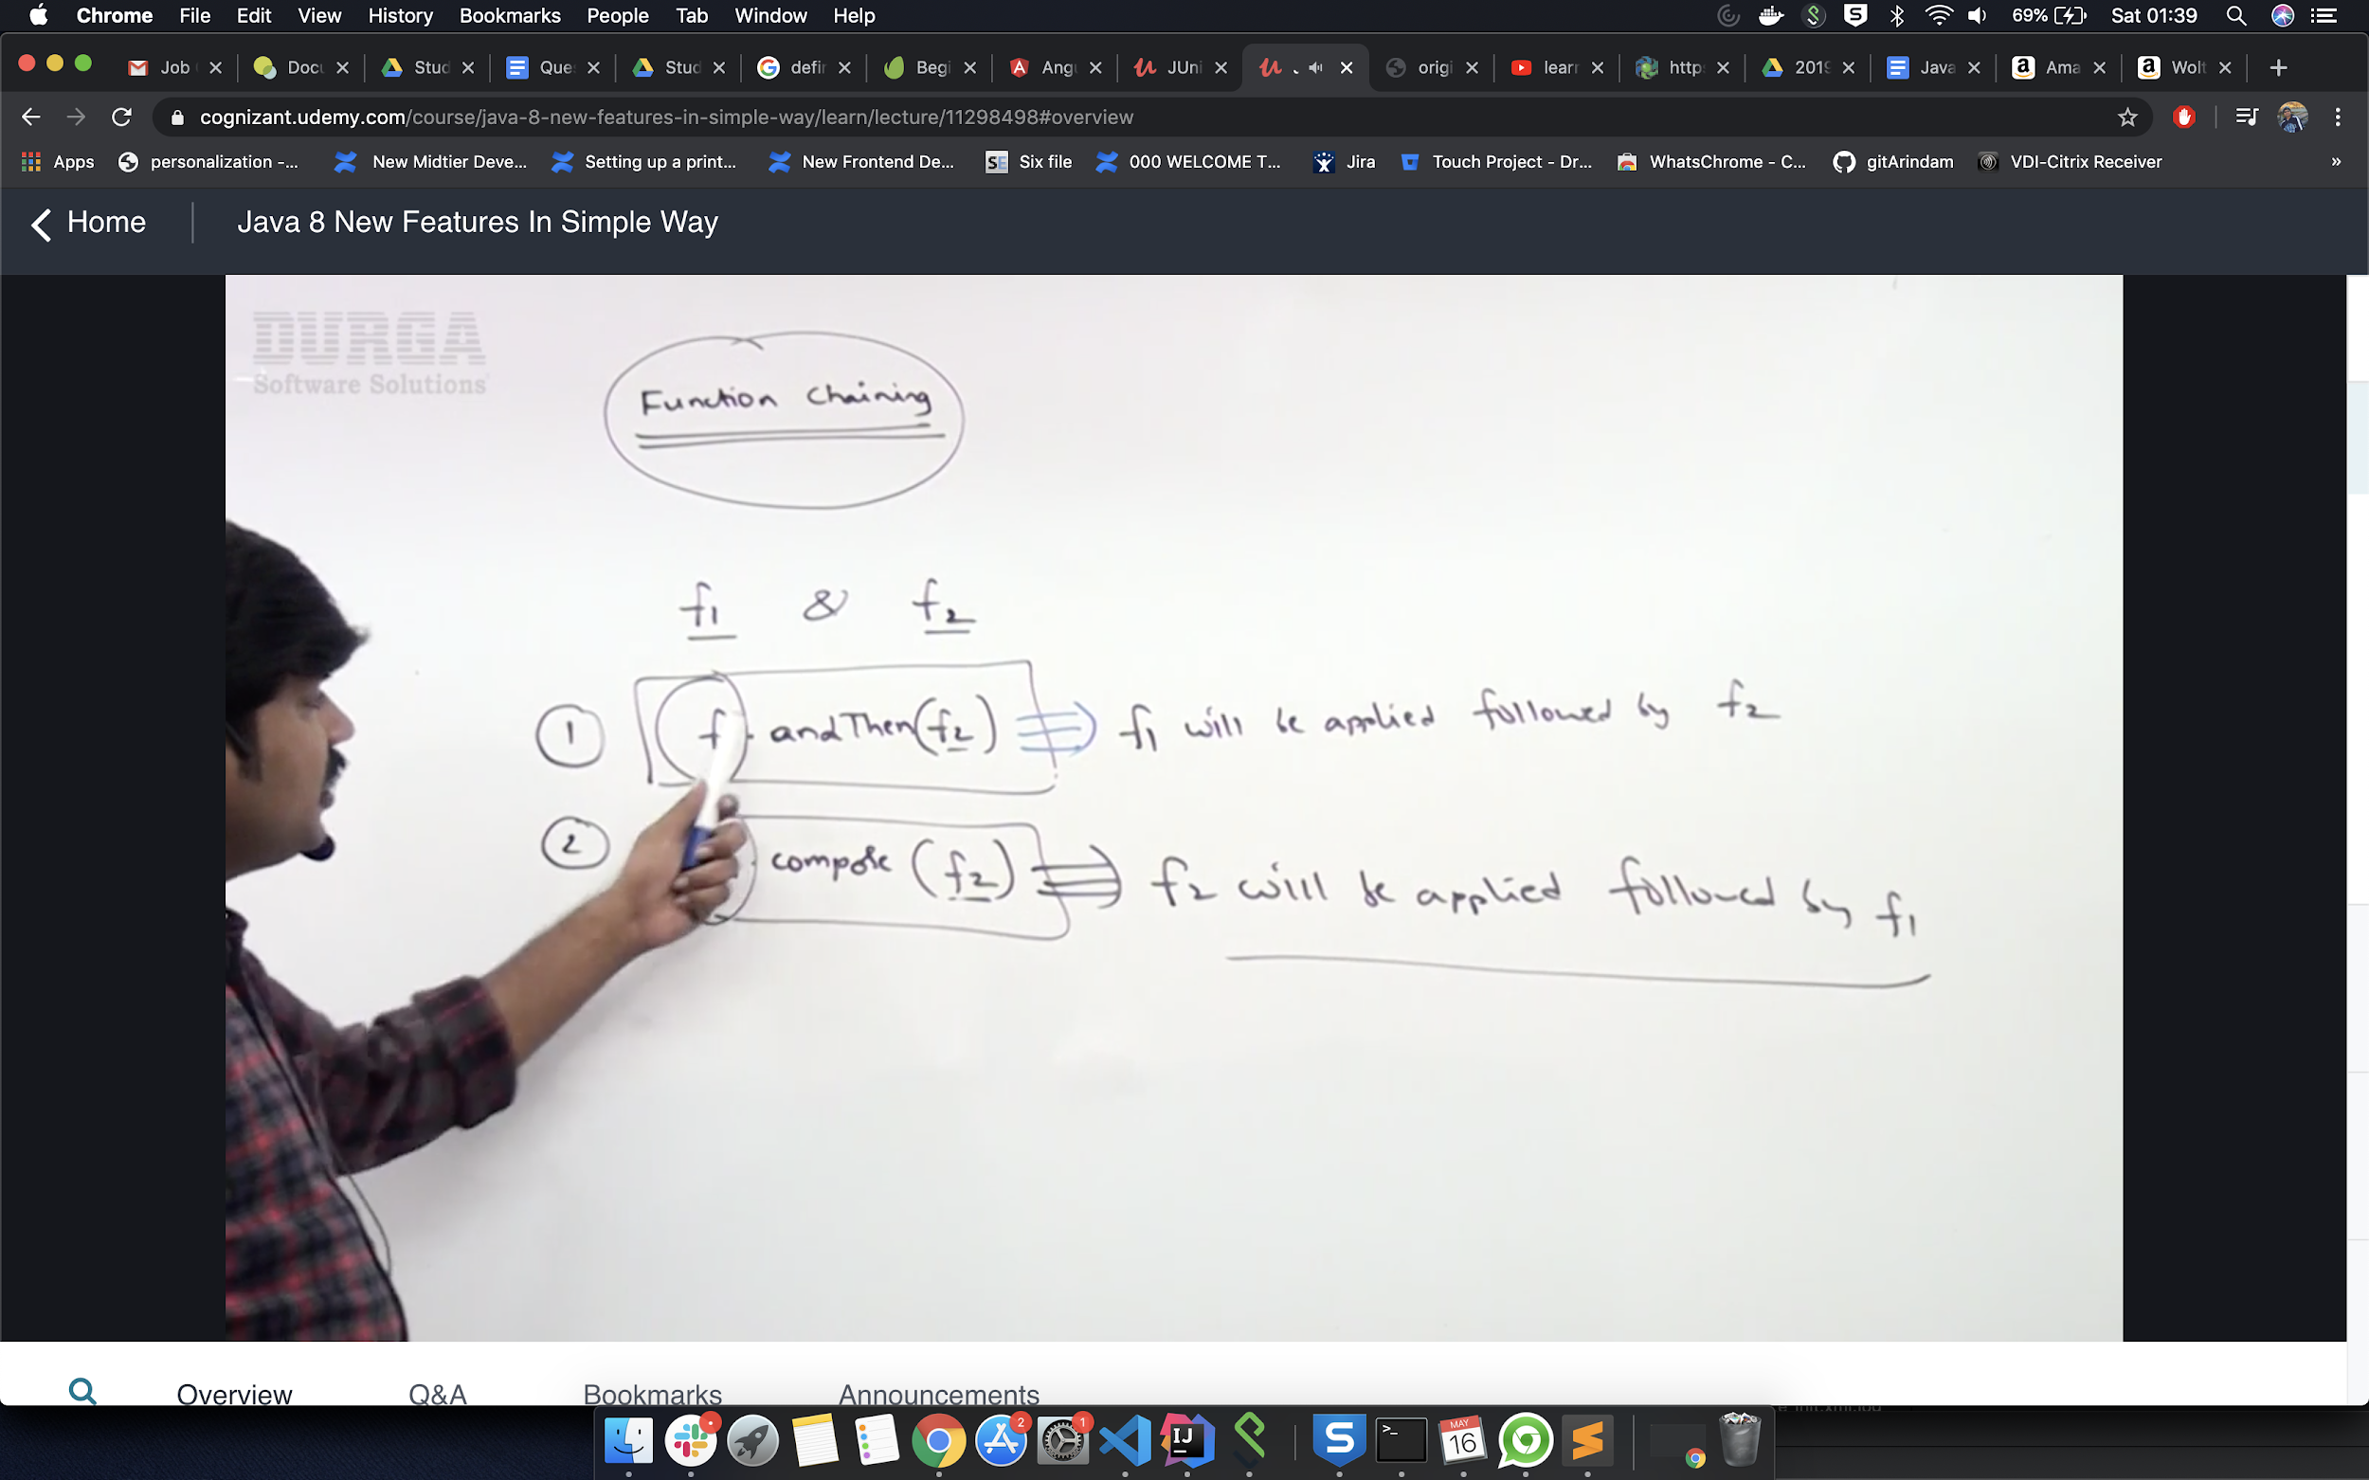

***5) Consumer***

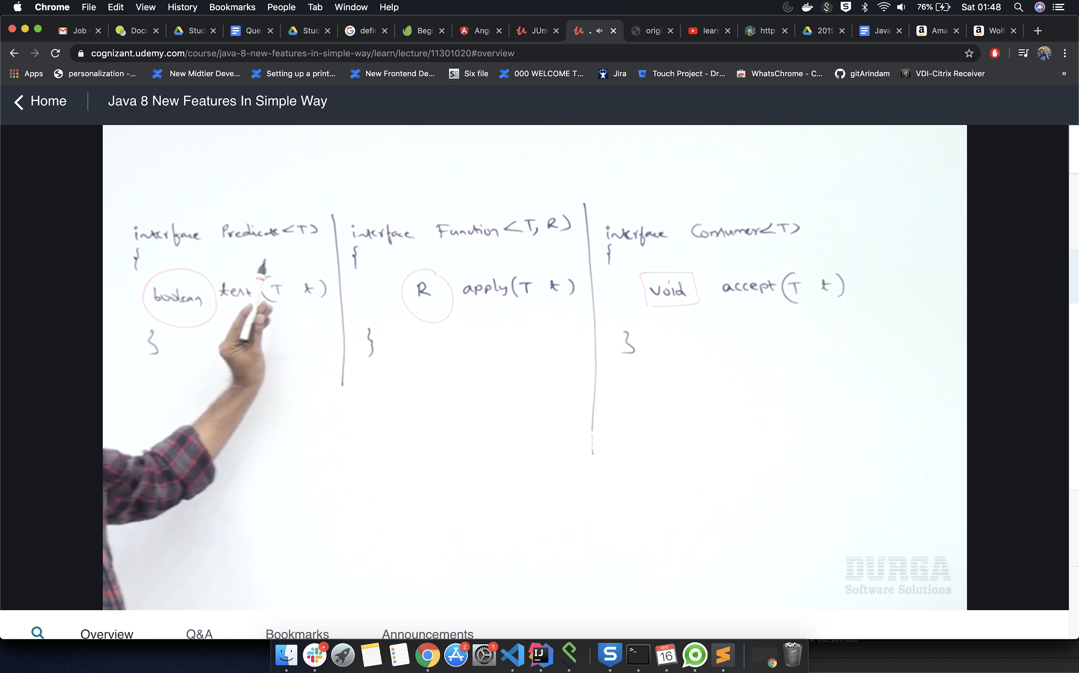

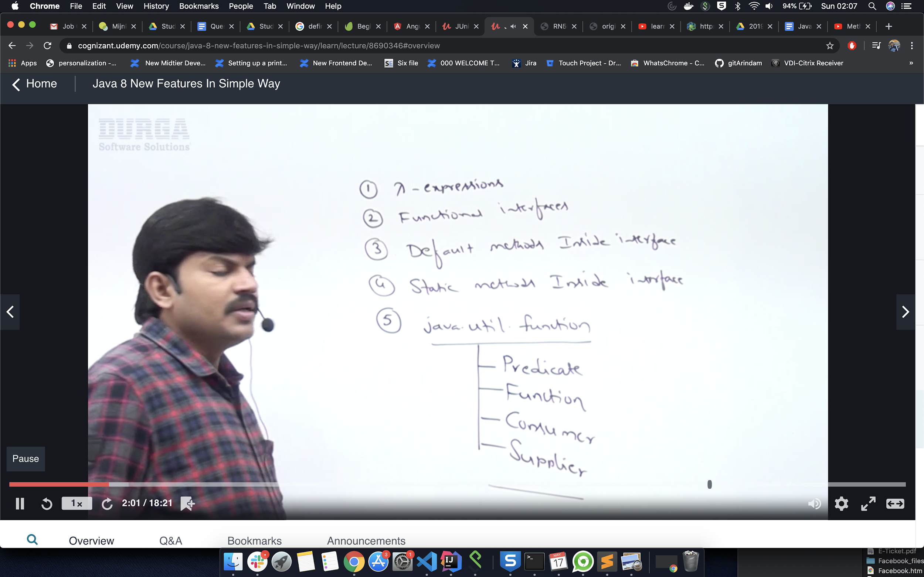

***6) Supplier***

The **Supplier Interface** is a part of the **java.util.function** package which has been introduced since Java 8, to implement [functional programming](https://www.geeksforgeeks.org/functional-programming-paradigm/) in Java. It represents a function which does not take in any argument but produces a value of type T.

Hence this functional interface takes in only one generic namely:-

* **T**: denotes the type of the result

The lambda expression assigned to an object of Supplier type is used to define its **get()** which eventually produces a value. Suppliers are useful when we don’t need to supply any value and obtain a result at the same time.

The Supplier interface consists of only one function:

### 1. get()

This method does not take in any argument but produces a value of type T.

**Syntax:**

T get()

**Returns:** This method returns a **value** of type T.

Below is the code to illustrate get() method:

**Program:**

|  |
| --- |
| import java.util.function.Supplier;    public class Main {  public static void main(String args[])  {    // This function returns a random value.  Supplier<Double> randomValue = () -> Math.random();    // Print the random value using get()  System.out.println(randomValue.get());  }  } |

**Output:**

0.5685808855697841

**7) Method and constructor reference by using Double colon ::**

**Java provides a new feature called method reference in Java 8. Method reference is used to refer method of functional interface. It is compact and easy form of lambda expression. Each time when you are using lambda expression to just referring a method, you can replace your lambda expression with method reference. In this tutorial, we are explaining method reference concept in detail.**

Method reference (::) is the alternative to lamda expression. Only thing we need to remember the target and the source method argument must be same.

The advantage of this is code reusability.

## Types of Method References

There are following types of method references in java:

1. Reference to a static method.
2. Reference to an instance method.
3. Reference to a constructor.

## 1) Reference to a Static Method

You can refer to static method defined in the class. Following is the syntax and example which describe the process of referring static method in Java.

Syntax

1. ContainingClass::staticMethodName

### Example 1

In the following example, we have defined a functional interface and referring a static method to it's functional method say().

1. **interface** Sayable{
2. **void** say();
3. }
4. **public** **class** MethodReference {
5. **public** **static** **void** saySomething(){
6. System.out.println("Hello, this is static method.");
7. }
8. **public** **static** **void** main(String[] args) {
9. // Referring static method
10. Sayable sayable = MethodReference::saySomething;
11. // Calling interface method
12. sayable.say();
13. }
14. }

Another example

You can also use predefined functional interface to refer methods. In the following example, we are using BiFunction interface and using it's apply() method.

1. **import** java.util.function.BiFunction;
2. **class** Arithmetic{
3. **public** **static** **int** add(**int** a, **int** b){
4. **return** a+b;
5. }
6. }
7. **public** **class** MethodReference3 {
8. **public** **static** **void** main(String[] args) {
9. BiFunction<Integer, Integer, Integer>adder = Arithmetic::add;
10. **int** result = adder.apply(10, 20);
11. System.out.println(result);
12. }
13. }

## 2) Reference to an Instance Method

like static methods, you can refer instance methods also. In the following example, we are describing the process of referring the instance method.

Syntax

1. containingObject::instanceMethodName

### Example 1

In the following example, we are referring non-static methods. You can refer methods by class object and anonymous object.

1. **interface** Sayable{
2. **void** say();
3. }
4. **public** **class** InstanceMethodReference {
5. **public** **void** saySomething(){
6. System.out.println("Hello, this is non-static method.");
7. }
8. **public** **static** **void** main(String[] args) {
9. InstanceMethodReference methodReference = **new** InstanceMethodReference(); // Creating object
10. // Referring non-static method using reference
11. Sayable sayable = methodReference::saySomething;
12. // Calling interface method
13. sayable.say();
14. // Referring non-static method using anonymous object
15. Sayable sayable2 = **new** InstanceMethodReference()::saySomething; // You can use anonymous object also
16. // Calling interface method
17. sayable2.say();
18. }
19. }

### Example 2

In the following example, we are referring instance (non-static) method. Runnable interface contains only one abstract method. So, we can use it as functional interface.

1. **public** **class** InstanceMethodReference2 {
2. **public** **void** printnMsg(){
3. System.out.println("Hello, this is instance method");
4. }
5. **public** **static** **void** main(String[] args) {
6. Thread t2=**new** Thread(**new** InstanceMethodReference2()::printnMsg);
7. t2.start();
8. }
9. }

### Example 3

In the following example, we are using BiFunction interface. It is a predefined interface and contains a functional method apply(). Here, we are referring add method to apply method.

1. **import** java.util.function.BiFunction;
2. **class** Arithmetic{
3. **public** **int** add(**int** a, **int** b){
4. **return** a+b;
5. }
6. }
7. **public** **class** InstanceMethodReference3 {
8. **public** **static** **void** main(String[] args) {
9. BiFunction<Integer, Integer, Integer>adder = **new** Arithmetic()::add;
10. **int** result = adder.apply(10, 20);
11. System.out.println(result);
12. }
13. }

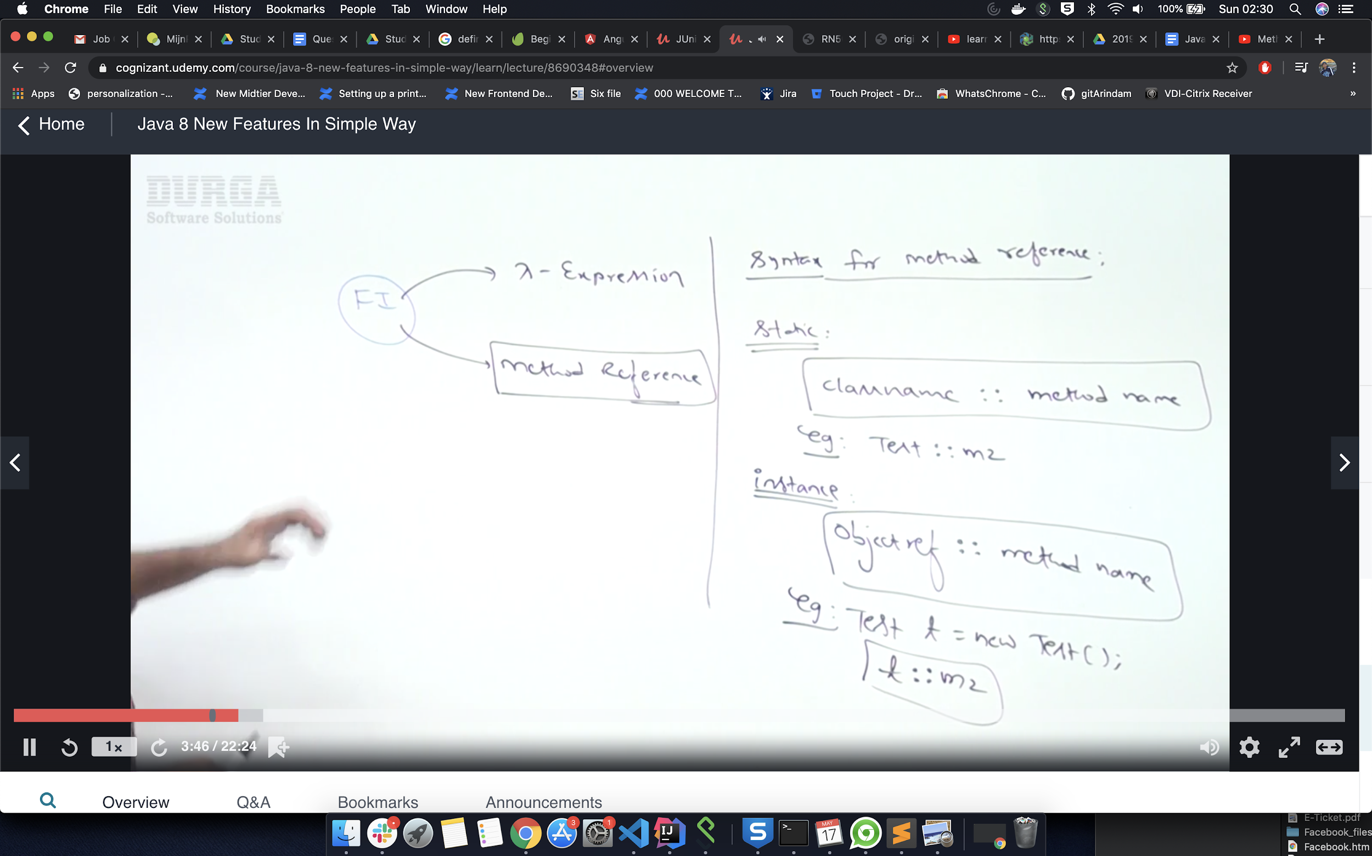

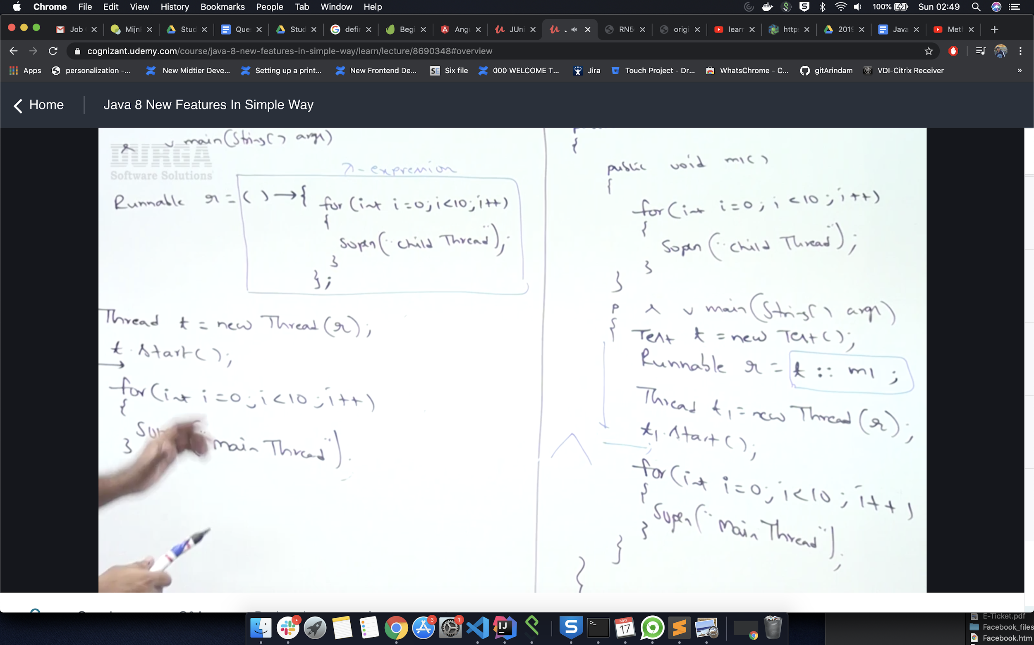

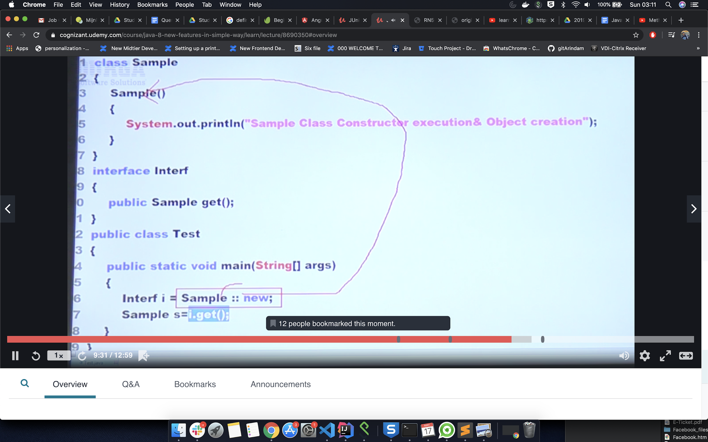

# ***8) Stream API ::***

**Collection revision::**

Collection is group of object representing single entity.

Java provides a new additional package in Java 8 called java.util.stream. This package consists of classes, interfaces and enum to allows functional-style operations on the elements. You can use stream by importing java.util.stream package.

Stream provides following features:

* Stream does not store elements. It simply conveys elements from a source such as a data structure, an array, or an I/O channel, through a pipeline of computational operations.
* Stream is functional in nature. Operations performed on a stream does not modify it's source. For example, filtering a Stream obtained from a collection produces a new Stream without the filtered elements, rather than removing elements from the source collection.
* Stream is lazy and evaluates code only when required.
* The elements of a stream are only visited once during the life of a stream. Like an Iterator, a new stream must be generated to revisit the same elements of the source.
* You can use stream to filter, collect, print, and convert from one data structure to other etc.

**What are the methods available in stream ?**

1. **Filter,**
2. **Map ,**
3. **Count,**
4. **Sorted ( default and with comparator param),**
5. **min & max,**
6. **forEach(); // some logic will apply for ecah element of the collection.**
7. **toArray(); //convert collection to Array;**
8. **stram.of() // streams is not only used for collection but also can be used for any group of values. ( even for array ) but you have to use stram.of() method**

** streams is not only used for collection but also can be used for any group of values. ( even for array ) but you have to use stram.of() method. Just convert the group of values to stream by stream.of () method. (eg. stream <Integer> strmInt = stream.of (1,12,123); then you can use all the methods availabel in stream api

## Java Stream Interface Methods

|  |  |
| --- | --- |
| **Methods** | **Description** |
| boolean allMatch(Predicate<? super T> predicate) | It returns all elements of this stream which match the provided predicate. If the stream is empty then true is returned and the predicate is not evaluated.  ***Predicate*** - (a single argument function that returns a boolean value. #test(); abstract method) |
| boolean anyMatch(Predicate<? super T> predicate) | It returns any element of this stream that matches the provided predicate. If the stream is empty then false is returned and the predicate is not evaluated.  ***Predicate*** - (a single argument function that returns a boolean value. #test(); abstract method) |
| static <T> Stream.Builder<T> builder() | It returns a builder for a Stream. |
| <R,A> R collect(Collector<? super T,A,R> collector) | It performs a mutable reduction operation on the elements of this stream using a Collector. A Collector encapsulates the functions used as arguments to collect(Supplier, BiConsumer, BiConsumer), allowing for reuse of collection strategies and composition of collect operations such as multiple-level grouping or partitioning. |
| <R> R collect(Supplier<R> supplier, BiConsumer<R,? super T> accumulator, BiConsumer<R,R> combiner) | It performs a mutable reduction operation on the elements of this stream. A mutable reduction is one in which the reduced value is a mutable result container, such as an ArrayList, and elements are incorporated by updating the state of the result rather than by replacing the result. |
| static <T> Stream<T> concat(Stream<? extends T> a, Stream<? extends T> b) | It creates a lazily concatenated stream whose elements are all the elements of the first stream followed by all the elements of the second stream. The resulting stream is ordered if both of the input streams are ordered, and parallel if either of the input streams is parallel. When the resulting stream is closed, the close handlers for both input streams are invoked. |
| long count() | It returns the count of elements in this stream. This is a special case of a reduction. |
| Stream<T> distinct() | It returns a stream consisting of the distinct elements (according to Object.equals(Object)) of this stream. |
| static <T> Stream<T> empty() | It returns an empty sequential Stream. |
| Stream<T> filter(Predicate<? super T> predicate) | It returns a stream consisting of the elements of this stream that match the given predicate. |
| Optional<T> findAny() | It returns an Optional describing some element of the stream, or an empty Optional if the stream is empty. |
| Optional<T> findFirst() | It returns an Optional describing the first element of this stream, or an empty Optional if the stream is empty. If the stream has no encounter order, then any element may be returned. |
| <R> Stream<R> flatMap(Function<? super T,? extends Stream<? extends R>> mapper) | It returns a stream consisting of the results of replacing each element of this stream with the contents of a mapped stream produced by applying the provided mapping function to each element. Each mapped stream is closed after its contents have been placed into this stream. (If a mapped stream is null an empty stream is used, instead.) |
| DoubleStream flatMapToDouble(Function<? super T,? extends DoubleStream> mapper) | It returns a DoubleStream consisting of the results of replacing each element of this stream with the contents of a mapped stream produced by applying the provided mapping function to each element. Each mapped stream is closed after its contents have placed been into this stream. (If a mapped stream is null an empty stream is used, instead.) |
| IntStream flatMapToInt(Function<? super T,? extends IntStream> mapper) | It returns an IntStream consisting of the results of replacing each element of this stream with the contents of a mapped stream produced by applying the provided mapping function to each element. Each mapped stream is closed after its contents have been placed into this stream. (If a mapped stream is null an empty stream is used, instead.) |
| LongStream flatMapToLong(Function<? super T,? extends LongStream> mapper) | It returns a LongStream consisting of the results of replacing each element of this stream with the contents of a mapped stream produced by applying the provided mapping function to each element. Each mapped stream is closed after its contents have been placed into this stream. (If a mapped stream is null an empty stream is used, instead.) |
| void forEach(Consumer<? super T> action) | It performs an action for each element of this stream. |
| void forEachOrdered(Consumer<? super T> action) | It performs an action for each element of this stream, in the encounter order of the stream if the stream has a defined encounter order. |
| static <T> Stream<T> generate(Supplier<T> s) | It returns an infinite sequential unordered stream where each element is generated by the provided Supplier. This is suitable for generating constant streams, streams of random elements, etc. |
| static <T> Stream<T> iterate(T seed,UnaryOperator<T> f) | It returns an infinite sequential ordered Stream produced by iterative application of a function f to an initial element seed, producing a Stream consisting of seed, f(seed), f(f(seed)), etc. |
| Stream<T> limit(long maxSize) | It returns a stream consisting of the elements of this stream, truncated to be no longer than maxSize in length. |
| <R> Stream<R> map(Function<? super T,? extends R> mapper) | It returns a stream consisting of the results of applying the given function to the elements of this stream. |
| DoubleStream mapToDouble(ToDoubleFunction<? super T> mapper) | It returns a DoubleStream consisting of the results of applying the given function to the elements of this stream. |
| IntStream mapToInt(ToIntFunction<? super T> mapper) | It returns an IntStream consisting of the results of applying the given function to the elements of this stream. |
| LongStream mapToLong(ToLongFunction<? super T> mapper) | It returns a LongStream consisting of the results of applying the given function to the elements of this stream. |
| Optional<T> max(Comparator<? super T> comparator) | It returns the maximum element of this stream according to the provided Comparator. This is a special case of a reduction. |
| Optional<T> min(Comparator<? super T> comparator) | It returns the minimum element of this stream according to the provided Comparator. This is a special case of a reduction. |
| boolean noneMatch(Predicate<? super T> predicate) | It returns elements of this stream match the provided predicate. If the stream is empty then true is returned and the predicate is not evaluated. |
| @SafeVarargs static <T> Stream<T> of(T... values) | It returns a sequential ordered stream whose elements are the specified values. |
| static <T> Stream<T> of(T t) | It returns a sequential Stream containing a single element. |
| Stream<T> peek(Consumer<? super T> action) | It returns a stream consisting of the elements of this stream, additionally performing the provided action on each element as elements are consumed from the resulting stream. |
| Optional<T> reduce(BinaryOperator<T> accumulator) | It performs a reduction on the elements of this stream, using an associative accumulation function, and returns an Optional describing the reduced value, if any. |
| T reduce(T identity, BinaryOperator<T> accumulator) | It performs a reduction on the elements of this stream, using the provided identity value and an associative accumulation function, and returns the reduced value. |
| <U> U reduce(U identity, BiFunction<U,? super T,U> accumulator, BinaryOperator<U> combiner) | It performs a reduction on the elements of this stream, using the provided identity, accumulation and combining functions. |
| Stream<T> skip(long n) | It returns a stream consisting of the remaining elements of this stream after discarding the first n elements of the stream. If this stream contains fewer than n elements then an empty stream will be returned. |
| Stream<T> sorted() | It returns a stream consisting of the elements of this stream, sorted according to natural order. If the elements of this stream are not Comparable, a java.lang.ClassCastException may be thrown when the terminal operation is executed. |
| Stream<T> sorted(Comparator<? super T> comparator) | It returns a stream consisting of the elements of this stream, sorted according to the provided Comparator. |
| Object[] toArray() | It returns an array containing the elements of this stream. |
| <A> A[] toArray(IntFunction<A[]> generator) | It returns an array containing the elements of this stream, using the provided generator function to allocate the returned array, as well as any additional arrays that might be required for a partitioned execution or for resizing. |

### Java Stream Example: Filtering Collection by using Stream

Here, we are filtering data by using stream. You can see that code is optimized and maintained. Stream provides fast execution.

1. **import** java.util.*;
2. **import** java.util.stream.Collectors;
3. **class** Product{
4. **int** id;
5. String name;
6. **float** price;
7. **public** Product(**int** id, String name, **float** price) {
8. **this**.id = id;
9. **this**.name = name;
10. **this**.price = price;
11. }
12. }
13. **public** **class** JavaStreamExample {
14. **public** **static** **void** main(String[] args) {
15. List<Product> productsList = **new** ArrayList<Product>();
16. //Adding Products
17. productsList.add(**new** Product(1,"HP Laptop",25000f));
18. productsList.add(**new** Product(2,"Dell Laptop",30000f));
19. productsList.add(**new** Product(3,"Lenevo Laptop",28000f));
20. productsList.add(**new** Product(4,"Sony Laptop",28000f));
21. productsList.add(**new** Product(5,"Apple Laptop",90000f));
22. List<Float> productPriceList2 =productsList.stream()
23. .filter(p -> p.price > 30000)// filtering data
24. .map(p->p.price) // fetching price
25. .collect(Collectors.toList()); // collecting as list
26. System.out.println(productPriceList2);
27. }
28. }

Output:

[90000.0]

### Java Stream Iterating Example

You can use stream to iterate any number of times. Stream provides predefined methods to deal with the logic you implement. In the following example, we are iterating, filtering and passed a limit to fix the iteration.

1. **import** java.util.stream.*;
2. **public** **class** JavaStreamExample {
3. **public** **static** **void** main(String[] args){
4. Stream.iterate(1, element->element+1)
5. .filter(element->element%5==0)
6. .limit(5)
7. .forEach(System.out::println);
8. }
9. }

Output:

5

10

15

20

25

### Java Stream Example: Filtering and Iterating Collection

In the following example, we are using filter() method. Here, you can see code is optimized and very concise.

1. **import** java.util.*;
2. **class** Product{
3. **int** id;
4. String name;
5. **float** price;
6. **public** Product(**int** id, String name, **float** price) {
7. **this**.id = id;
8. **this**.name = name;
9. **this**.price = price;
10. }
11. }
12. **public** **class** JavaStreamExample {
13. **public** **static** **void** main(String[] args) {
14. List<Product> productsList = **new** ArrayList<Product>();
15. //Adding Products
16. productsList.add(**new** Product(1,"HP Laptop",25000f));
17. productsList.add(**new** Product(2,"Dell Laptop",30000f));
18. productsList.add(**new** Product(3,"Lenevo Laptop",28000f));
19. productsList.add(**new** Product(4,"Sony Laptop",28000f));
20. productsList.add(**new** Product(5,"Apple Laptop",90000f));
21. // This is more compact approach for filtering data
22. productsList.stream()
23. .filter(product -> product.price == 30000)
24. .forEach(product -> System.out.println(product.name));
25. }
26. }

Output:

Dell Laptop

### Java Stream Example : reduce() Method in Collection

This method takes a sequence of input elements and combines them into a single summary result by repeated operation. For example, finding the sum of numbers, or accumulating elements into a list.

In the following example, we are using reduce() method, which is used to sum of all the product prices.

1. **import** java.util.*;
2. **class** Product{
3. **int** id;
4. String name;
5. **float** price;
6. **public** Product(**int** id, String name, **float** price) {
7. **this**.id = id;
8. **this**.name = name;
9. **this**.price = price;
10. }
11. }
12. **public** **class** JavaStreamExample {
13. **public** **static** **void** main(String[] args) {
14. List<Product> productsList = **new** ArrayList<Product>();
15. //Adding Products
16. productsList.add(**new** Product(1,"HP Laptop",25000f));
17. productsList.add(**new** Product(2,"Dell Laptop",30000f));
18. productsList.add(**new** Product(3,"Lenevo Laptop",28000f));
19. productsList.add(**new** Product(4,"Sony Laptop",28000f));
20. productsList.add(**new** Product(5,"Apple Laptop",90000f));
21. // This is more compact approach for filtering data
22. Float totalPrice = productsList.stream()
23. .map(product->product.price)
24. .reduce(0.0f,(sum, price)->sum+price); // accumulating price
25. System.out.println(totalPrice);
26. // More precise code
27. **float** totalPrice2 = productsList.stream()
28. .map(product->product.price)
29. .reduce(0.0f,Float::sum); // accumulating price, by referring method of Float class
30. System.out.println(totalPrice2);
32. }
33. }

Output:

201000.0

201000.0

### Java Stream Example: Sum by using Collectors Methods

We can also use collectors to compute sum of numeric values. In the following example, we are using Collectors class and it?s specified methods to compute sum of all the product prices.

1. **import** java.util.*;
2. **import** java.util.stream.Collectors;
3. **class** Product{
4. **int** id;
5. String name;
6. **float** price;
7. **public** Product(**int** id, String name, **float** price) {
8. **this**.id = id;
9. **this**.name = name;
10. **this**.price = price;
11. }
12. }
13. **public** **class** JavaStreamExample {
14. **public** **static** **void** main(String[] args) {
15. List<Product> productsList = **new** ArrayList<Product>();
16. //Adding Products
17. productsList.add(**new** Product(1,"HP Laptop",25000f));
18. productsList.add(**new** Product(2,"Dell Laptop",30000f));
19. productsList.add(**new** Product(3,"Lenevo Laptop",28000f));
20. productsList.add(**new** Product(4,"Sony Laptop",28000f));
21. productsList.add(**new** Product(5,"Apple Laptop",90000f));
22. // Using Collectors's method to sum the prices.
23. **double** totalPrice3 = productsList.stream()
24. .collect(Collectors.summingDouble(product->product.price));
25. System.out.println(totalPrice3);
27. }
28. }

Output:

201000.0

### Java Stream Example: Find Max and Min Product Price

Following example finds min and max product price by using stream. It provides convenient way to find values without using imperative approach.

1. **import** java.util.*;
2. **class** Product{
3. **int** id;
4. String name;
5. **float** price;
6. **public** Product(**int** id, String name, **float** price) {
7. **this**.id = id;
8. **this**.name = name;
9. **this**.price = price;
10. }
11. }
12. **public** **class** JavaStreamExample {
13. **public** **static** **void** main(String[] args) {
14. List<Product> productsList = **new** ArrayList<Product>();
15. //Adding Products
16. productsList.add(**new** Product(1,"HP Laptop",25000f));
17. productsList.add(**new** Product(2,"Dell Laptop",30000f));
18. productsList.add(**new** Product(3,"Lenevo Laptop",28000f));
19. productsList.add(**new** Product(4,"Sony Laptop",28000f));
20. productsList.add(**new** Product(5,"Apple Laptop",90000f));
21. // max() method to get max Product price
22. Product productA = productsList.stream()
23. .max((product1, product2)->
24. product1.price > product2.price ? 1: -1).get();
26. System.out.println(productA.price);
27. // min() method to get min Product price
28. Product productB = productsList.stream()
29. .max((product1, product2)->
30. product1.price < product2.price ? 1: -1).get();
31. System.out.println(productB.price);
33. }
34. }

Output:

90000.0

25000.0

### Java Stream Example: count() Method in Collection

1. **import** java.util.*;
2. **class** Product{
3. **int** id;
4. String name;
5. **float** price;
6. **public** Product(**int** id, String name, **float** price) {
7. **this**.id = id;
8. **this**.name = name;
9. **this**.price = price;
10. }
11. }
12. **public** **class** JavaStreamExample {
13. **public** **static** **void** main(String[] args) {
14. List<Product> productsList = **new** ArrayList<Product>();
15. //Adding Products
16. productsList.add(**new** Product(1,"HP Laptop",25000f));
17. productsList.add(**new** Product(2,"Dell Laptop",30000f));
18. productsList.add(**new** Product(3,"Lenevo Laptop",28000f));
19. productsList.add(**new** Product(4,"Sony Laptop",28000f));
20. productsList.add(**new** Product(5,"Apple Laptop",90000f));
21. // count number of products based on the filter
22. **long** count = productsList.stream()
23. .filter(product->product.price<30000)
24. .count();
25. System.out.println(count);
26. }
27. }

Output:

3

stream allows you to collect your result in any various forms. You can get you result as set, list or map and can perform manipulation on the elements.

### Java Stream Example : Convert List into Set

1. **import** java.util.*;
2. **import** java.util.stream.Collectors;
3. **class** Product{
4. **int** id;
5. String name;
6. **float** price;
7. **public** Product(**int** id, String name, **float** price) {
8. **this**.id = id;
9. **this**.name = name;
10. **this**.price = price;
11. }
12. }
14. **public** **class** JavaStreamExample {
15. **public** **static** **void** main(String[] args) {
16. List<Product> productsList = **new** ArrayList<Product>();
18. //Adding Products
19. productsList.add(**new** Product(1,"HP Laptop",25000f));
20. productsList.add(**new** Product(2,"Dell Laptop",30000f));
21. productsList.add(**new** Product(3,"Lenevo Laptop",28000f));
22. productsList.add(**new** Product(4,"Sony Laptop",28000f));
23. productsList.add(**new** Product(5,"Apple Laptop",90000f));
25. // Converting product List into Set
26. Set<Float> productPriceList =
27. productsList.stream()
28. .filter(product->product.price < 30000) // filter product on the base of price
29. .map(product->product.price)
30. .collect(Collectors.toSet()); // collect it as Set(remove duplicate elements)
31. System.out.println(productPriceList);
32. }
33. }

Output:

[25000.0, 28000.0]

### Java Stream Example : Convert List into Map

1. **import** java.util.*;
2. **import** java.util.stream.Collectors;
3. **class** Product{
4. **int** id;
5. String name;
6. **float** price;
7. **public** Product(**int** id, String name, **float** price) {
8. **this**.id = id;
9. **this**.name = name;
10. **this**.price = price;
11. }
12. }
14. **public** **class** JavaStreamExample {
15. **public** **static** **void** main(String[] args) {
16. List<Product> productsList = **new** ArrayList<Product>();
18. //Adding Products
19. productsList.add(**new** Product(1,"HP Laptop",25000f));
20. productsList.add(**new** Product(2,"Dell Laptop",30000f));
21. productsList.add(**new** Product(3,"Lenevo Laptop",28000f));
22. productsList.add(**new** Product(4,"Sony Laptop",28000f));
23. productsList.add(**new** Product(5,"Apple Laptop",90000f));
25. // Converting Product List into a Map
26. Map<Integer,String> productPriceMap =
27. productsList.stream()
28. .collect(Collectors.toMap(p->p.id, p->p.name));
30. System.out.println(productPriceMap);
31. }
32. }

Output:

{1=HP Laptop, 2=Dell Laptop, 3=Lenevo Laptop, 4=Sony Laptop, 5=Apple Laptop}

### Method Reference in stream

1. **import** java.util.*;
2. **import** java.util.stream.Collectors;
4. **class** Product{
5. **int** id;
6. String name;
7. **float** price;
9. **public** Product(**int** id, String name, **float** price) {
10. **this**.id = id;
11. **this**.name = name;
12. **this**.price = price;
13. }
15. **public** **int** getId() {
16. **return** id;
17. }
18. **public** String getName() {
19. **return** name;
20. }
21. **public** **float** getPrice() {
22. **return** price;
23. }
24. }
26. **public** **class** JavaStreamExample {
28. **public** **static** **void** main(String[] args) {
30. List<Product> productsList = **new** ArrayList<Product>();
32. //Adding Products
33. productsList.add(**new** Product(1,"HP Laptop",25000f));
34. productsList.add(**new** Product(2,"Dell Laptop",30000f));
35. productsList.add(**new** Product(3,"Lenevo Laptop",28000f));
36. productsList.add(**new** Product(4,"Sony Laptop",28000f));
37. productsList.add(**new** Product(5,"Apple Laptop",90000f));
39. List<Float> productPriceList =
40. productsList.stream()
41. .filter(p -> p.price > 30000) // filtering data
42. .map(Product::getPrice) // fetching price by referring getPrice method
43. .collect(Collectors.toList()); // collecting as list
44. System.out.println(productPriceList);
45. }
46. }

Output:

[90000.0]

**Stream ::**

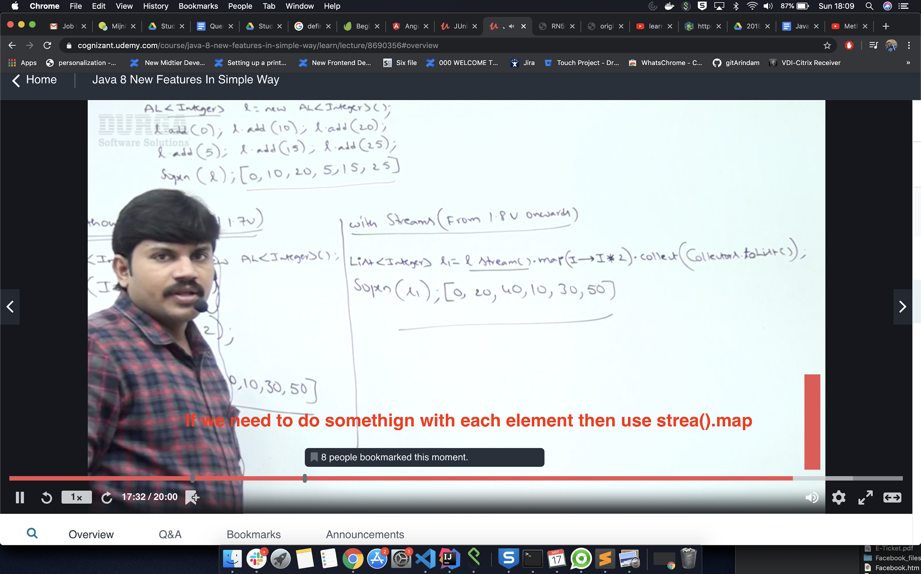

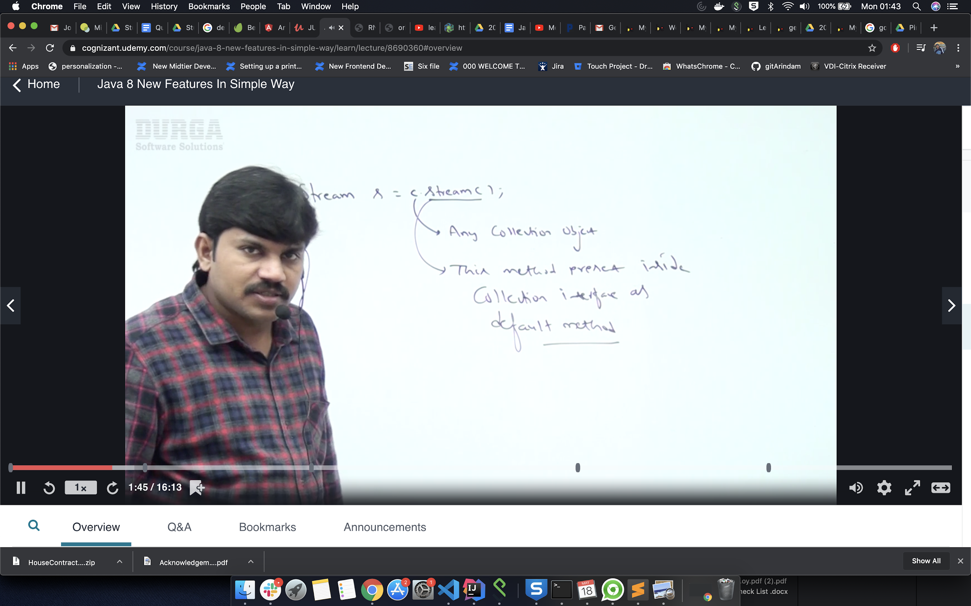

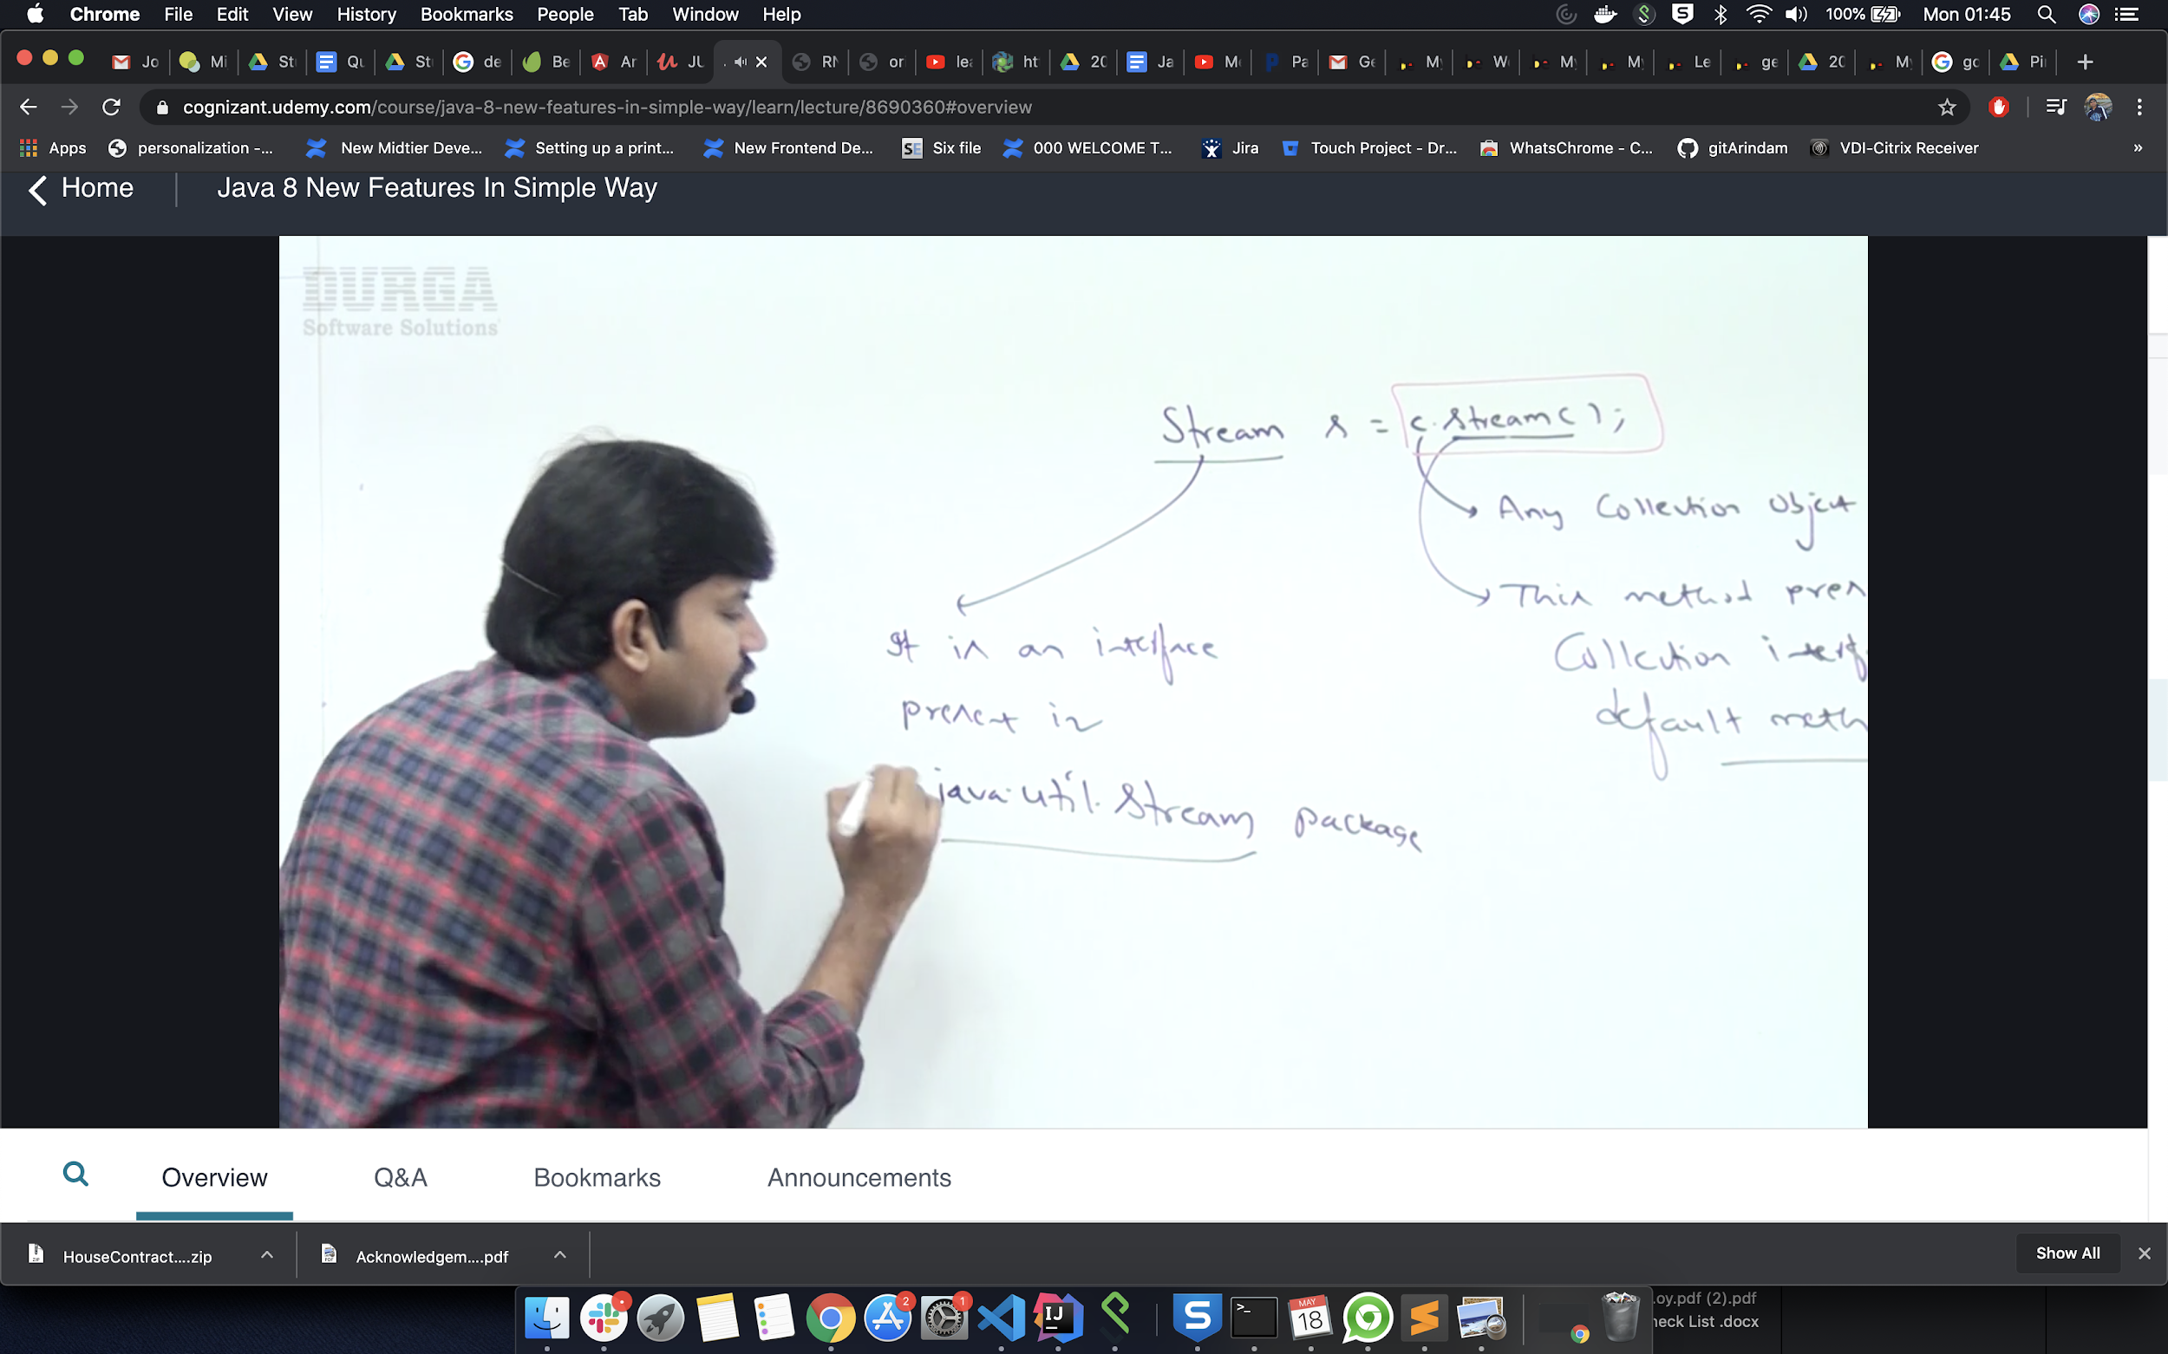

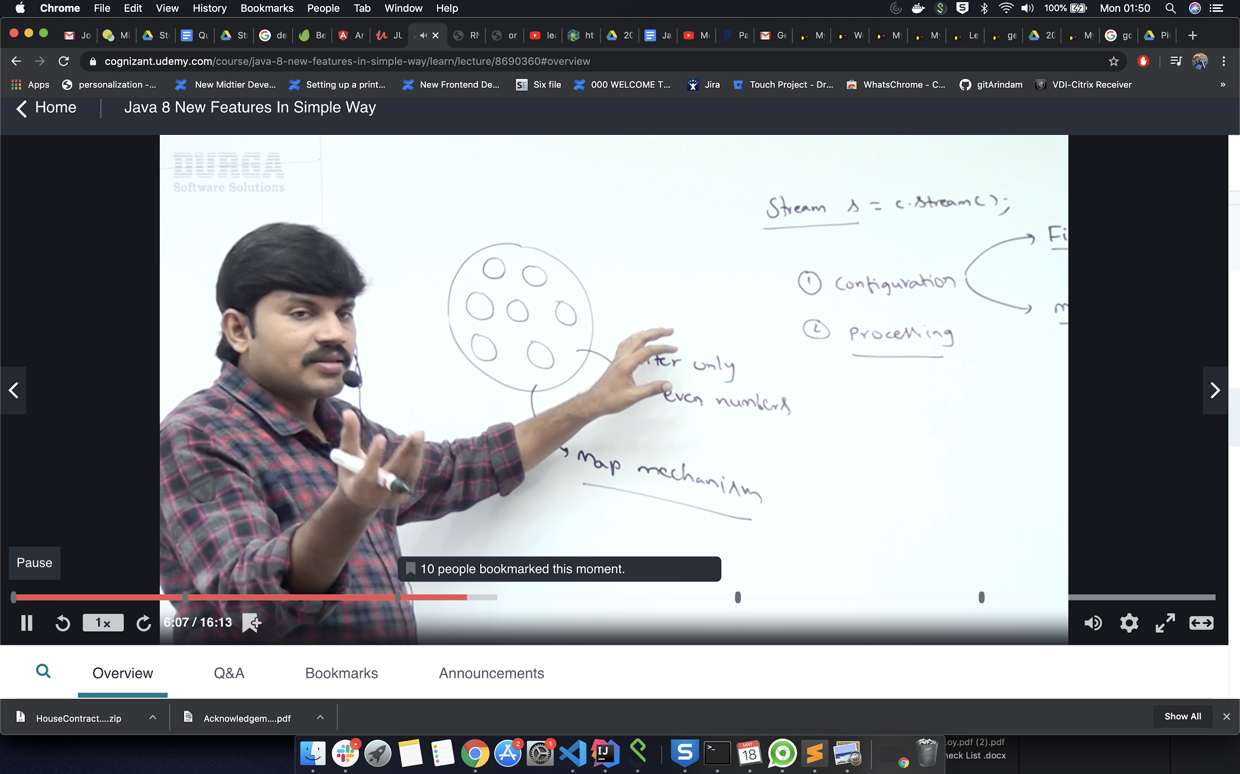

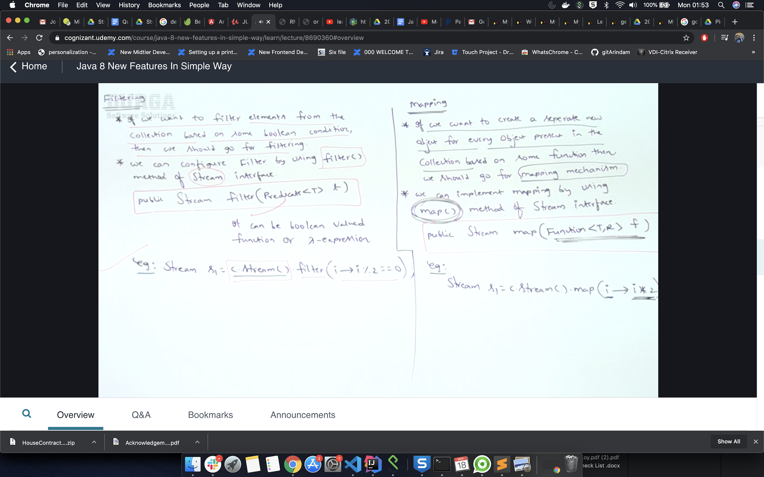

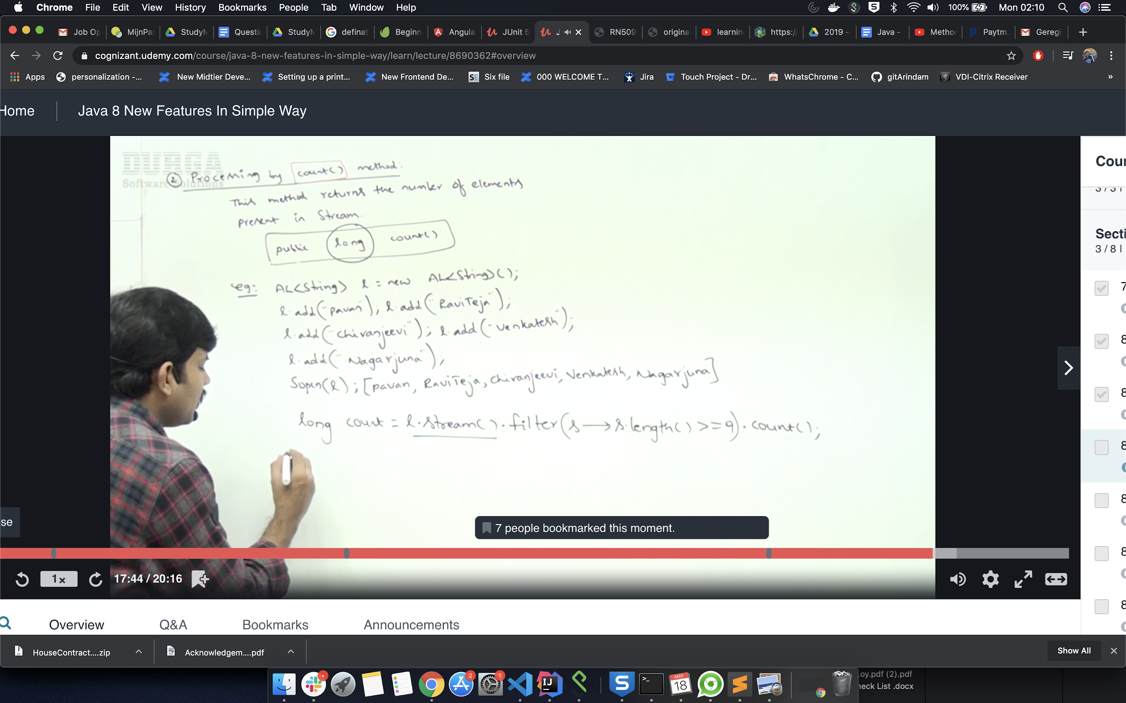

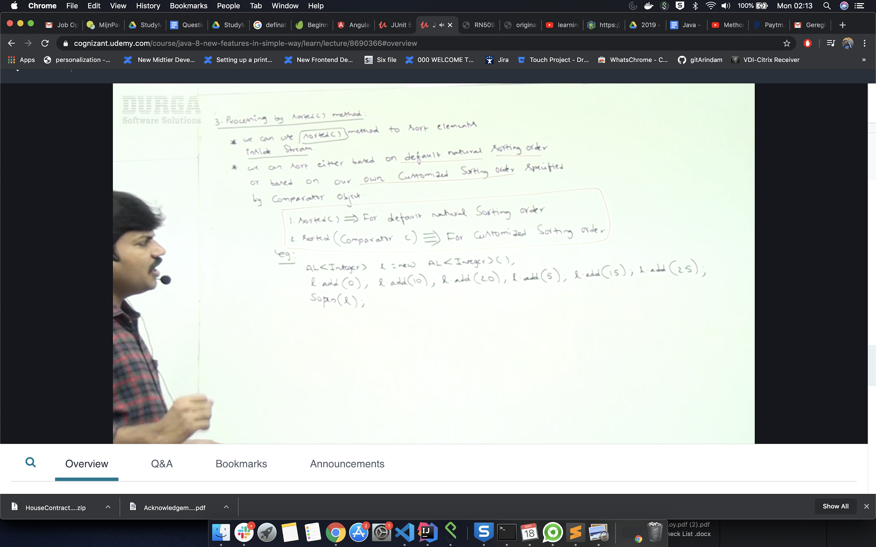

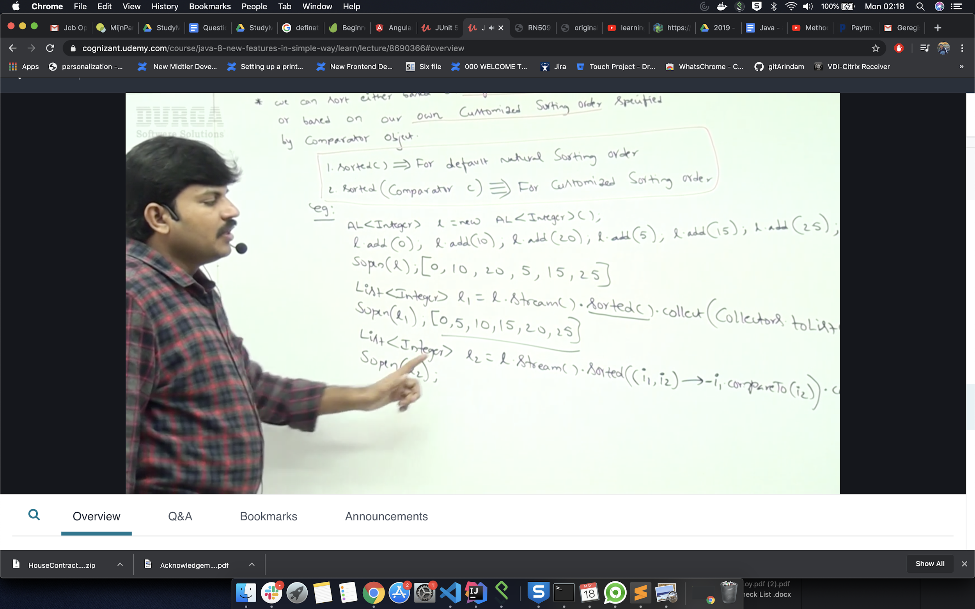

**ForEach**

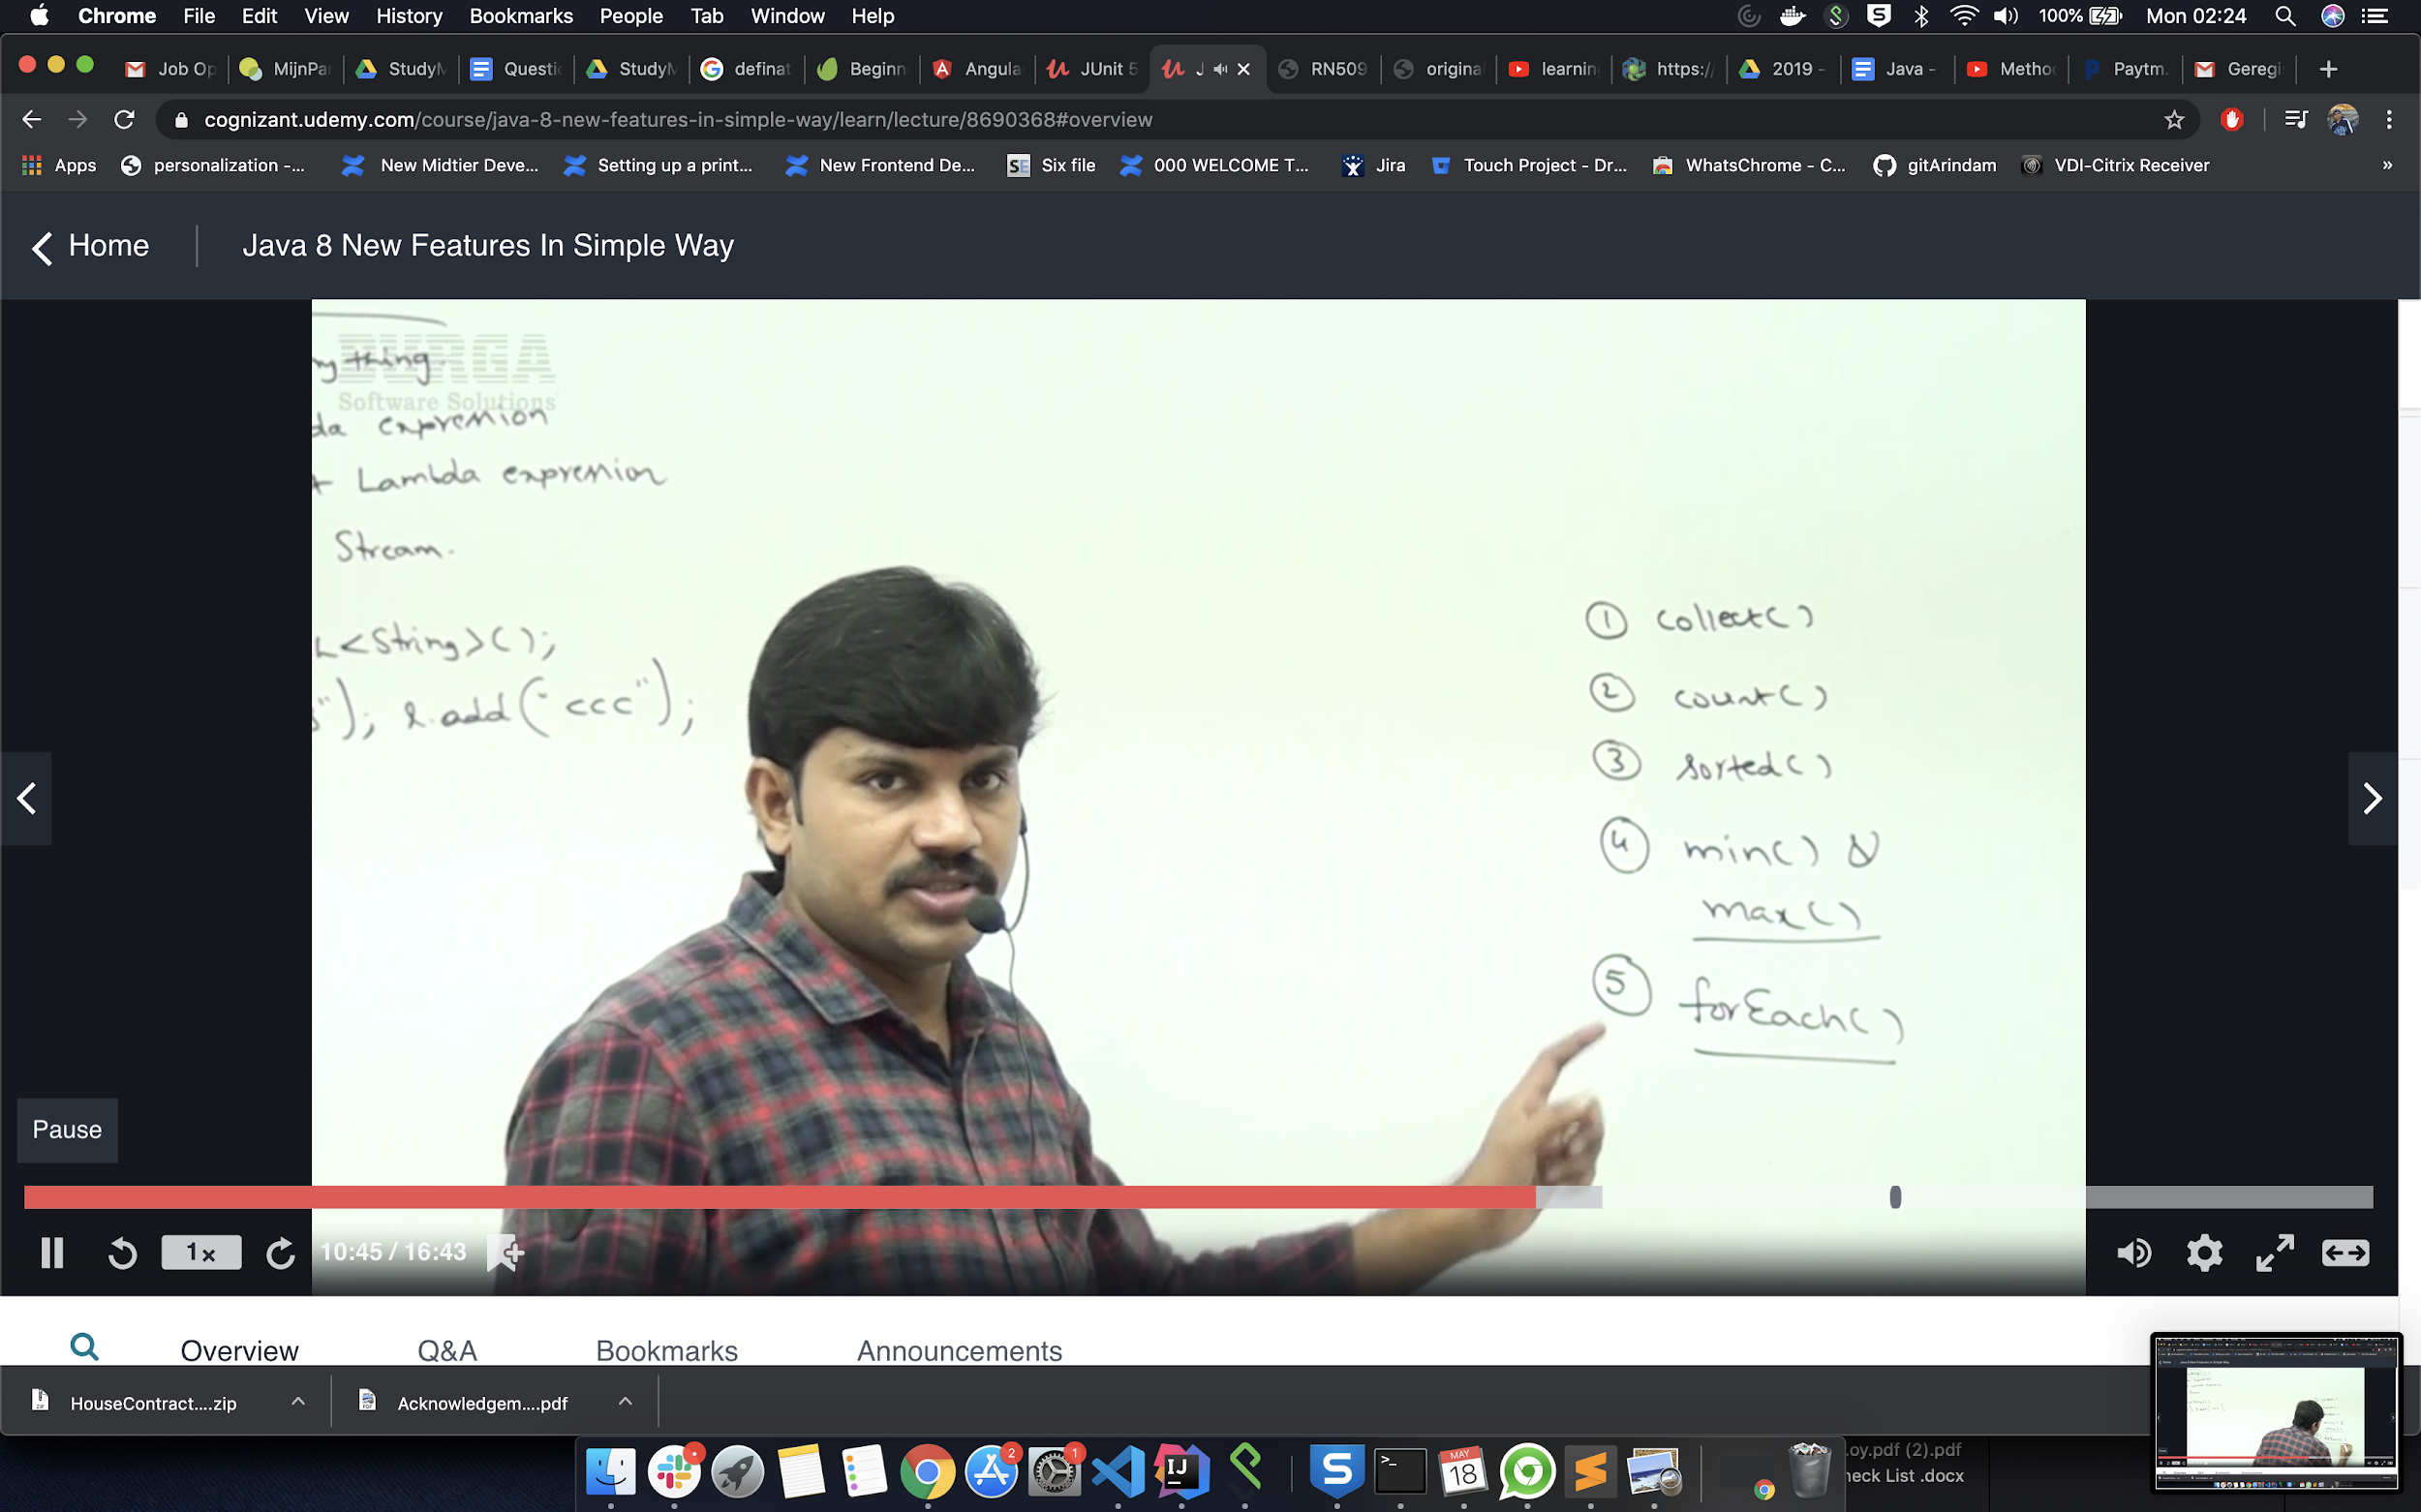

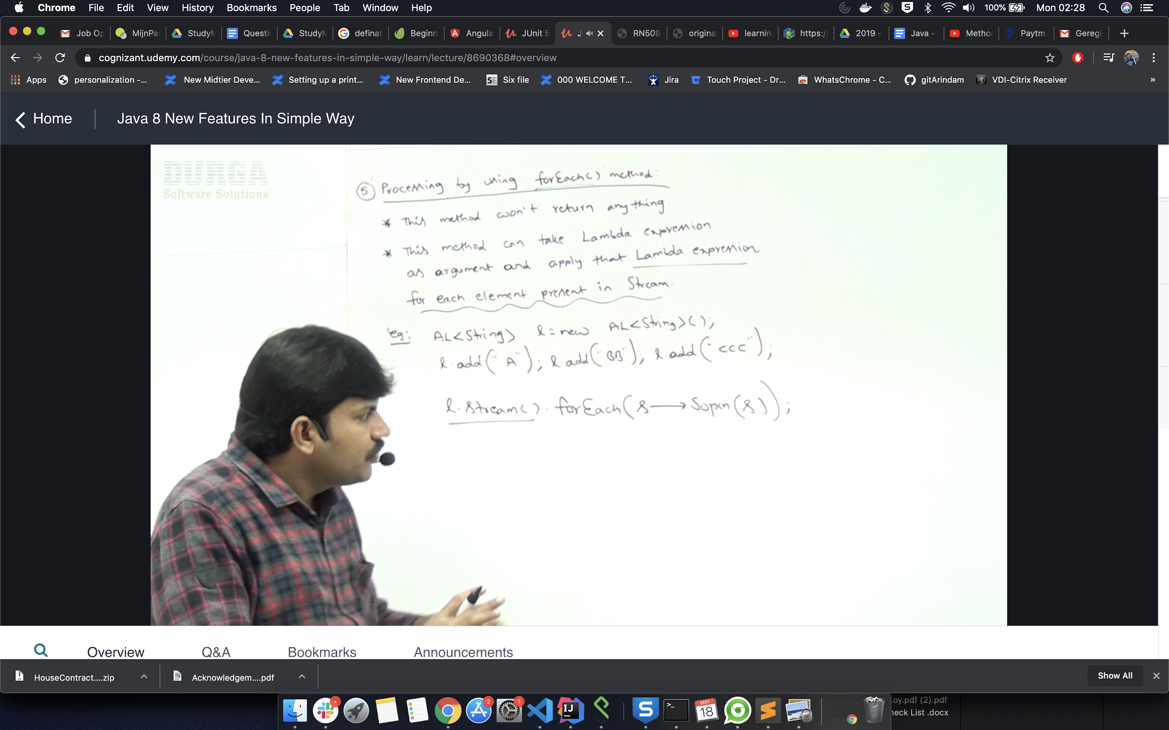

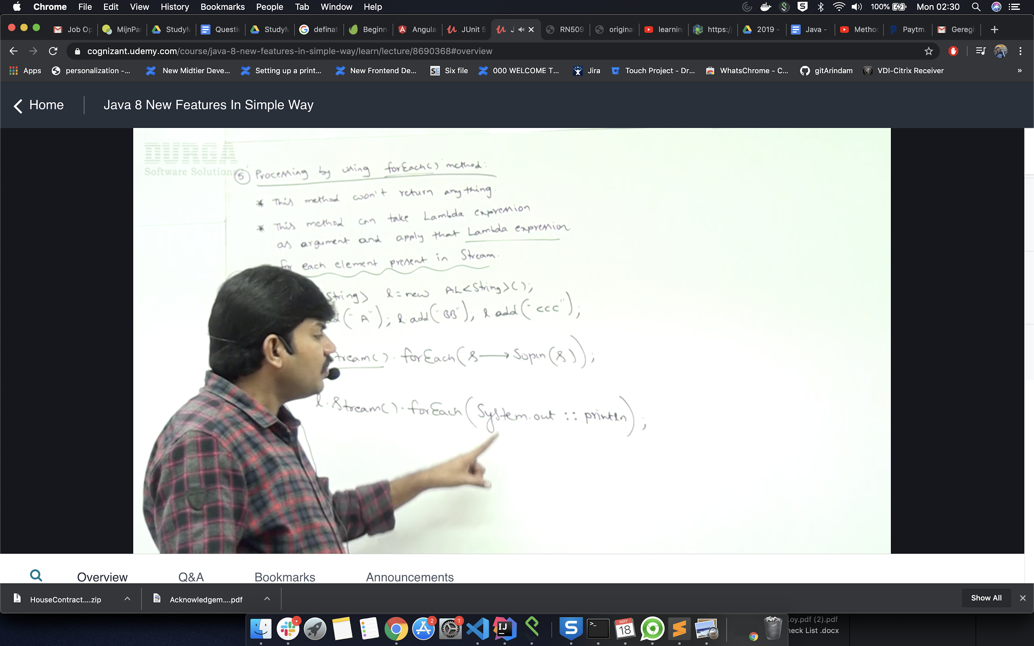

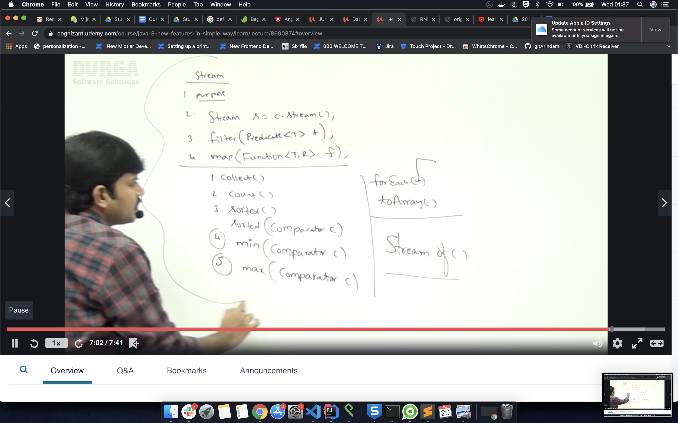

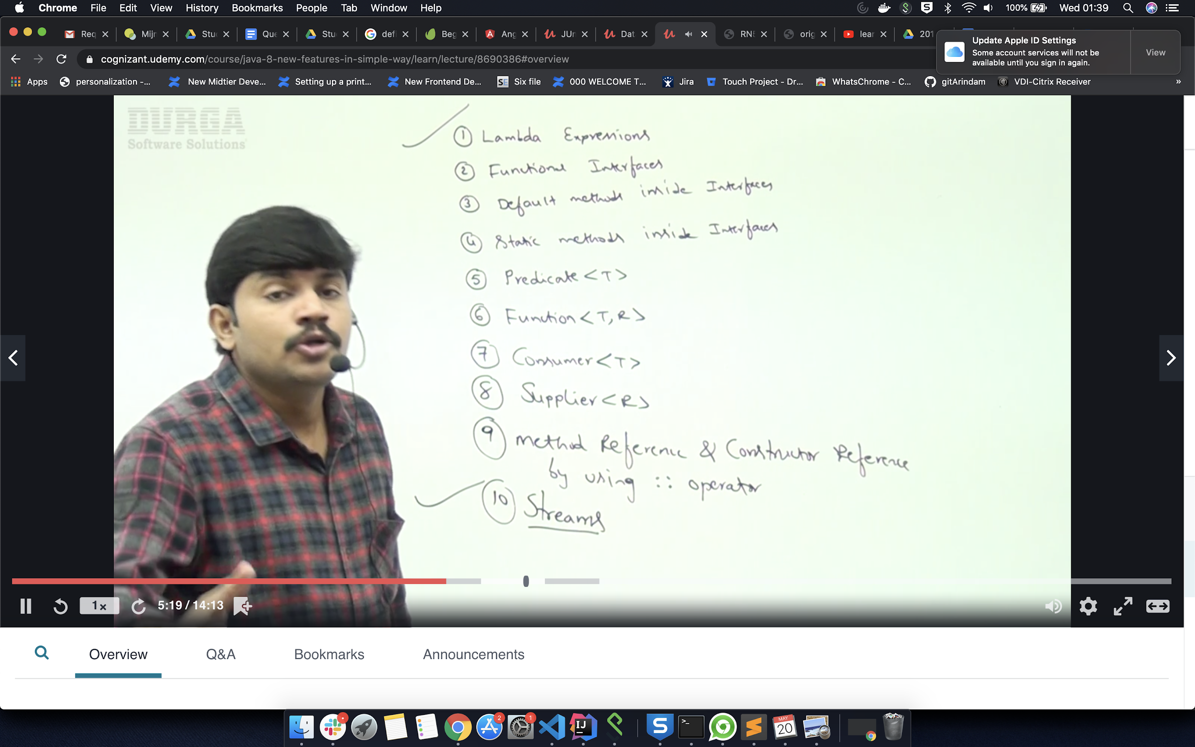

**9) Default Methods In Java 8**

Before Java 8, interfaces could have only abstract methods. The implementation of these methods has to be provided in a separate class. So, if a new method is to be added in an interface, then its implementation code has to be provided in the class implementing the same interface. To overcome this issue, Java 8 has introduced the concept of default methods which allow the interfaces to have methods with implementation without affecting the classes that implement the interface.

filter_none

edit

play_arrow

brightness_4

|  |
| --- |
| // A simple program to Test Interface default  // methods in java  interface TestInterface  {  // abstract method  public void square(int a);    // default method  default void show()  {  System.out.println("Default Method Executed");  }  }    class TestClass implements TestInterface  {  // implementation of square abstract method  public void square(int a)  {  System.out.println(a*a);  }    public static void main(String args[])  {  TestClass d = new TestClass();  d.square(4);    // default method executed  d.show();  }  } |

Output:

16

Default Method Executed

The default methods were introduced to provide backward compatibility so that existing interfaces can use the lambda expressions without implementing the methods in the implementation class. Default methods are also known as **defender methods** or **virtual extension methods**.

**10) Static Methods:**

The interfaces can have static methods as well which is similar to static method of classes.

filter_none

edit

play_arrow

brightness_4

|  |
| --- |
| // A simple Java program to TestClassnstrate static  // methods in java  interface TestInterface  {  // abstract method  public void square (int a);    // static method  static void show()  {  System.out.println("Static Method Executed");  }  }    class TestClass implements TestInterface  {  // Implementation of square abstract method  public void square (int a)  {  System.out.println(a*a);  }    public static void main(String args[])  {  TestClass d = new TestClass();  d.square(4);    // Static method executed  TestInterface.show();  }  } |

Output:

16

Static Method Executed

**Default Methods and Multiple Inheritance**

In case both the implemented interfaces contain default methods with same method signature, the implementing class should explicitly specify which default method is to be used or it should override the default method.

filter_none

edit

play_arrow

brightness_4

|  |
| --- |
| // A simple Java program to demonstrate multiple  // inheritance through default methods.  interface TestInterface1  {  // default method  default void show()  {  System.out.println("Default TestInterface1");  }  }    interface TestInterface2  {  // Default method  default void show()  {  System.out.println("Default TestInterface2");  }  }    // Implementation class code  class TestClass implements TestInterface1, TestInterface2  {  // Overriding default show method  public void show()  {  // use super keyword to call the show  // method of TestInterface1 interface  TestInterface1.super.show();    // use super keyword to call the show  // method of TestInterface2 interface  TestInterface2.super.show();  }    public static void main(String args[])  {  TestClass d = new TestClass();  d.show();  }  } |

Output:

Default TestInterface1

Default TestInterface2

**Important Points:**

1. Interfaces can have default methods with implementation in Java 8 on later.
2. Interfaces can have static methods as well, similar to static methods in classes.
3. Default methods were introduced to provide backward compatibility for old interfaces so that they can have new methods without affecting existing code.

**DATE and Time**

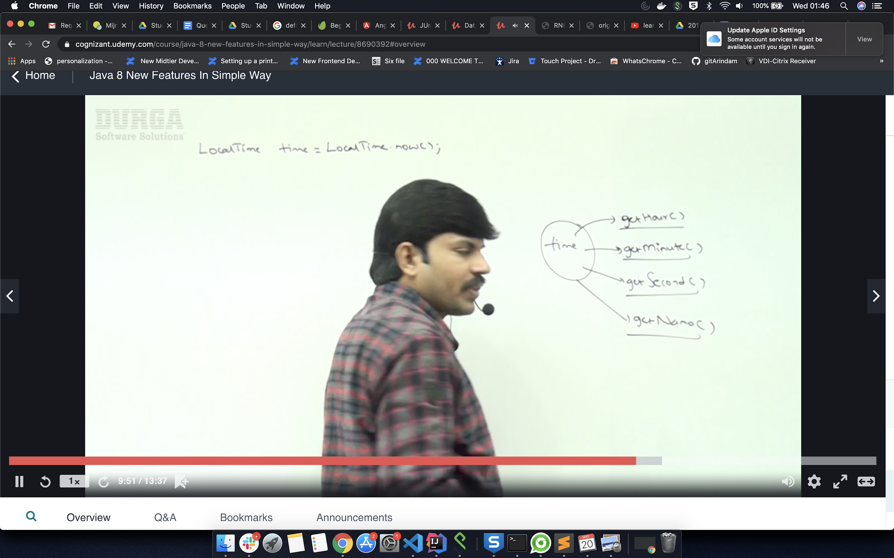

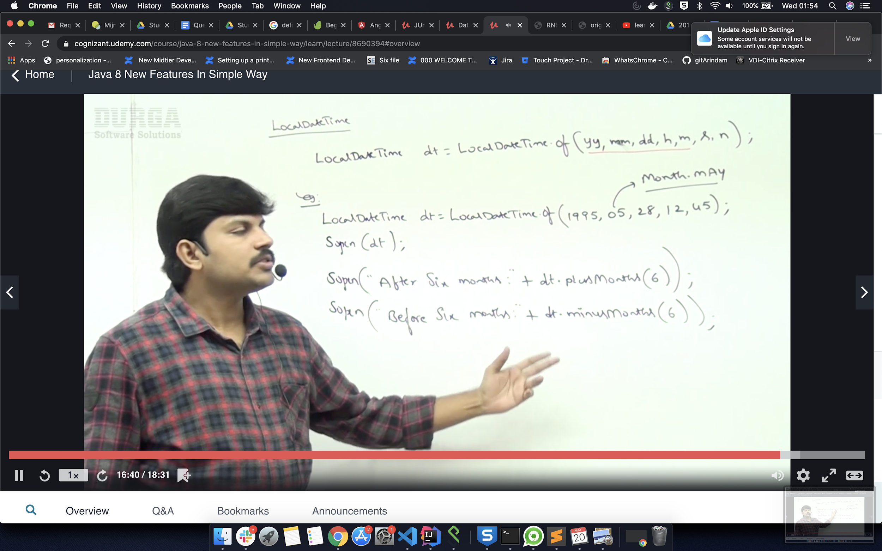

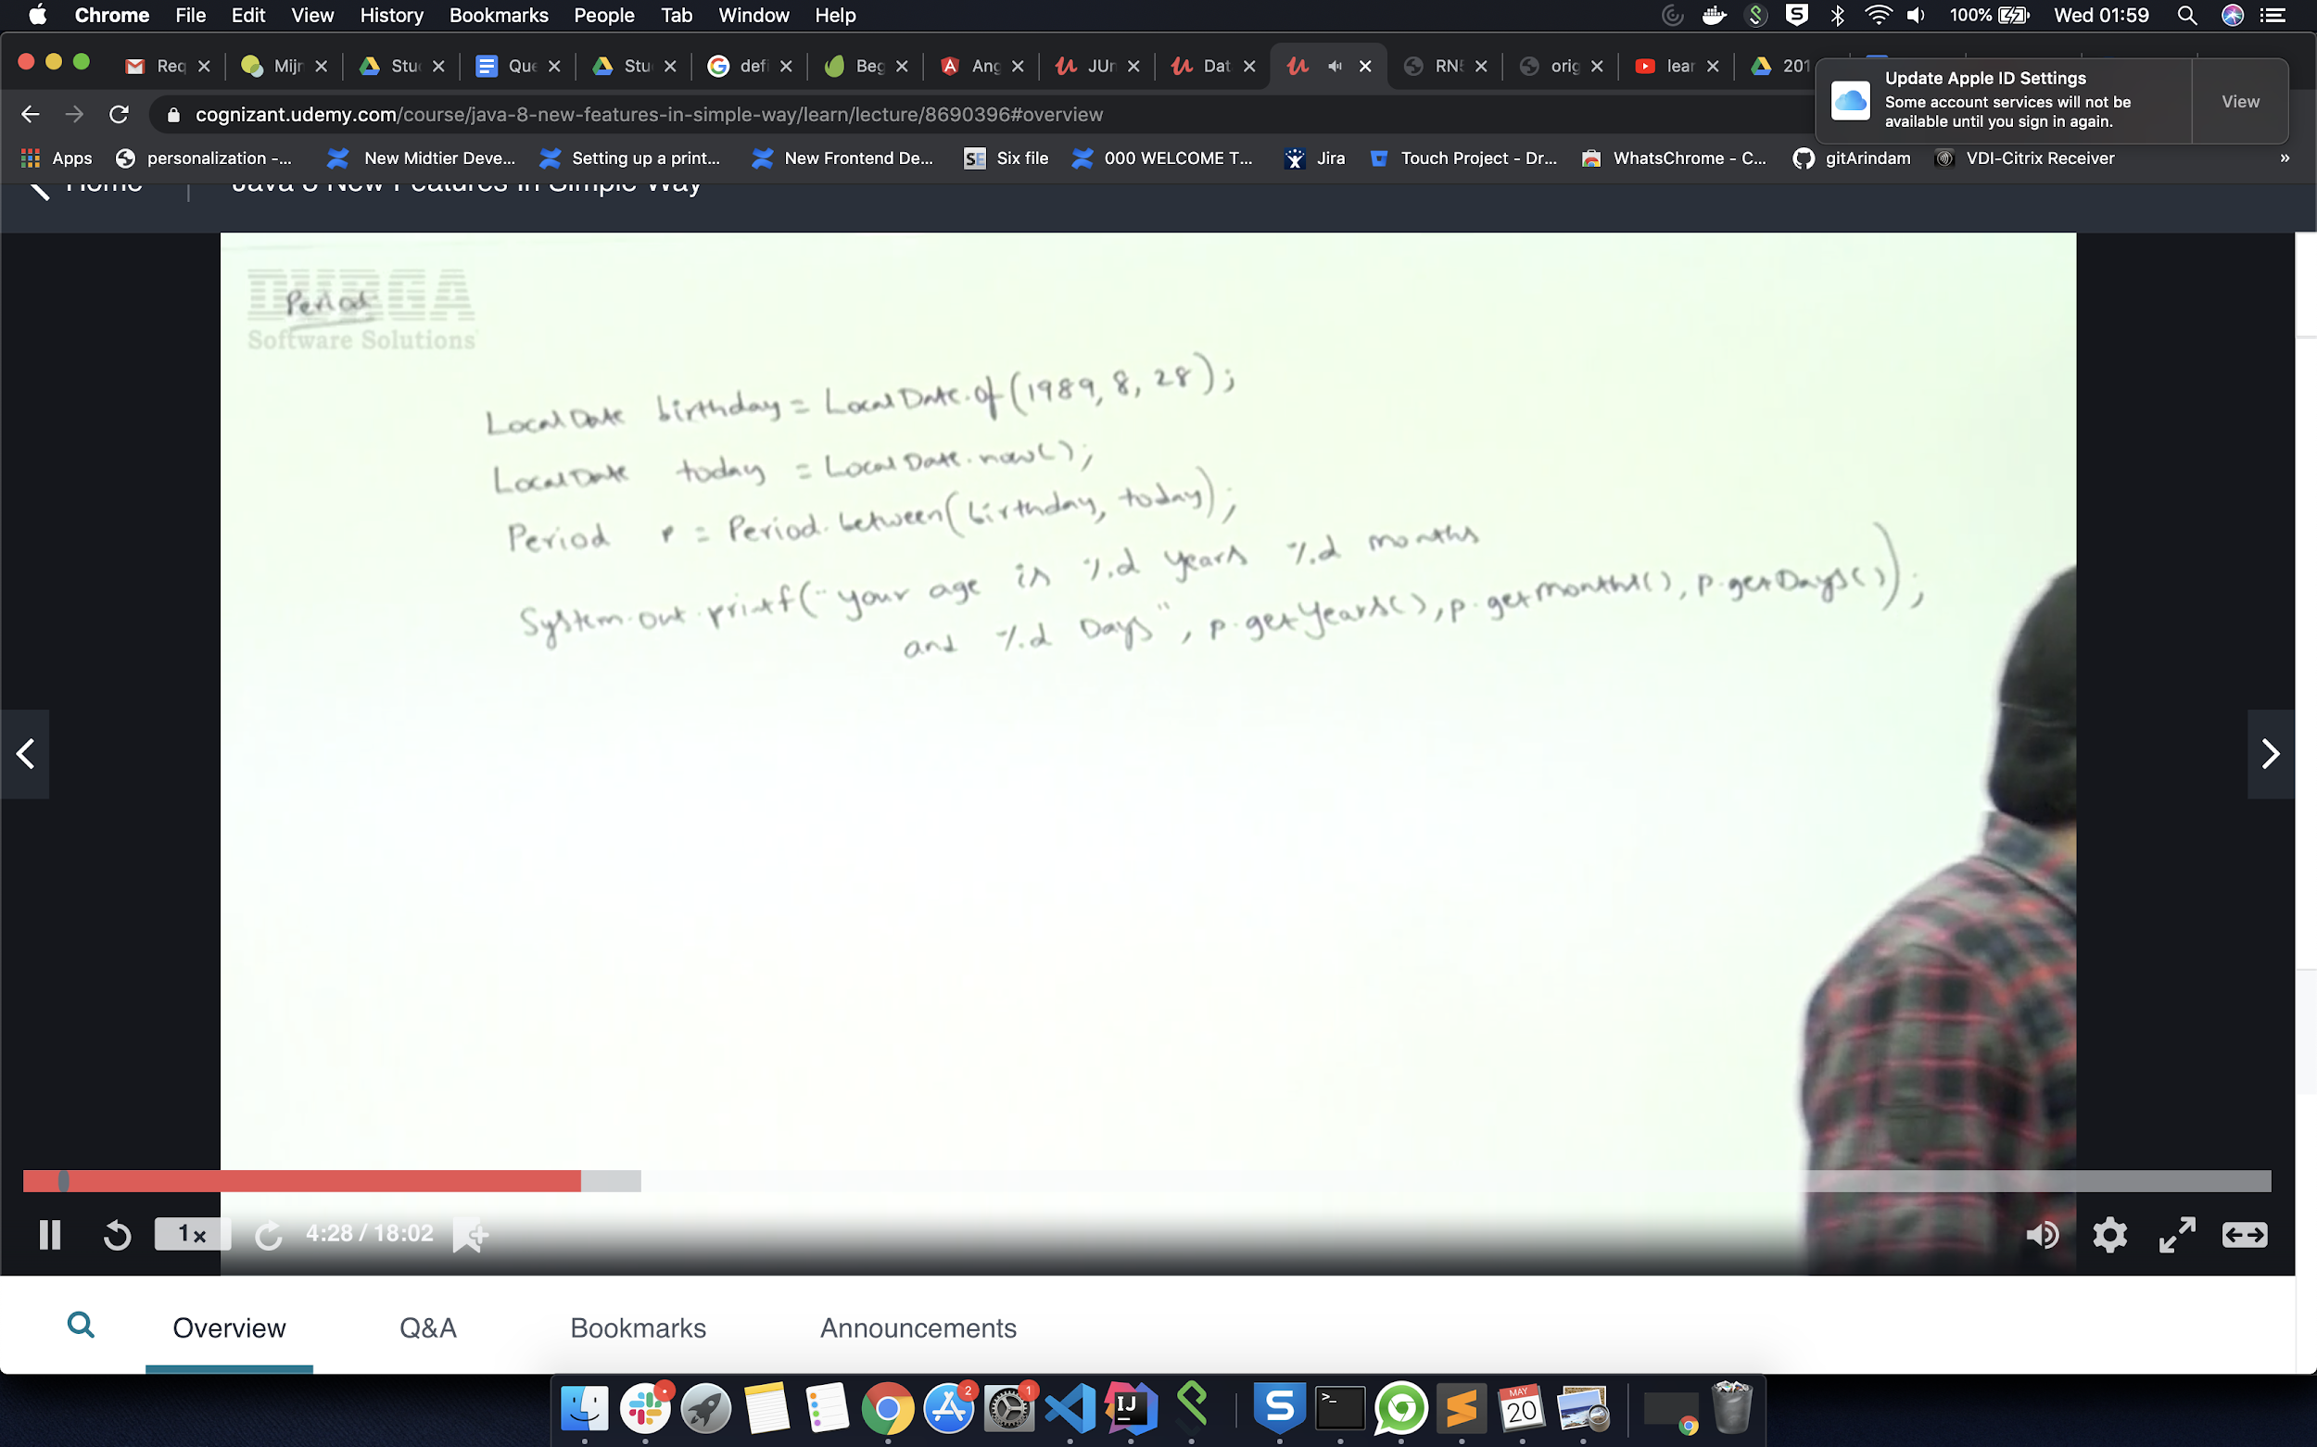

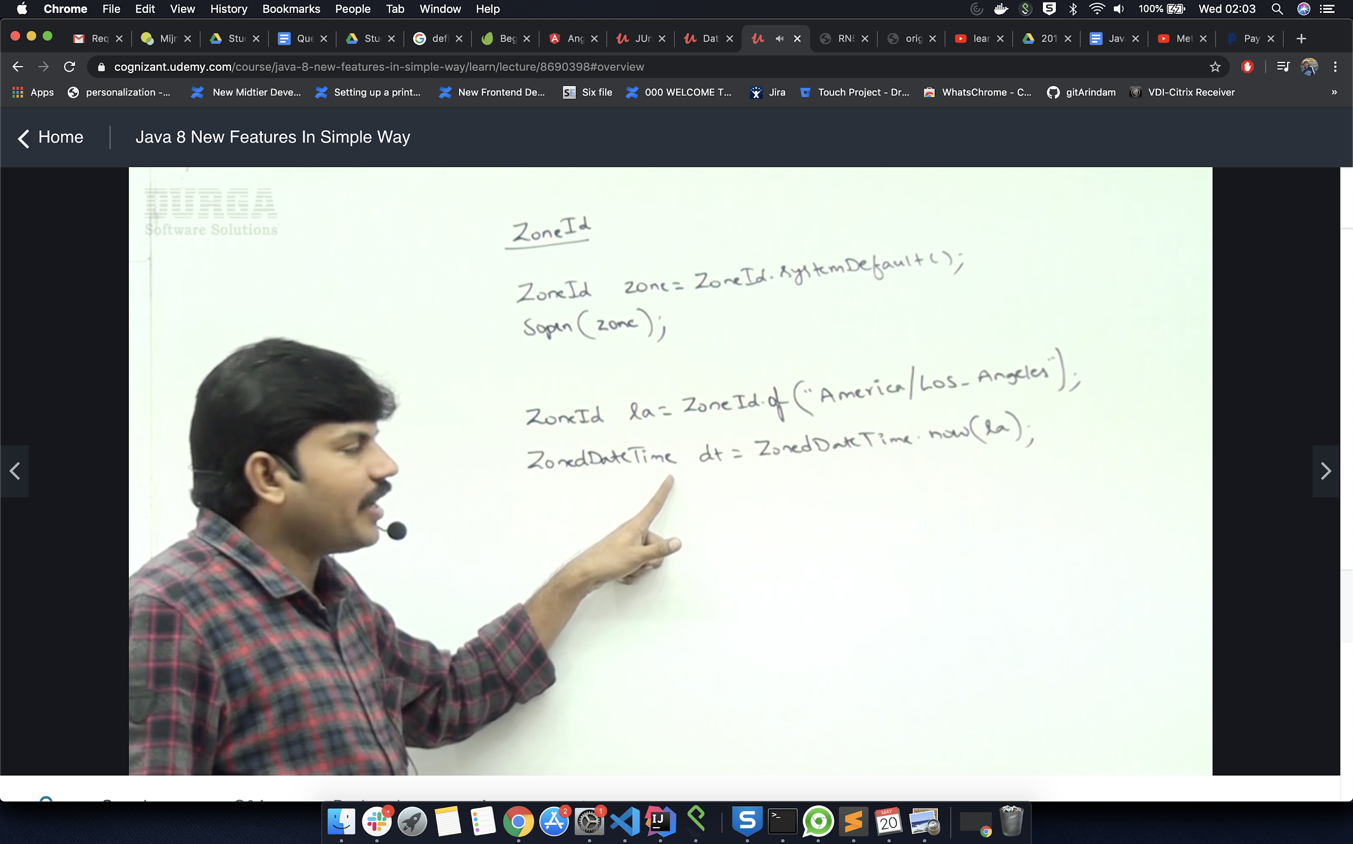

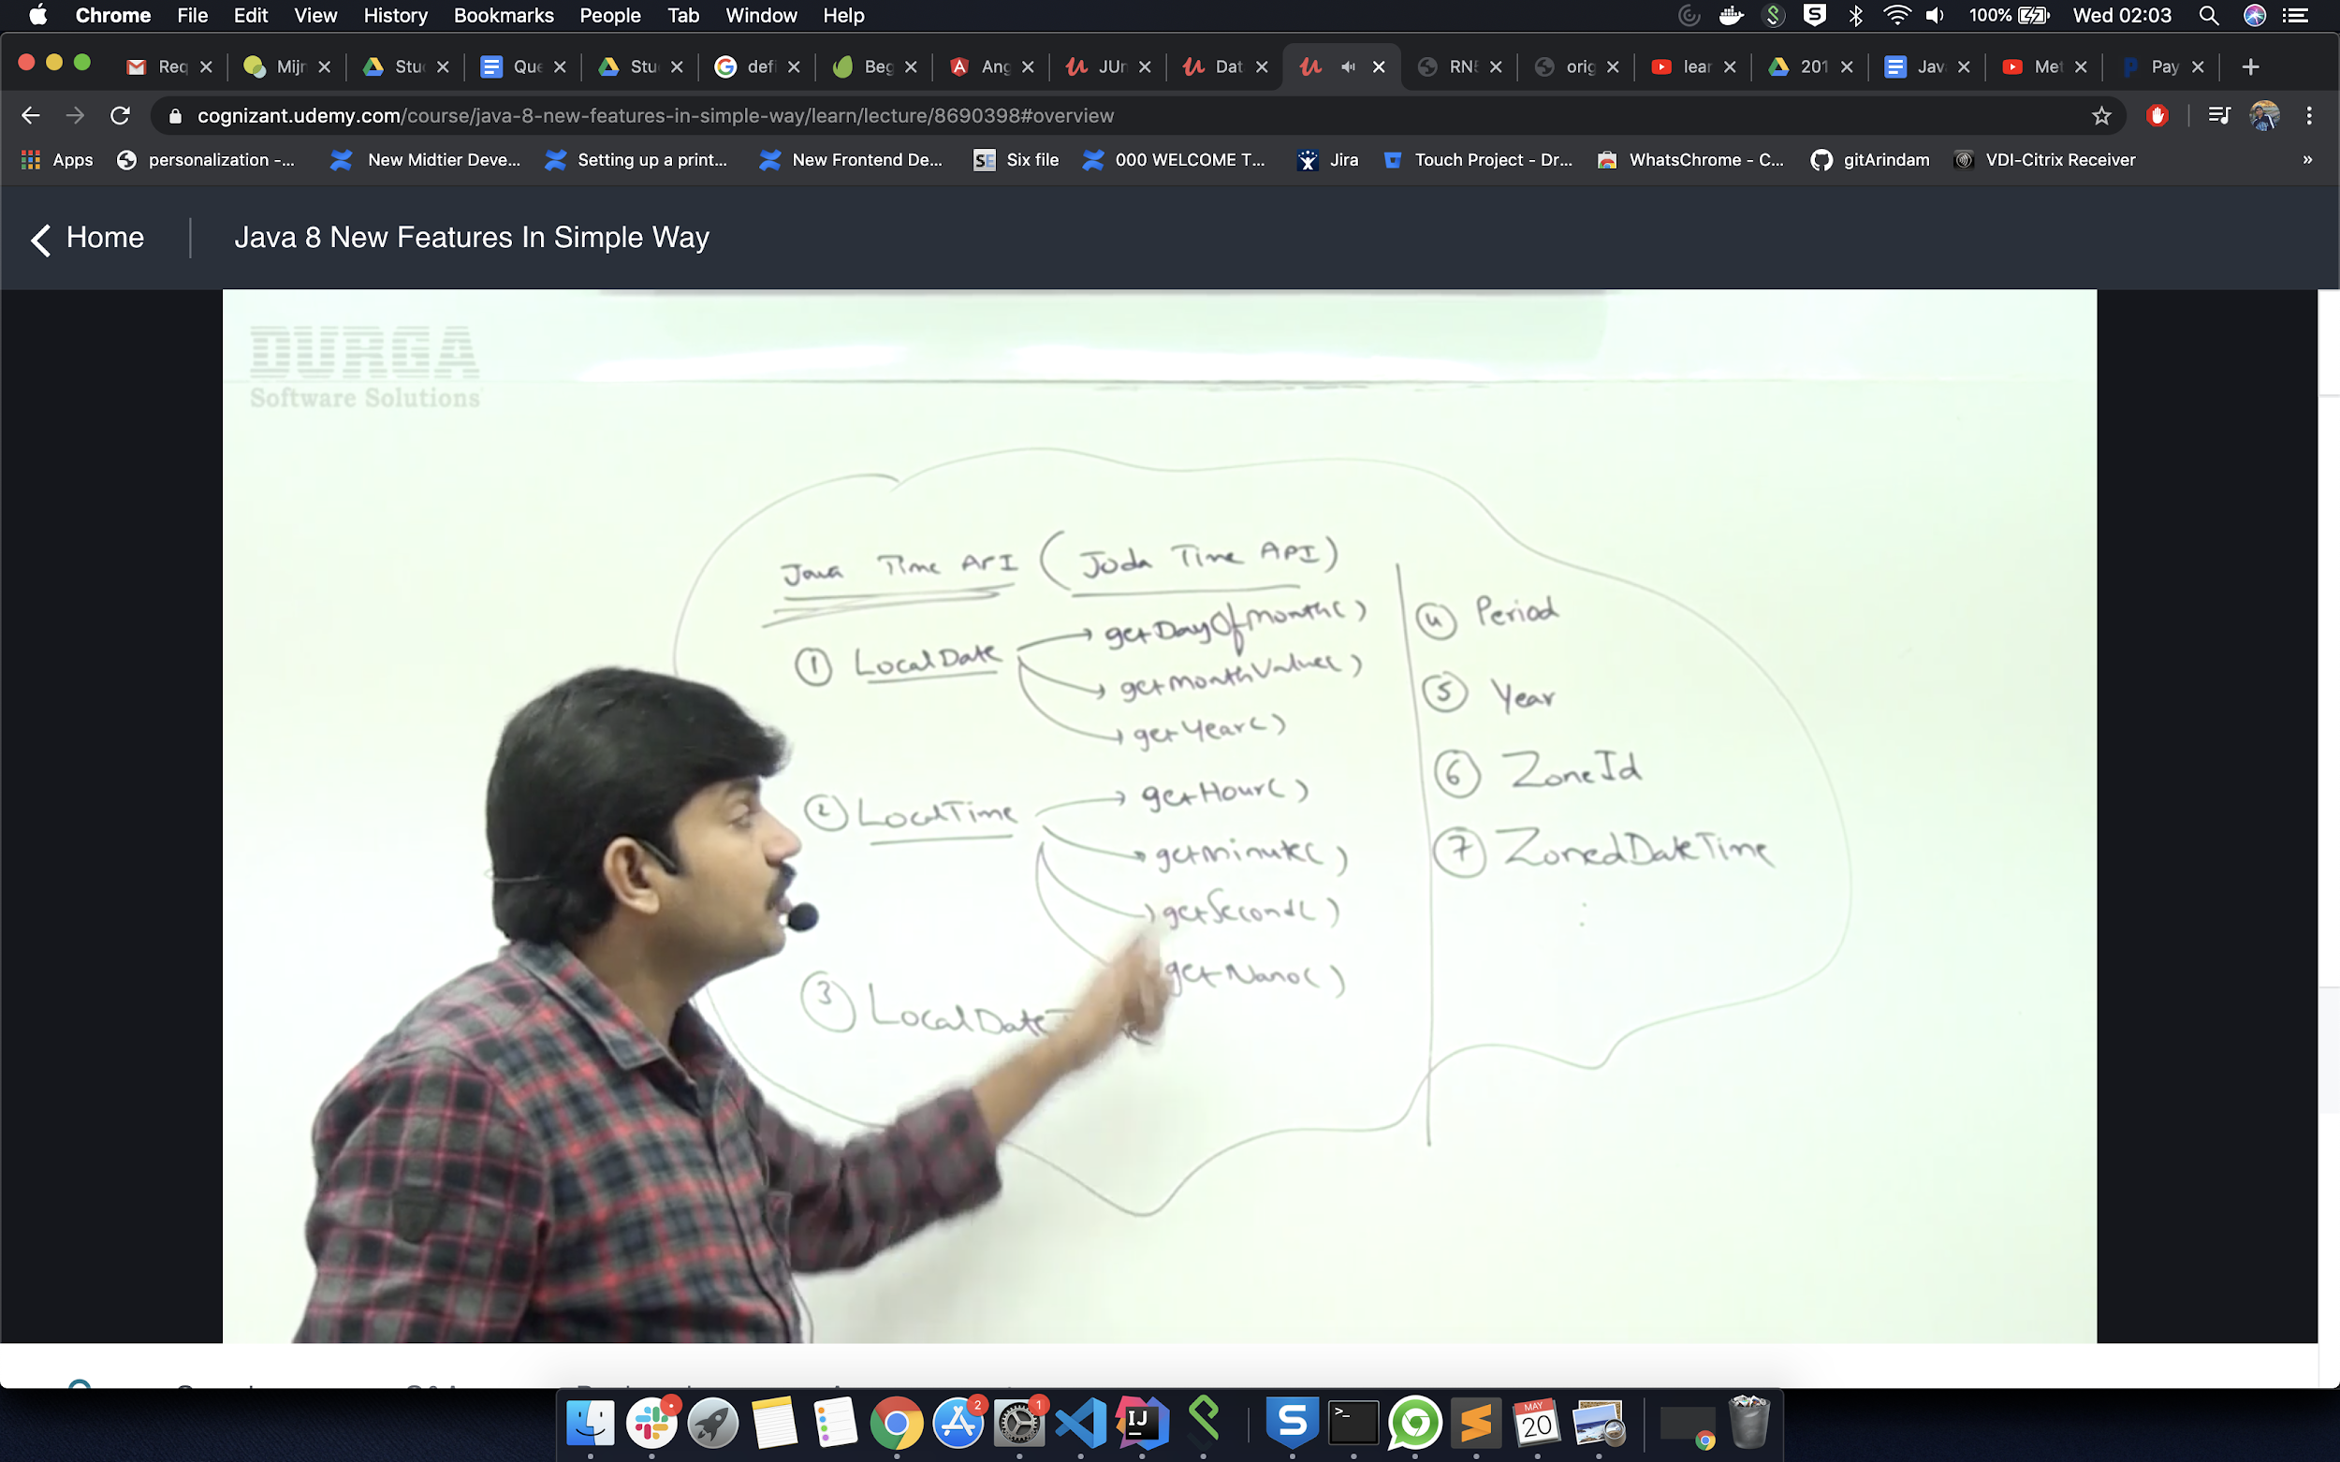

**-----------------Java-------------------**

**Multi threading in java**

**>>** Multithreading is a process of executing multiple threads simultaneously. Its main advantage is:

* Threads share the same address space.
* Thread is lightweight.
* Cost of communication between process is low.

If you have a task (suppose multiple arrya of element by 2) so if we create multiple thread like t1,t2,t3,t4 then it can use different core of the cpu and give us the result in faster time than 1 thread.

* In android also we use multi thread as async task to accomplish background work.
* For web application if 5 client wants to use the same servlet then we need to use multi thread.
* In gaming also we need to use multi thread like we play counterstrike with multiple player.

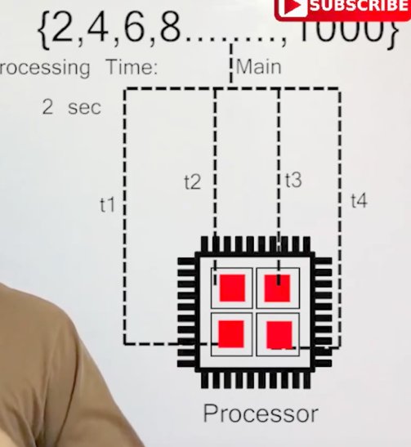 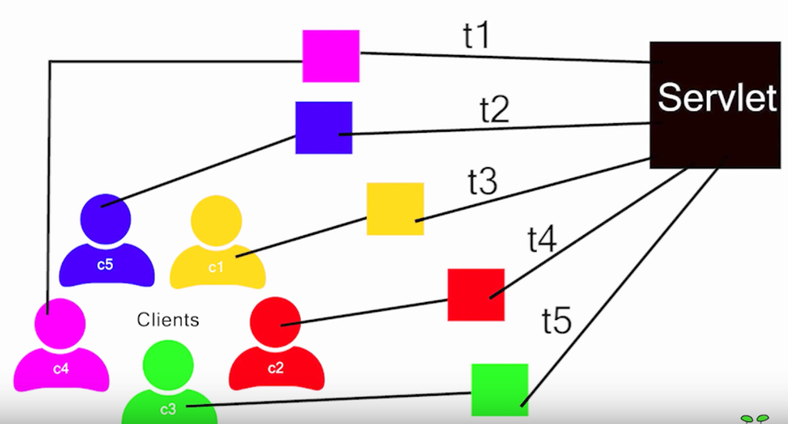

1. what are early binding (overloading) and late binding  (Overriding)
2. OOPS Concepts,
3. Core Java,
4. Collections framework,
5. Hibernate,
6. JavaScript
7. Use of Hashcode and equals() method,
8. Serilization concepts.
9. internal structure of hashmap and also questions on sql
10. about http
11. wrapper class

**Cross cutting concern in spring**

# **Test Driven Development (TDD):**

1. Write the test
2. Run the test (there is no implementation code, test does not pass)
3. Write just enough implementation code to make the test pass
4. Run all tests (tests pass)
5. Refactor
6. Repeat

**BDD ::** Let’s see an example of Behavior-Driven Development

The scenario: You’re a developer on a team responsible for the company accounting system, implemented in Rails. One day, a business person asks you to implement a reminder system to remind clients of their pending invoices. Because you’re practicing BDD per this tutoria; (versus TDD), you sit down with that business person and start defining behaviors.

You open your text editor and start creating pending specs for the behaviors the business user wants:

it "adds a reminder date when an invoice is created"

it "sends an email to the invoice's account's primary contact after the reminder date has passed"

it "marks that the user has read the email in the invoice"

**You need to add spring core jar file if you want to use spring features in normal java project.**

1) **What is encapsulation?**

>> Encapsulation is one of the four fundamental OOP concepts. The other three are inheritance, polymorphism, and abstraction.

Encapsulation in Java is a mechanism of wrapping the data (variables) and code acting on the data (methods) together as single unit. In encapsulation the variables of a class will be hidden from other classes, and can be accessed only through the methods of their current class, therefore it is also known as data hiding.

To achieve encapsulation in Java

* Declare the variables of a class as private.
* Provide public setter and getter methods to modify and view the variables values.

## Example:

Below given is an example that demonstrates how to achieve Encapsulation in Java:

/* File name : EncapTest.java */

public class EncapTest{

private String name;

private String idNum;

private int age;

public int getAge(){

return age;

}

public String getName(){

return name;

}

public String getIdNum(){

return idNum;

}

public void setAge( int newAge){

age = newAge;

}

public void setName(String newName){

name = newName;

}

public void setIdNum( String newId){

idNum = newId;

}

}

The public setXXX() and getXXX() methods are the access points of the instance variables of the EncapTest class. Normally, these methods are referred as getters and setters. Therefore any class that wants to access the variables should access them through these getters and setters.

## Benefits of Encapsulation:

* The fields of a class can be made read-only or write-only.
* A class can have total control over what is stored in its fields.
* The users of a class do not know how the class stores its data. A class can change the data type of a field and users of the class do not need to change any of their code.

**2) What is abstruction & polymorphism? (VVVVI For Interview http://www.javatpoint.com/corejava-interview-questions-2)**

>> **Abstract class in Java**

A class that is declared with abstract keyword, is known as abstract class in java. It can have abstract and non-abstract methods (method with body).

Before learning java abstract class, let's understand the abstraction in java first.

### Abstraction in Java

**Abstraction** is a process of hiding the implementation details and showing only functionality to the user.

Another way, it shows only important things to the user and hides the internal details for example sending sms, you just type the text and send the message. You don't know the internal processing about the message delivery.

Abstraction lets you focus on what the object does instead of how it does it.

### Ways to achieve Abstaction

There are two ways to achieve abstraction in java

1. Abstract class (0 to 100%)
2. Interface (100%)

### Abstract class in Java

A class that is declared as abstract is known as **abstract class**. It needs to be extended and its method implemented. It cannot be instantiated.

### Example abstract class

1. **abstract** **class** A{}

### abstract method

|  |
| --- |
| A method that is declared as abstract and does not have implementation is known as abstract method. |

### Example abstract method

**abstract** **void** printStatus();//no body and abstract

### Example of abstract class that has abstract method

In this example, Bike the abstract class that contains only one abstract method run. It implementation is provided by the Honda class.

**abstract** **class** Bike{

**abstract** **void** run();

}

**class** Honda4 **extends** Bike{

**void** run(){System.out.println("running safely..");}

**public** **static** **void** main(String args[]){

 Bike obj = **new** Honda4();

 obj.run();

}

}

**polymorphism**

**>>**In more simple words, polymorphism is the ability by which, we **can create functions or reference variables which behaves differently in different programmatic context**.

**Polymorphism is one of the major building blocks of object oriented programming along with inheritance, abstraction and encapsulation**. Read more about [**abstraction and its relation with encapsulation**](http://howtodoinjava.com/object-oriented/encapsulation-in-java-and-its-relation-with-abstraction/).

An example of polymorphism is referring the instance of subclass, with reference variable of super-class. e.g.

Object o = new Object(); //o can hold the reference of any subtype

Object o = new String();

Object o = new Integer();

Here, String is subclass of Object class. This is basic example of polymorphism.

In java language, polymorphism is essentially considered into two versions.

1. **Compile time polymorphism (static binding or method overloading)**
2. **Runtime polymorphism (dynamic binding or method overriding)**

Here, it is important to understand the these divisions are specific to java. In context to software engineering, there are other form of polymorphisms also applicable to different languages, but for java, these are mainly considered.

### **Compile time polymorphism (static binding or method overloading)**

As the meaning is implicit, this is used to write the program in such a way, that flow of control is decided in compile time itself. It is achieved using method overloading.

In method overloading, an object can have two or more methods with same name, BUT, with their method parameters different. These parameters may be different on two bases:

**1) Parameter type**: Type of method parameters can be different. e.g. java.util.Math.max() function comes with following versions:

public static double Math.max(double a, double b){..}

public static float Math.max(float a, float b){..}

public static int Math.max(int a, int b){..}

public static long Math.max(long a, long b){..}

The actual method to be called is decided on compile time based on parameters passed to function in program.

**2) Parameter count**: Functions accepting different number of parameters. e.g. in employee management application, a factory can have these methods:

EmployeeFactory.create(String firstName, String lastName){...}

EmployeeFactory.create(Integer id, String firstName, String lastName){...}

Both methods have same name “create” but actual method invoked will be based on parameters passed in program.

### **Runtime polymorphism (dynamic binding or method overriding)**

**Runtime polymorphism is essentially referred as method overriding.** Method overriding is a feature which you get when you **implement inheritance in your program.**

A simple example can be from real world e.g. Animal. An application can have Animal class, and its specialized sub classes like Cat and Dog. These subclasses will override the default behavior provided by Animal class + some of its own specific behavior.

|  |
| --- |
| **public** **class** Animal {  **public** **void** makeNoise()      {          System.out.println("Some sound");      }  }    **class** Dog **extends** Animal{  **public** **void** makeNoise()      {          System.out.println("Bark");      }  }    **class** Cat **extends** Animal{  **public** **void** makeNoise()      {          System.out.println("Meawoo");      }  } |

Now which makeNoise() method will be called, depends on type of actual instance created on runtime e.g.

|  |
| --- |
| **public** **class** Demo  {  **public** **static** **void** main(String[] args) {          Animal a1 = **new** Cat();          a1.makeNoise(); //Prints Meowoo            Animal a2 = **new** Dog();          a2.makeNoise(); //Prints Bark      }  } |

**3) What is serilazion and seralizable perticle.**

**>>What is Serialization**

Serialization is a process in which current state of Object will be saved in stream of bytes. As byte stream create is platform neutral hence once objects created in one system can be deserialized in other platform.

# What is the use of Serialization

As written above serialization will translate the Object state to Byte Streams. This Byte stream can be used for different purpose.

* Write to Disk
* Store in Memory
* Sent byte stream to other platform over network
* Save byte stream in DB(As BLOB)

# Serialization and Deserialization in Java

Now we know what is serialization. But in terms of Java how this serialization will work and how to make a class serializable. Java has already provided out of the box way(**java.io.Serializable** Interface) to serialize an Object. If you want any class to be serialized then that class needs to implement give interface.

**Note*: Serializable Interface is a Marker Interface. Hence there is no method in Serializable interface.**

# Code for Serialization of Java Class

**Employee.java**

|  |  |
| --- | --- |
| 1  2  3  4  5  6  7  8  9  10  11  12 | package com.jbt;    import java.io.Serializable;    public class Employee implements Serializable  {     public String firstName;     public String lastName;     private static final long serialVersionUID = 5462223600l;  } |

**SerializaitonClass.java**

|  |  |
| --- | --- |
| 1  2  3  4  5  6  7  8  9  10  11  12  13  14  15  16  17  18  19  20  21  22  23  24  25  26  27 | package com.jbt;    import java.io.FileOutputStream;  import java.io.IOException;  import java.io.ObjectOutputStream;    public class SerializaitonClass {    public static void main(String[] args) {  Employee emp = new Employee();  emp.firstName = "Vivekanand";  emp.lastName = "Gautam";    try {  FileOutputStream fileOut = new FileOutputStream("./employee.txt");  ObjectOutputStream out = new ObjectOutputStream(fileOut);  out.writeObject(emp);  out.close();  fileOut.close();  System.out.printf("Serialized data is saved in ./employee.txt file");  } catch (IOException i) {  i.printStackTrace();  }  }  } |

**DeserializationClass.java**

|  |  |
| --- | --- |
| 1  2  3  4  5  6  7  8  9  10  11  12  13  14  15  16  17  18  19  20  21  22  23  24  25  26  27  28 | package com.jbt;    import java.io.*;    public class DeserializationClass {  public static void main(String[] args) {  Employee emp = null;  try {  FileInputStream fileIn = new FileInputStream("./employee.txt");  ObjectInputStream in = new ObjectInputStream(fileIn);  emp = (Employee) in.readObject();  in.close();  fileIn.close();  } catch (IOException i) {  i.printStackTrace();  return;  } catch (ClassNotFoundException c) {  System.out.println("Employee class not found");  c.printStackTrace();  return;  }  System.out.println("Deserializing Employee...");  System.out.println("First Name of Employee: " + emp.firstName);  System.out.println("Last Name of Employee: " + emp.lastName);  }  } |

First run “**SerializaitonClass**” and you will get “**employee.txt**” file created.

Second run “**DeserializationClass**” and java will deserialize the class and value will be printed in console.

Output would be

|  |  |
| --- | --- |
| 1  2  3  4  5 | Deserializing Employee...  First Name of Employee: Vivekanand  Last Name of Employee: Gautam |

*Serialization* interface needs to be implemented in order to make object *serialized.*

* **Transient instance** variable doesn’t serialized with Object state.
* If Super class implements Serializable then sub class are also Serializable automatically.
* If Super class is not serializable then when sub class is de serialized then super class’s default constructor will be invoked. Hence all variable will get default value and reference will be null.

Read more at http://javabeginnerstutorial.com/core-java-tutorial/java-serialization-concept-example/#hZLqY5bVoO6CXAcz.99

**4) What is inner class and how many types of inner classes we have?**

Inner classes are of three types depending on how and where you define them. They are −

* Inner Class
* Method-local Inner Class
* Static innerClass or nested class (you can use static variable here)
* Anonymous Inner Class

**5) What is static binding and dynamic binding?**

**6) Upcasting and downcasting.**

**Up-casting:** Converting a subclass type to a superclass type is known as up casting.

**Example:**

class Super {

void Sample() {

System.out.println("method of super class");

}

}

public class Sub extends Super {

void Sample() {

System.out.println("method of sub class");

}

public static void main(String args[]) {

Super obj =(Super) new Sub(); obj.Sample();

}

}

>>Upcasting is casting to a supertype, while downcasting is casting to a subtype. Upcasting is always allowed, but downcasting involves a type check and can throw a ClassCastException.

UpCast -> From lower level class type to upper level class type

Downcast -> From upper level class type to lover level class type

7) Difference between abstract class and interface.

|  |  |
| --- | --- |
| **Abstract class** | **Interface** |
| 1) Abstract class can have abstract and non-abstractmethods. | Interface can have only abstract methods. |
| 2) **Abstract class doesn't support multiple inheritance.** | **Interface supports multiple inheritance.** |
| 3) Abstract class can have final, non-final, static and non-static variables. | Interface has only static and final variables. |
| 4) Abstract class can have static methods, main method and constructor. | Interface can't have static methods, main method or constructor. |
| 5) Abstract class can provide the implementation of interface. | Interface can't provide the implementation of abstract class. |
| 6) The abstract keyword is used to declare abstract class. | The interface keyword is used to declare interface. |
| 7) Example: public abstract class Shape{ public abstract void draw(); } | Example: public interface Drawable{ void draw(); } |

Simply, abstract class achieves partial abstraction (0 to 100%) whereas interface achieves fully abstraction (100%).

### Example of abstract class and interface in Java

Let's see a simple example where we are using interface and abstract class both.

1. //Creating interface that has 4 methods
2. **interface** A{
3. **void** a();//bydefault, public and abstract
4. **void** b();
5. **void** c();
6. **void** d();
7. }
9. //Creating abstract class that provides the implementation of one method of A interface
10. **abstract** **class** B **implements** A{
11. **public** **void** c(){System.out.println("I am C");}
12. }
14. //Creating subclass of abstract class, now we need to provide the implementation of rest of the methods
15. **class** M **extends** B{
16. **public** **void** a(){System.out.println("I am a");}
17. **public** **void** b(){System.out.println("I am b");}
18. **public** **void** d(){System.out.println("I am d");}
19. }
21. //Creating a test class that calls the methods of A interface
22. **class** Test5{
23. **public** **static** **void** main(String args[]){
24. A a=**new** M();
25. a.a();
26. a.b();
27. a.c();
28. a.d();
29. }}

**8) Can we have constructer in abstructclass.**

Yes, an abstract class can have a constructor. Consider this:

abstract class Product {

int multiplyBy;

public Product( int multiplyBy ) {

this.multiplyBy = multiplyBy;

}

public int mutiply(int val) {

return multiplyBy * val;

}

}

class TimesTwo extends Product {

public TimesTwo() {

super(2);

}

}

class TimesWhat extends Product {

public TimesWhat(int what) {

super(what);

}

}

9) **Can we create any object of that abstruct calss?**

>> NO

If you've written an abstract class that you **want** to instantiate completely on its own,**then it isn't an abstract class**.

The answer there is that you *are* allowed to instantiate an abstract class - you're just not allowed to instantiate it *directly* using the new keyword. But the most important part of abstract classes is that they're designed *to be extended*.

abstract class Vehicle {

// You might have some common variables defined here

Vehicle() { }

}

**10) What is marker interface?**

>> it does not have any method

11) What is overriding and overloading?

**12) Can the return type of overloading be different?**

>> Overloaded methods in java may have different return types given that the argument lists are also different.

**13) can we put a normal intger as argument?**

Yes, it's possible:

public void myMethod(int...numbers) { ... }

**14) can we put a normal intger in arrayList?**

>> YES, ArrayList<Integer> list = new ArrayList<Integer>();

**15) What is string buffer? wen can we use it?**

|  |  |  |
| --- | --- | --- |
| **No.** | **String** | **StringBuffer** |
| 1 | String class is immutable. | StringBuffer class is mutable. |
| 2 | String is slow and consumes more memory when you concat too many strings because every time it creates new instance. | StringBuffer is fast and consumes less memory when you cancat strings. |
| 3 | String class overrides the equals() method of Object class. So you can compare the contents of two strings by equals() method. | StringBuffer class doesn't override the equals() method of Object class. |

**String** str = **new** **String** ("Stanford ");

str += "Lost!!";

If you were to use StringBuffer to perform the same concatenation, you would need code that looks like this:

**StringBuffer** str = **new** **StringBuffer** ("Stanford ");

str.append("Lost!!");

17) What is error and exception?

An Error "indicates serious problems that a reasonable application should not try to catch."

while

An Exception "indicates conditions that a reasonable application might want to catch."

Both are sub classes of java.lang.Throwable class

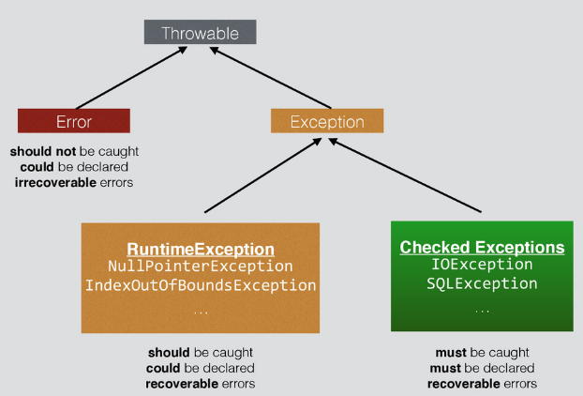

**18) Can u write a try block without catch?**

Yes, we can have try without catch block by using finally block

**19) Can u write only finally without catch?**

>> Yes

**20) There are 2 trypes of using thread what are the occation of those?**

**Do you knowthe syntax to create and start thread?**

**What is the syntax of start and run method of thread?**

1. **—>> By implementing the Runnableinterface.**
2. **—>>By extending the Thread.**
3. ***To implement Runnable interface,*** a **class need only implement a single method called run( ),** which is declared like this:

public void run( )

Inside run( ), we will define the code that constitutes the new thread. Example:

public class MyClass implements Runnable {

public void run(){

System.out.println("MyClass running");

}

}

To execute the run() method by a thread, pass an instance of MyClass to a Thread in its constructor.

Here is how that is done:

Thread t1 = new Thread(new MyClass ());

t1.start();

### Extending Java Thread

The second way to create a thread is to create a new class t**hat extends Thread**, then override the run() method and then to create an instance of that class. The run() method is what is executed by the thread after you call start(). Here is an example of creating a Java Thread subclass:

public class MyClass extends Thread {

public void run(){

System.out.println("MyClass running");

}

}

To create and start the above thread:

MyClass t1 = new MyClass ();

T1.start();

**21) Can you stop one thread and start again?**

>> No Once we start a thread we ca not start it again.

Once a thread stops you cannot restart it. However, there is nothing stopping you from creating and starting a new thread.

**Option 1:** Create a new thread rather than trying to restart.

**Option 2:** Instead of letting the thread stop, have it wait and then when it receives notification you can allow it to do work again. This way the thread never stops and will never need to be restarted.

**Edit based on comment:**

To "kill" the thread you can do something like the following.

yourThread.setIsTerminating(true); // tell the thread to stop

yourThread.join(); // wait for the thread to stop

**22) What is synchronization and how many different type of synchronizations are there?**

**23) in banking project when we need to use synchronization?**

**24) Have you used any thread pool? what is it?**

# Java Thread Pool

**Java Thread pool** represents a group of worker threads that are waiting for the job and reuse many times.

In case of thread pool, a group of fixed size threads are created. A thread from the thread pool is pulled out and assigned a job by the service provider. After completion of the job, thread is contained in the thread pool again.

#### **Advantage of Java Thread Pool**

**Better performance** It saves time because there is no need to create new thread.

**Real time usage**

It is used in Servlet and JSP where container creates a thread pool to process the request.

#### Example of Java Thread Pool

Let's see a simple example of java thread pool using ExecutorService and Executors.

*File: WorkerThread.java*

1. **import** java.util.concurrent.ExecutorService;
2. **import** java.util.concurrent.Executors;
3. **class** WorkerThread **implements** Runnable {
4. **private** String message;
5. **public** WorkerThread(String s){
6. **this**.message=s;
7. }
8. **public** **void** run() {
9. System.out.println(Thread.currentThread().getName()+" (Start) message = "+message);
10. processmessage();//call processmessage method that sleeps the thread for 2 seconds
11. System.out.println(Thread.currentThread().getName()+" (End)");//prints thread name
12. }
13. **private** **void** processmessage() {
14. **try** {  Thread.sleep(2000);  } **catch** (InterruptedException e) { e.printStackTrace(); }
15. }
16. }

*File: JavaThreadPoolExample.java*

1. **public** **class** TestThreadPool {
2. **public** **static** **void** main(String[] args) {
3. ExecutorService executor = Executors.newFixedThreadPool(5);//creating a pool of 5 threads
4. **for** (**int** i = 0; i < 10; i++) {
5. Runnable worker = **new** WorkerThread("" + i);
6. executor.execute(worker);//calling execute method of ExecutorService
7. }
8. executor.shutdown();
9. **while** (!executor.isTerminated()) {   }
11. System.out.println("Finished all threads");
12. }
13. }

**25) What is hashmap? What is the difference between concurrent hashmap and normal hashmap?**

**>>**A HashMap contains values based on the key. It implements the Map interface and extends AbstractMap class.

ConcurrentHashMap is the class that is similar to HashMap but works fine when you try to modify your map at runtime.

**HashMap vs ConcurrentHashMap**

**1.  Thread -Safe :**  
   **ConcurrentHashMap is thread-safe that is the code can be accessed by single thread at a time .      
     while HashMap is not thread-safe .**  
  
**2.  Synchronization Method :**  
  
    HashMap can be synchronized by using      
    synchronizedMap(HashMap)  method .  By using this    
    method we get a HashMap object which is equivalent   
    to the HashTable object . So every modification  is performed      
    on  Map is locked on Map object.  
   ConcurrentHashMap synchronizes or locks on the certain portion of the Map . To optimize  
   the performance of ConcurrentHashMap , Map is divided into different partitions depending  
   upon the Concurrency level . So that we do not need to synchronize the whole Map Object.  
**3.  Null Key**  
**ConcurrentHashMap does not allow NULL values . So the key can not be null in  
     ConcurrentHashMap .While In HashMap there can only be one null key .**

**4.Performance**   
In multiple threaded environment HashMap is usually faster than ConcurrentHashMap . As      
     only single thread can access the certain portion of the Map and thus reducing the performance .   
     While in HashMap any number of threads can access the code at the same time .

**import** java.util.*;

1. **class** TestCollection13{
2. **public** **static** **void** main(String args[]){
4. HashMap<Integer,String> hm=**new** HashMap<Integer,String>();
6. hm.put(100,"Amit");
7. hm.put(101,"Vijay");
8. hm.put(102,"Rahul");
10. **for**(Map.Entry m:hm.entrySet()){
11. System.out.println(m.getKey()+" "+m.getValue());
12. }
13. }
14. }

**26) What is singleton calass and what is duble check & single check singleton class?**

**27) Can you make a constructor private?**

Yes, a constructor can be private. There are different uses of this. One such use is for the [singleton***design anti-pattern***](http://www.michaelsafyan.com/tech/design/patterns/singleton), which I would advise against you using. Another, more legitimate use, is in delegating constructors; you can have one constructor that takes lots of different options that is really an implementation detail, so you make it private, but then your remaining constructors delegate to it.

**Private constructors can prevent creation of objects**

### What is comparable and comparator what is in Java****interview KBC

## **Comparable**

### As the name suggests, **Comparable is an interface defining a strategy of comparing an object with other objects of the same type. This is called the class’s “natural ordering”.**

### A comparable object is capable of comparing itself with another object. The class itself must implements the **java.lang.Comparable** interface to compare its instances.

**class** Movie **implements** Comparable<Movie>

{

**private** **double** rating;

**private** String name;

**private** **int** year;

    // Used to sort movies by year

**public** **int** compareTo(Movie m)

    {

**return** **this**.year - m.year;

    }

## **Comparator**

**The Comparator interface defines a compare(arg1, arg2) method** with two arguments which represent compared objects and works similarly to the Comparable.compareTo() method.

Unlike Comparable, Comparator is external to the element type we are comparing. It’s a separate class. We create multiple separate classes (that implement Comparator) to compare by different members.

/// Class to compare Movies by ratings

**class** RatingCompare **implements** Comparator<Movie>

{

**public** **int** compare(Movie m1, Movie m2)

    {

**if** (m1.getRating() < m2.getRating()) **return** -1;

**if** (m1.getRating() > m2.getRating()) **return** 1;

**else** **return** 0;

    }

}

// Class to compare Movies by name

**class** NameCompare **implements** Comparator<Movie>

{

**public** **int** compare(Movie m1, Movie m2)

    {

**return** m1.getName().compareTo(m2.getName());

    }

}

|  |  |
| --- | --- |
| **Comparable** | **Comparator** |
| 1) Comparable provides single sorting sequence. In other words, we can sort the collection on the basis of single element such as id or name or price etc. | Comparator provides multiple sorting sequence. In other words, we can sort the collection on the basis of multiple elements such as id, name and price etc. |
| 2) Comparable affects the original class i.e. actual class is modified. | Comparator doesn't affect the original class i.e. actual class is not modified. |
| 3) Comparable provides compareTo() method to sort elements. | Comparator provides compare() method to sort elements. |
| 4) Comparable is found in java.lang package. | Comparator is found in java.util package. |
| 5) We can sort the list elements of Comparable type by Collections.sort(List) method. | We can sort the list elements of Comparator type by Collections.sort(List,Comparator) method. |

### What is difference between JDK,JRE and JVM?

**JVM** Java Virtual Machine, it is an abstract machine which provides the runtime environment in which java bytecode can be executed.

JVMs are available for many hardware and software platforms (so JVM is platform dependent).

**JRE** stands for Java Runtime Environment. It is the implementation of JVM.

**JDK** is an acronym for Java Development Kit. It physically exists. It contains JRE + development tools.

### What is JIT compiler?

**Just-In-Time(JIT) compiler:**It is used to improve the performance. JIT compiles parts of the byte code that have similar functionality at the same time, and hence reduces the amount of time needed for compilation.Here the term “compiler” refers to a translator from the instruction set of a Java virtual machine (JVM) to the instruction set of a specific CPU.

### What is classloader?

### The classloader is a subsystem of JVM that is used to load classes and interfaces.There are many types of classloaders e.g. Bootstrap classloader, Extension classloader, System classloader, Plugin classloader etc.

### What if I write static public void instead of public static void?

Program compiles and runs properly.

### What is the default value of the local variables?

The local variables are not initialized to any default value, neither primitives nor object references.

### What is difference between object oriented programming language and object based programming language?

Object based programming languages follow all the features of OOPs except Inheritance. Examples of object based programming languages are JavaScript, VBScript etc.

### What will be the initial value of an object reference which is defined as an instance variable?

The object references are all initialized to null in Java.

### What is constructor?

Constructor is just like a method that is used to initialize the state of an object. It is invoked at the time of object creation.

### What is the purpose of default constructor?

The default constructor provides the default values to the objects. The java compiler creates a default constructor only if there is no constructor in the class.

### Does constructor return any value?

yes, that is current instance (You cannot use return type yet it returns a value).

### Is constructor inherited?

No, constructor is not inherited.

### Can you make a constructor final?

No, constructor can't be final.

### What is static variable?

* static variable is used to refer the common property of all objects (that is not unique for each object) e.g. company name of employees,college name of students etc.
* static variable gets memory only once in class area at the time of class loading.

### What is static method?

* A static method belongs to the class rather than object of a class.
* A static method can be invoked without the need for creating an instance of a class.
* static method can access static data member and can change the value of it.

### What is static block?

* Is used to initialize the static data member.
* It is excuted before main method at the time of classloading.

### Can we execute a program without main() method?

Ans) Yes, one of the way is static block.

### What if the static modifier is removed from the signature of the main method?

Program compiles. But at runtime throws an error "NoSuchMethodError".

### What is this in java?

It is a keyword that that refers to the current object.

### What is Inheritance?

Inheritance is a mechanism in which one object acquires all the properties and behaviour of another object of another class. It represents IS-A relationship. It is used for Code Resusability and Method Overriding.

### What is super in java?

It is a keyword that refers to the immediate parent class object.

### Can you use this() and super() both in a constructor?

No. Because super() or this() must be the first statement.

### Why method overloading is not possible by changing the return type in java?

Becauseof ambiguity

### Why we cannot override static method?

It is because the static method is the part of class and it is bound with class whereas instance method is bound with object and static gets memory in class area and instance gets memory in heap.

### Can we override the overloaded method?

Yes.

### What is blank final variable?

A final variable, not initalized at the time of declaration, is known as blank final variable

**What is the difference between static binding and dynamic binding?**

In case of static binding type of object is determined at compile time whereas in dynamic binding type of object is determined at runtime.

### What is abstraction?

Abstraction is a process of hiding the implementation details and showing only functionality to the user.

Abstraction lets you focus on what the object does instead of how it does it.

### Can there be any abstract method without abstract class?

No, if there is any abstract method in a class, that class must be abstract.

### What is interface?

Interface is a blueprint of a class that have static constants and abstract methods.It can be used to achieve fully abstraction and multiple inheritance.

### What is marker interface?

An interface that have no data member and method is known as a marker interface.For example Serializable, Cloneable etc.

### What is difference between abstract class and interface?

|  |  |
| --- | --- |
| **Abstract class** | **Interface** |
| 1)An abstract class can have method body (non-abstract methods). | Interface have only abstract methods. |
| 2)An abstract class can have instance variables. | An interface cannot have instance variables. |
| 3)An abstract class can have constructor. | Interface cannot have constructor. |
| 4)An abstract class can have static methods. | Interface cannot have static methods. |
| 5)You can extends one abstract class. | You can implement multiple interfaces. |

### Can we define private and protected modifiers for variables in interfaces?

No, they are implicitly public.

### What are Exceptions?

Exceptions are events that occur during the execution of programs that disrupt the normal flow of instructions (e.g. divide by zero, array access out of bound, etc.)

### What is difference between Checked Exception and Unchecked Exception?

### 1)Checked Exception

The classes that extend Throwable class except RuntimeException and Error are known as checked exceptions e.g.IOException,SQLException etc. Checked exceptions are checked at compile-time.

### 2)Unchecked Exception

The classes that extend RuntimeException are known as unchecked exceptions e.g. ArithmeticException,NullPointerException etc. Unchecked exceptions are not checked at compile-time.

### Is it necessary that each try block must be followed by a catch block?

It is not necessary that each try block must be followed by a catch block. It should be followed by either a catch block OR a finally block. And whatever exceptions are likely to be thrown should be declared in the throws clause of the method.

### Can finally block be used without catch?

Yes, by try block. finally must be followed by either try or catch

### Is there any case when finally will not be executed?

finally block will not be executed if program exits(either by calling System.exit() or by causing a fatal error that causes the process to abort)

### What is difference between throw and throws?

|  |  |
| --- | --- |
| **throw keyword** | **throws keyword** |
| 1)throw is used to explicitly throw an exception. | throws is used to declare an exception. |
| 2)checked exceptions can not be propagated with throw only. | checked exception can be propagated with throws. |
| 3)throw is followed by an instance. | throws is followed by class. |
| 4)throw is used within the method. | throws is used with the method signature. |
| 5)You cannot throw multiple exception | You can declare multiple exception e.g. public void method()throws IOException,SQLException.   1. return_type method_name() **throws** exception_class_name{ 2. //method code 3. } |

### Can subclass overriding method declare an exception if parent class method doesn't throw an exception ?

Yes but only unchecked exception not checked.

### Why string objects are immutable in java?

Because java uses the concept of **string literal**. Suppose there are 5 reference variables, all refers to one object "sachin".If one reference variable changes the value of the object, it will be affected to all the reference variables. That is why string objects are immutable in java.

1. **class** Testimmutablestring{
2. **public** **static** **void** main(String args[]){
3. String s="Sachin";
4. s.concat(" Tendulkar");//concat() method appends the string at the end
5. System.out.println(s);//will print Sachin because strings are immutable objects
6. }
7. }

Now it can be understood by the diagram given below. Here Sachin is not changed but a new object is created with sachintendulkar. That is why string is known as immutable.

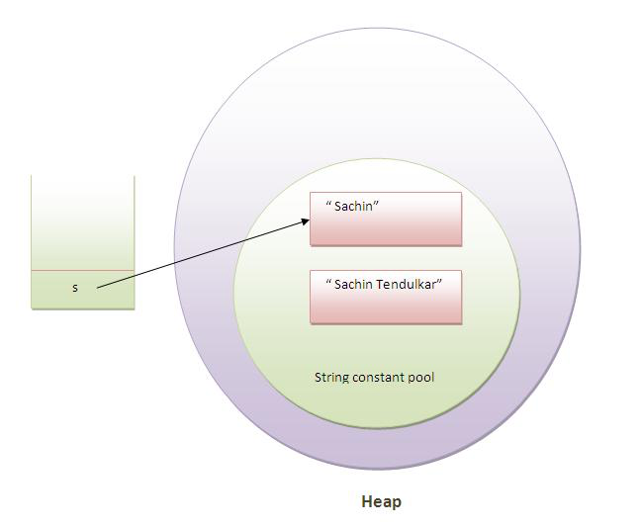

But if we explicitely assign it to the reference variable, it will refer to "Sachin Tendulkar" object.For example:

1. **class** Testimmutablestring1{
2. **public** **static** **void** main(String args[]){
3. String s="Sachin";
4. s=s.concat(" Tendulkar");
5. System.out.println(s);
6. }
7. }

### **String Literal Vs String Object in Java**

Compare string initialization performance for String Literal and String object.

***String Literal***

String str = “GeeksForGeeks”;

This is string literal. When you declare string like this, you are actually calling intern() method on String. This method references internal pool of string objects. If there already exists a string value “GeeksForGeeks”, then str will reference of that string and no new String object will be created. Please refer [Initialize and Compare Strings in Java](https://www.geeksforgeeks.org/how-to-initialize-and-compare-strings-in-java/) for details.

***String Object***

String str = new String(“GeeksForGeeks”);

This is string object. In this method JVM is forced to create a new string reference, even if “GeeksForGeeks” is in the reference pool.

Therefore, if we compare performance of string literal and string object, string object will always take more time to execute than string literal because it will construct a new string every time it is executed.

### ****Why java uses the concept of string literal? ****interview KBC

To make Java more memory efficient (because no new objects are created if it exists already in string constant pool).

### How to create String object?

There are two ways to create String object:

By string literal (String s="welcome"; )

1. By new keyword (String s = **new** String("Welcome");  )

### How many objects will be created in the following code?

1. String s = **new** String("Welcome");

Two objects, one in string constant pool and other in non-pool(heap).

**What is the basic difference between string and stringbuffer object?**

String is an immutable object. StringBuffer is a mutable object.

### What is the difference between StringBuffer and StringBuilder ?

StringBuffer is synchronized(allow one thread at a time) whereas StringBuilder is not synchronized.

### What is nested class?

A class which is declared inside another class is known as nested class. There are 4 types of nested class member **inner class, local inner class, annonymous inner class and static nested class.**

### Is there any difference between nested classes and inner classes?

Yes, inner classes are non-static nested classes i.e. inner classes are the part of nested classes.

### Can a class have an interface?

Yes, it is known as nested interface.

### Can an Interface have a class?

Yes, they are static implicitly.

1. **interface** M{
2. **class** A{}
3. }

### What is difference between final, finally and finalize?

|  |
| --- |
| **final:** final is a keyword, final can be variable, method or class.You, can't change the value of final variable, can't override final method, can't inherit final class. |
| **finally:** finally block is used in exception handling. finally block is always executed. |
| **finalize():**finalize() method is used in garbage collection.finalize() method is invoked just before the object is garbage collected.The finalize() method can be used to perform any cleanup processing. |

### What an I/O filter?

An I/O filter is an object that reads from one stream and writes to another, usually altering the data in some way as it is passed from one stream to another.

### What is serialization?

Serialization is a process of writing the state of an object into a byte stream.It is mainly used to travel object's state on the network.

### What is transient keyword?

If you define any data member as transient,it will not be serialized.

### What is Externalizable?

Externalizable interface is used to write the state of an object into a byte stream in compressed format.It is not a marker interface.

### What is the difference between Serializalble and Externalizable interface?

Serializable is a marker interface but Externalizable is not a marker interface.When you use Serializable interface, your class is serialized automatically by default. But you can override writeObject() and readObject() two methods to control more complex object serialization process. When you use Externalizable interface, you have a complete control over your class's serialization process.

### Can you access the private method from outside the class?

**Yes, by changing the runtime behaviour of a class if the class is not secured.**

### Example of calling private method from another class

Let's see the simple example to call private method from another class.

1. **public** **class** A {
2. **private** **void** message(){System.out.println("hello java"); }
3. }
4. **import** java.lang.reflect.Method;
5. **public** **class** MethodCall{
6. **public** **static** **void** main(String[] args)**throws** Exception{
8. Class c = Class.forName("A");
9. Object o= c.newInstance();
10. Method m =c.getDeclaredMethod("message", **null**);
11. m.setAccessible(**true**);
12. m.invoke(o, **null**);
13. }
14. }

### What are wrapper classes?

Wrapper classes are classes that allow primitive types to be accessed as objects.

### What comes to mind when someone mentions a shallow copy in Java?

Object cloning.

### What is singleton class?

Singleton class means that any given time only one instance of the class is present, in one JVM.

### What is Locale?

A Locale object represents a specific geographical, political, or cultural region.

### How will you load a specific locale?

By ResourceBundle.getBundle(?) method.

### What is multithreading?

Multithreading is a process of executing multiple threads simultaneously. Its main advantage is:

* Threads share the same address space.
* Thread is lightweight.
* Cost of communication between process is low.

### What is thread?

A thread is a lightweight subprocess.It is a separate path of execution.It is called separate path of execution because each thread runs in a separate stack frame.

### What does join() method?

The join() method waits for a thread to die. In other words, it causes the currently running threads to stop executing until the thread it joins with completes its task.

### What is difference between wait() and sleep() method?

|  |  |
| --- | --- |
| **wait()** | **sleep()** |
| 1) The wait() method is defined in Object class. | The sleep() method is defined in the Thread class. |
| 2) wait() method releases the lock. | The sleep() method doesn't releases the lock. |

### Is it possible to start a thread twice?

No, there is no possibility to start a thread twice. If we does, it throws an exception.

### Can we call the run() method instead of start()?

yes, but it will not work as a thread rather it will work as a normal object so there will not be context-switching between the threads.

### What about the daemon threads?

The daemon threads are basically the low priority threads that provides the background support to the user threads. It provides services to the user threads.

### What is shutdown hook?

The shutdown hook is basically a thread i.e. invoked implicitely before JVM shuts down. So we can use it perform clean up resource.

### What is synchronization?

Synchronization is the capability to control the access of multiple threads to any shared resource.It is used:

### What is the purpose of Synchronized block?

* Synchronized block is used to lock an object for any shared resource.
* Scope of synchronized block is smaller than the method.

### Can Java object be locked down for exclusive use by a given thread?

Yes. You can lock an object by putting it in a "synchronized" block. The locked object is inaccessible to any thread other than the one that explicitly claimed it.

### What is static synchronization?

If you make any static method as synchronized, the lock will be on the class not on object.

### What is the difference between notify() and notifyAll()?

The notify() is used to unblock one waiting thread whereas notifyAll() method is used to unblock all the threads in waiting state.

### What is deadlock?

Deadlock is a situation when two threads are waiting on each other to release a resource. Each thread waiting for a resource which is held by the other waiting thread.

### What is the difference between ArrayList and LinkedList?

|  |  |  |
| --- | --- | --- |
| **No.** | **ArrayList** | **LinkedList** |
| 1) | ArrayList uses a dynamic array. | LinkedList uses doubly linked list. |
| 2) | ArrayList is not efficient for manipulation because a lot of shifting is required. | LinkedList is efficient for manipulation. |
| 3) | ArrayList is better to store and fetch data. | LinkedList is better to manipulate data. |

### What is the difference between Iterator and ListIterator?

Iterator traverses the elements in forward direction only whereas ListIterator traverses the elements in forward and backward direction.

|  |  |  |
| --- | --- | --- |
| **No.** | **Iterator** | **ListIterator** |
| 1) | Iterator traverses the elements in forward direction only. | ListIterator traverses the elements in backward and forward directions  both. |
| 2) | Iterator can be used in List, Set and Queue. | ListIterator can be used in List only. |

### What is the difference between List and Set?

List can contain duplicate elements whereas Set contains only unique elements.

### What is the difference between HashSet and TreeSet?

HashSet maintains **no order** whereas TreeSet maintains **ascending order**.

### What is the difference between Set and Map?

Set contains values only whereas Map contains key and values both.



### What is the difference between HashSet and HashMap?

* **HashSet contains only values whereas HashMap contains entry(key,value).**
* **HashSet can be iterated but HashMap need to convert into Set to be iterated.**



### What is the difference between HashMap and TreeMap?

HashMap maintains **no order** but TreeMap maintains **ascending order**.

### What is the difference between HashMap and Hashtable?

|  |  |  |
| --- | --- | --- |
| **No.** | **HashMap** | **Hashtable** |
| 1) | HashMap is not synchronized. | Hashtable is synchronized. |
| 2) | HashMap can contain one null key and multiple null values. | Hashtable cannot contain any null key or null value. |

### What is the difference between Collection and Collections?

Collection is an interface whereas Collections is a class. Collection interface provides normal functionality of data structure to List, Set and Queue. But, Collections class is to sort and synchronize collection elements.

### **What is the advantage of generic collection? -interview cognizone

If we use generic class, we don't need typecasting. It is typesafe and checked at compile time.

### What is the Dictionary class?

The Dictionary class provides the capability to store key-value pairs.

### Array vs ArrayList in Java

**Array is a fixed length** data structure whereas **ArrayList is a variable length** Collection class. **We cannot change length of array once created in Java but ArrayList can be changed.**

### Difference between length of array and size() of ArrayList in Java

ArrayList doesn't have length() method, the size() method of ArrayList provides the number of objects available in the collection.

Array has length property which provides the length or capacity of the Array. It is the total space allocated during the intialization of the array.

**———————-DBMS————————**

**1. What is DBMS?**

**A Database Management System (DBMS) is a program that controls creation, maintenance and use of a database. DBMS can be termed as File Manager that manages data in a database rather than saving it in file systems.**

**2. What is RDBMS?**

**RDBMS stands for Relational Database Management System. RDBMS store the data into the collection of tables, which is related by common fields between the columns of the table. It also provides relational operators to manipulate the data stored into the tables.**

**Example: SQL Server.**

**3. What is SQL?**

**SQL stands for Structured Query Language , and it is used to communicate with the Database. This is a standard language used to perform tasks such as retrieval, updation, insertion and deletion of data from a database.**

**Standard SQL Commands are Select.**

**4. What is a Database?**

**Database is nothing but an organized form of data for easy access, storing, retrieval and managing of data. This is also known as structured form of data which can be accessed in many ways.**

**Example: School Management Database, Bank Management Database.**

**5. What are tables and Fields?**

**A table is a set of data that are organized in a model with Columns and Rows. Columns can be categorized as vertical, and Rows are horizontal. A table has specified number of column called fields but can have any number of rows which is called record.**

**Example:.**

**Table: Employee.**

**Field: Emp ID, Emp Name, Date of Birth.**

**Data: 201456, David, 11/15/1960.**

**6. What is a primary key?**

**A primary key is a combination of fields which uniquely specify a row. This is a special kind of unique key, and it has implicit NOT NULL constraint. It means, Primary key values cannot be NULL.**

**7. What is a unique key?**

**A Unique key constraint uniquely identified each record in the database. This provides uniqueness for the column or set of columns.**

**A Primary key constraint has automatic unique constraint defined on it. But not, in the case of Unique Key.**

**There can be many unique constraint defined per table, but only one Primary key constraint defined per table.**

**8. What is a foreign key?**

**A FOREIGN KEY is a key used to link two tables together.**

**A FOREIGN KEY is a field (or collection of fields) in one table that refers to the PRIMARY KEY in another table.**

**9. What is a join?**

**This is a keyword used to query data from more tables based on the relationship between the fields of the tables. Keys play a major role when JOINs are used.**

**10. What are the types of join and explain each?**

**There are various types of join which can be used to retrieve data and it depends on the relationship between tables.**

* **Inner Join.**

**Inner join return rows when there is at least one match of rows between the tables.**

* **Right Join.**

**Right join return rows which are common between the tables and all rows of Right hand side table. Simply, it returns all the rows from the right hand side table even though there are no matches in the left hand side table.**

* **Left Join.**

**Left join return rows which are common between the tables and all rows of Left hand side table. Simply, it returns all the rows from Left hand side table even though there are no matches in the Right hand side table.**

* **Full Join.**

**Full join return rows when there are matching rows in any one of the tables. This means, it returns all the rows from the left hand side table and all the rows from the right hand side table.**

**11. What is normalization?**

**Normalization is the process of minimizing redundancy and dependency by organizing fields and table of a database. The main aim of Normalization is to add, delete or modify field that can be made in a single table.**

**12. What is Denormalization.**

**DeNormalization is a technique used to access the data from higher to lower normal forms of database. It is also process of introducing redundancy into a table by incorporating data from the related tables.**

**13. What are all the different normalizations?**

**The normal forms can be divided into 5 forms, and they are explained below -.**

* **First Normal Form (1NF):.**

**This should remove all the duplicate columns from the table. Creation of tables for the related data and identification of unique columns.**

* **Second Normal Form (2NF):.**

**Meeting all requirements of the first normal form. Placing the subsets of data in separate tables and Creation of relationships between the tables using primary keys.**

* **Third Normal Form (3NF):.**

**This should meet all requirements of 2NF. Removing the columns which are not dependent on primary key constraints.**

* **Fourth Normal Form (4NF):.**

**Meeting all the requirements of third normal form and it should not have multi- valued dependencies.**

**14. What is a View?**

**A view is a virtual table which consists of a subset of data contained in a table. Views are not virtually present, and it takes less space to store. View can have data of one or more tables combined, and it is depending on the relationship.**

**15. What is an Index?**

**An index is performance tuning method of allowing faster retrieval of records from the table. An index creates an entry for each value and it will be faster to retrieve data.**

**16. What are all the different types of indexes?**

**There are three types of indexes -.**

* **Unique Index.**

**This indexing does not allow the field to have duplicate values if the column is unique indexed. Unique index can be applied automatically when primary key is defined.**

* **Clustered Index.**

**This type of index reorders the physical order of the table and search based on the key values. Each table can have only one clustered index.**

* **NonClustered Index.**

**NonClustered Index does not alter the physical order of the table and maintains logical order of data. Each table can have 999 nonclustered indexes.**

**17. What is a Cursor?**

**A database Cursor is a control which enables traversal over the rows or records in the table. This can be viewed as a pointer to one row in a set of rows. Cursor is very much useful for traversing such as retrieval, addition and removal of database records.**

**18. What is a relationship and what are they?**

**Database Relationship is defined as the connection between the tables in a database. There are various data basing relationships, and they are as follows:.**

* **One to One Relationship.**
* **One to Many Relationship.**
* **Many to One Relationship.**
* **Self-Referencing Relationship.**

**19. What is a query?**

**A DB query is a code written in order to get the information back from the database. Query can be designed in such a way that it matched with our expectation of the result set. Simply, a question to the Database.**

**20. What is subquery?**

**A subquery is a query within another query. The outer query is called as main query, and inner query is called subquery. SubQuery is always executed first, and the result of subquery is passed on to the main query.**

**21. What are the types of subquery?**

**There are two types of subquery – Correlated and Non-Correlated.**

**A correlated subquery cannot be considered as independent query, but it can refer the column in a table listed in the FROM the list of the main query.**

**A Non-Correlated sub query can be considered as independent query and the output of subquery are substituted in the main query.**

**22. What is a stored procedure?**

**Stored Procedure is a function consists of many SQL statement to access the database system. Several SQL statements are consolidated into a stored procedure and execute them whenever and wherever required.**

**23. What is a trigger?**

**A DB trigger is a code or programs that automatically execute with response to some event on a table or view in a database. Mainly, trigger helps to maintain the integrity of the database.**

**Example: When a new student is added to the student database, new records should be created in the related tables like Exam, Score and Attendance tables.**

**24. What is the difference between DELETE and TRUNCATE commands?**

**DELETE command is used to remove rows from the table, and WHERE clause can be used for conditional set of parameters. Commit and Rollback can be performed after delete statement.**

**TRUNCATE removes all rows from the table. Truncate operation cannot be rolled back.**

**25. What are local and global variables and their differences?**

**Local variables are the variables which can be used or exist inside the function. They are not known to the other functions and those variables cannot be referred or used. Variables can be created whenever that function is called.**

**Global variables are the variables which can be used or exist throughout the program. Same variable declared in global cannot be used in functions. Global variables cannot be created whenever that function is called.**

**26. What is a constraint?**

**Constraint can be used to specify the limit on the data type of table. Constraint can be specified while creating or altering the table statement. Sample of constraint are.**

* **NOT NULL.**
* **CHECK.**
* **DEFAULT.**
* **UNIQUE.**
* **PRIMARY KEY.**
* **FOREIGN KEY.**

**27. What is data Integrity?**

**Data Integrity defines the accuracy and consistency of data stored in a database. It can also define integrity constraints to enforce business rules on the data when it is entered into the application or database.**

**28. What is Auto Increment?**

**Auto increment keyword allows the user to create a unique number to be generated when a new record is inserted into the table. AUTO INCREMENT keyword can be used in Oracle and IDENTITY keyword can be used in SQL SERVER.**

**Mostly this keyword can be used whenever PRIMARY KEY is used.**

**29. What is the difference between Cluster and Non-Cluster Index?**

**Clustered index is used for easy retrieval of data from the database by altering the way that the records are stored. Database sorts out rows by the column which is set to be clustered index.**

**A nonclustered index does not alter the way it was stored but creates a complete separate object within the table. It point back to the original table rows after searching.**

**30. What is Datawarehouse?**

**Datawarehouse is a central repository of data from multiple sources of information. Those data are consolidated, transformed and made available for the mining and online processing. Warehouse data have a subset of data called Data Marts.**

**31. What is Self-Join?**

**Self-join is set to be query used to compare to itself. This is used to compare values in a column with other values in the same column in the same table. ALIAS ES can be used for the same table comparison.**

**32. What is Cross-Join?**

**Cross join defines as Cartesian product where number of rows in the first table multiplied by number of rows in the second table. If suppose, WHERE clause is used in cross join then the query will work like an INNER JOIN.**

**33. What is user defined functions?**

**User defined functions are the functions written to use that logic whenever required. It is not necessary to write the same logic several times. Instead, function can be called or executed whenever needed.**

**34. What are all types of user defined functions?**

**Three types of user defined functions are.**

* **Scalar Functions.**
* **Inline Table valued functions.**
* **Multi statement valued functions.**

**Scalar returns unit, variant defined the return clause. Other two types return table as a return.**

**35. What is collation?**

**Collation is defined as set of rules that determine how character data can be sorted and compared. This can be used to compare A and, other language characters and also depends on the width of the characters.**

**ASCII value can be used to compare these character data.**

**36. What are all different types of collation sensitivity?**

**Following are different types of collation sensitivity -.**

* **Case Sensitivity – A and a and B and b.**
* **Accent Sensitivity.**
* **Kana Sensitivity – Japanese Kana characters.**
* **Width Sensitivity – Single byte character and double byte character.**

**37. Advantages and Disadvantages of Stored Procedure?**

**Stored procedure can be used as a modular programming – means create once, store and call for several times whenever required. This supports faster execution instead of executing multiple queries. This reduces network traffic and provides better security to the data.**

**Disadvantage is that it can be executed only in the Database and utilizes more memory in the database server.**

**38. What is Online Transaction Processing (OLTP)?**

**Online Transaction Processing (OLTP) manages transaction based applications which can be used for data entry, data retrieval and data processing. OLTP makes data management simple and efficient. Unlike OLAP systems goal of OLTP systems is serving real-time transactions.**

**Example – Bank Transactions on a daily basis.**

**39. What is CLAUSE?**

**SQL clause is defined to limit the result set by providing condition to the query. This usually filters some rows from the whole set of records.**

**Example – Query that has WHERE condition**

**Query that has HAVING condition.**

**40. What is recursive stored procedure?**

**A stored procedure which calls by itself until it reaches some boundary condition. This recursive function or procedure helps programmers to use the same set of code any number of times.**

**41. What is Union, minus and Interact commands?**

**UNION operator is used to combine the results of two tables, and it eliminates duplicate rows from the tables.**

**MINUS operator is used to return rows from the first query but not from the second query. Matching records of first and second query and other rows from the first query will be displayed as a result set.**

**INTERSECT operator is used to return rows returned by both the queries.**

**42. What is an ALIAS command?**

**ALIAS name can be given to a table or column. This alias name can be referred in WHERE clause to identify the table or column.**

**Example-.**

**Select st.StudentID, Ex.Result from student st, Exam as Ex where st.studentID = Ex. StudentID**

**Here, st refers to alias name for student table and Ex refers to alias name for exam table.**

**43. What is the difference between TRUNCATE and DROP statements?**

**TRUNCATE removes all the rows from the table, and it cannot be rolled back. DROP command removes a table from the database and operation cannot be rolled back.**

**44. What are aggregate and scalar functions?**

**Aggregate functions are used to evaluate mathematical calculation and return single values. This can be calculated from the columns in a table. Scalar functions return a single value based on the input value.**

**Example -.**

**Aggregate – max(), count - Calculated with respect to numeric.**

**Scalar – UCASE(), NOW() – Calculated with respect to strings.**

**45. How can you create an empty table from an existing table?**

**Example will be -.**

**Select * into studentcopy from student where 1=2**

**Here, we are copying student table to another table with the same structure with no rows copied.**

**46. How to fetch common records from two tables?**

**Common records result set can be achieved by -.**

**Select studentID from student. <strong>INTERSECT </strong> Select StudentID from Exam**

**47. How to fetch alternate records from a table?**

**Records can be fetched for both Odd and Even row numbers -.**

**To display even numbers-.**

**Select studentId from (Select rowno, studentId from student) where mod(rowno,2)=0**

**To display odd numbers-.**

**Select studentId from (Select rowno, studentId from student) where mod(rowno,2)=1**

**from (Select rowno, studentId from student) where mod(rowno,2)=1.[/sql]**

**48. How to select unique records from a table?**

**Select unique records from a table by using DISTINCT keyword.**

**Select DISTINCT StudentID, StudentName from Student.**

**49. What is the command used to fetch first 5 characters of the string?**

**There are many ways to fetch first 5 characters of the string -.**

**Select SUBSTRING(StudentName,1,5) as studentname from student**

**Select LEFT(Studentname,5) as studentname from student**

**50. Which operator is used in query for pattern matching?**

**LIKE operator is used for pattern matching, and it can be used as -.**

1. **% - Matches zero or more characters.**
2. **_(Underscore) – Matching exactly one character.**

**Example -.**

**Select * from Student where studentname like 'a%'**

**Select * from Student where studentname like 'ami_'**

**What is data model?**

**>>** It is set of tables which display the relations among them.

**3 main concept of deta model is :**

* **Conceptual deta model** ( entity and its relationship )
* **Logical data model** ( LDM is created by adding more detail to CDM and adding more detail to CDM. Attribute will be added along with entity and primary attribute will be defined))
* **Physical data model**. ( It derived from LDM where entities are referred as table and attributes are referred as column. DB rules should be followed while creating the table and col names (eg no space allowed) and datatype (eg, varchar(50), integer , DATE ect.) are added with column )

**Conceptual data model (CDM)**

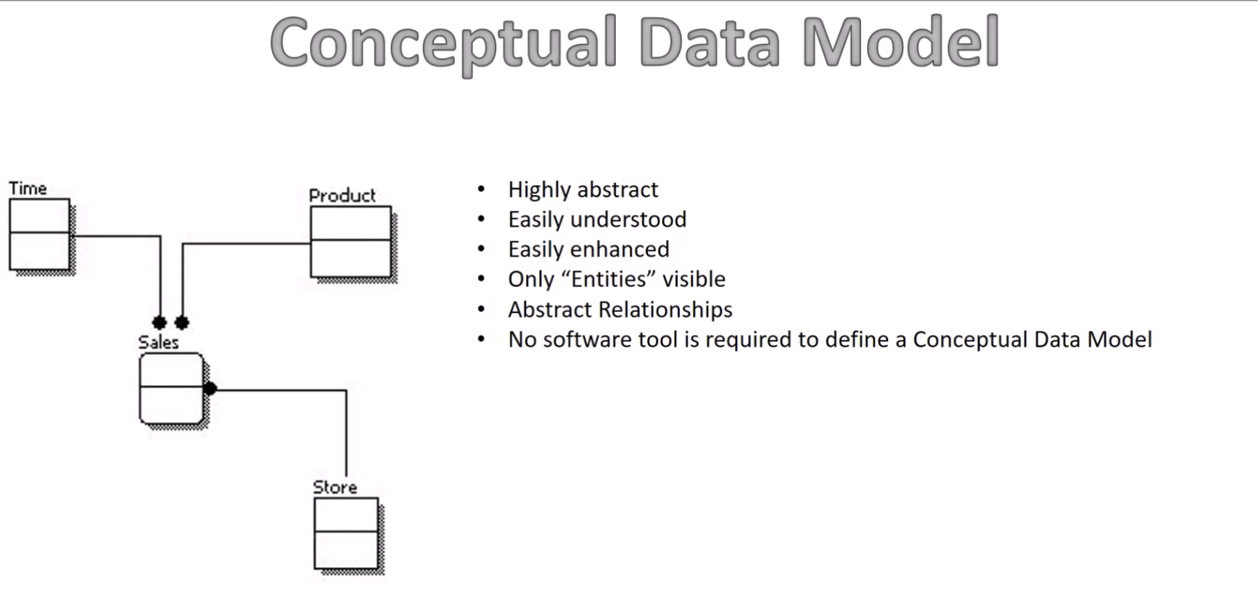

**Logical Data Model (LDM)**

Once CDM is finalized then we can start creating LDM.

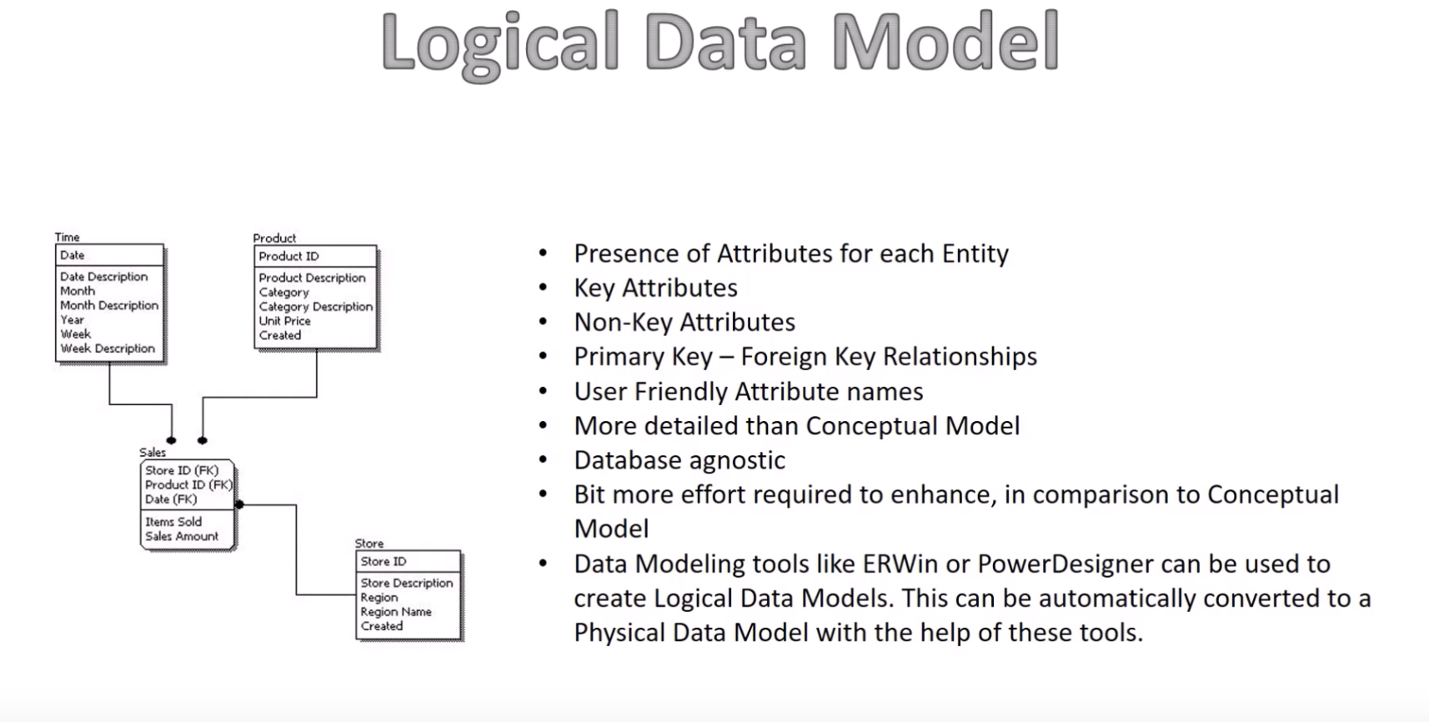

**Physical Data Model**

PDM derived from LDM.

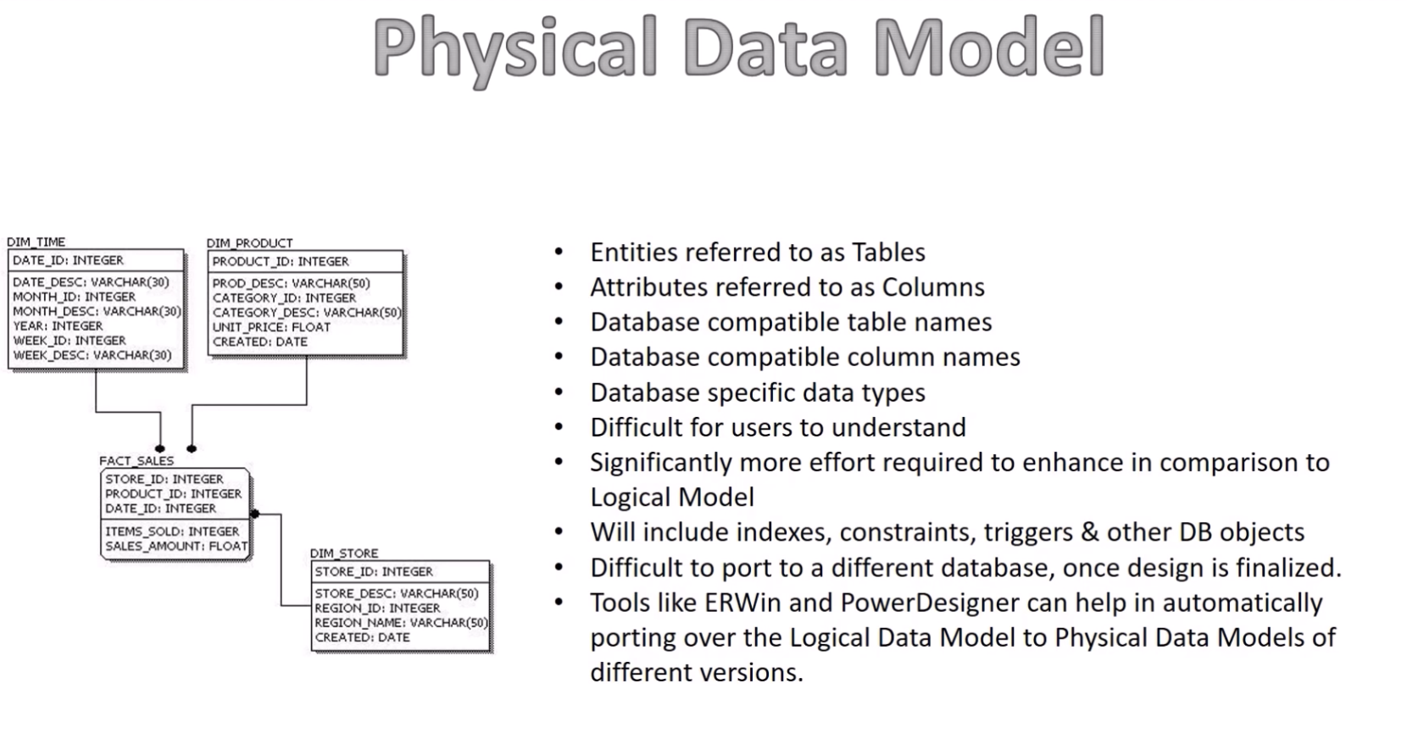

**-----------------------Android------------------**

**What happen when you move to activity A to activity B**

>> When activity A starts then Activity's -->> onCreate calls--> onStart calls-->>(onResume)-->> Activity is RUNNING

When we are moving to Activity B then Activity A is in **onPause** state and activity **B's onCreate** calls-->> onStart calls --> Now activity B is in running state.

Now if we move to activity A again then activity A's onRestart will call then again onStart -->>onResume -->> Running

**When we pass some data to activity A to activity B then whcih state of Activity A the data passed.**

>> Activity A is in onPause state.

**What are the methods available in touch events?**

**>> 3 Touch events are there**

* MotionEvent.ACTION_DOWN
* MotionEvent.ACTION_MOVE:
* MotionEvent.ACTION_UP:

@Override

public boolean onTouchEvent(MotionEvent event) {

int X = (int) event.getX();

int Y = (int) event.getY();

int eventaction = event.getAction();

switch (eventaction) {

case MotionEvent.ACTION_DOWN:

Toast.makeText(this, "ACTION_DOWN AT COORDS "+"X: "+X+" Y: "+Y, Toast.LENGTH_SHORT).show();

isTouch = true;

break;

case MotionEvent.ACTION_MOVE:

Toast.makeText(this, "MOVE "+"X: "+X+" Y: "+Y, Toast.LENGTH_SHORT).show();

break;

case MotionEvent.ACTION_UP:

Toast.makeText(this, "ACTION_UP "+"X: "+X+" Y: "+Y, Toast.LENGTH_SHORT).show();

break;

}

return true;

}

**what is the latest version spring boot**

what is dependency injection.

SOAP vs REST

In order to work with rest what are the things we need to do?

various GIT command

what is generic in java

new features in java8

why use spring and not something else

difference btn var and let

why to use super in java

what is spring boot.



What is joint cut

[What is the difference between “INNER JOIN” and “OUTER JOIN”?](https://stackoverflow.com/questions/38549/what-is-the-difference-between-inner-join-and-outer-join)

different project of spring framework

what is generic in java

new features in java8

why use spring and not something else

difference btn var and let

why to use super in java

**InOrder to use custom view what needs to be Override?**

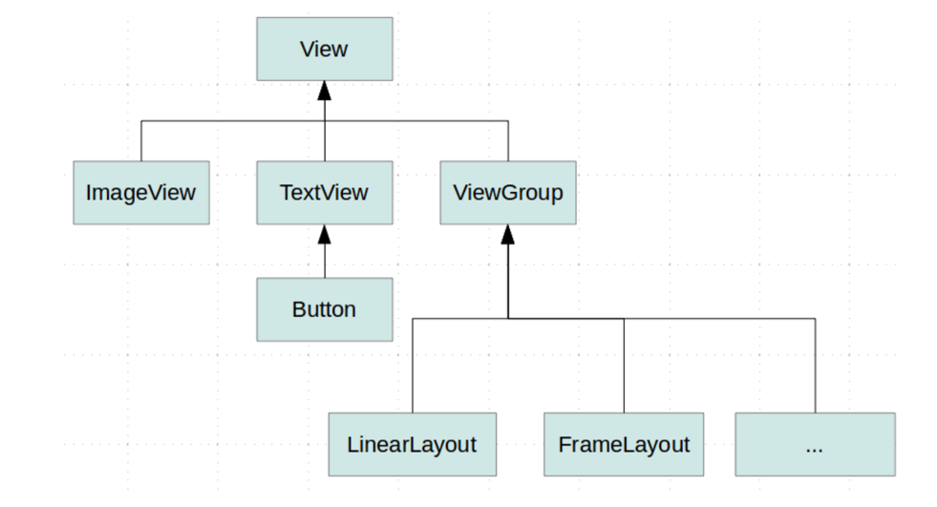

@Override

protected void onMeasure(int widthMeasureSpec, int heightMeasureSpec) {/* ... */}

@Override

protected void onDraw(Canvas canvas) {/* ... */}

**Have you use constraints?**

**Any specific framework for https call?**

Volley provides the following classes for JSON requests:

Retrofit Library

* JsonArrayRequest—A request for retrieving a [JSONArray](https://developer.android.com/reference/org/json/JSONArray.html) response body at a given URL.
* JsonObjectRequest—A request for retrieving a [JSONObject](https://developer.android.com/reference/org/json/JSONObject.html) response body at a given URL, allowing for an optional [JSONObject](https://developer.android.com/reference/org/json/JSONObject.html) to be passed in as part of the request body.

Both classes are based on the common base class JsonRequest. You use them following the same basic pattern you use for other types of requests. For example, this snippet fetches a JSON feed and displays it as text in the UI:

TextView mTxtDisplay;  
ImageView mImageView;  
mTxtDisplay = (TextView) findViewById(R.id.txtDisplay);  
String url = "http://my-json-feed";  
  
JsonObjectRequest jsObjRequest = new JsonObjectRequest  
        (Request.Method.GET, url, null, new Response.Listener<JSONObject>() {  
  
    @Override  
    public void onResponse(JSONObject response) {  
        mTxtDisplay.setText("Response: " + response.toString());  
    }  
}, new Response.ErrorListener() {  
  
    @Override  
    public void onErrorResponse(VolleyError error) {  
        // TODO Auto-generated method stub  
  
    }  
});  
  
// Access the RequestQueue through your singleton class.  
MySingleton.getInstance(this).addToRequestQueue(jsObjRequest);

**Dependency injuction in android.**

**What do you know about expresso to test android code?**

**What rebase in git?**

**1) What is broadcast receiver? how many different type of broadcast revceiver we have?**

**>>** A broadcast receiver (short receiver) is an Android component which allows you to register for system or application events. All registered receivers for an event are notified by the Android runtime once this event happens.

For example, applications can register for the ACTION_BOOT_COMPLETED system event which is fired once the Android system has completed the boot process.

 Android broadcastreceiver is also a component where you can register for system or application events. You will be notified about the events after registering. Broadcast originates from the system as well as applications. Instance for broadcast originating from the system is ‘low battery notification’. Application level is, like when you download an mp3 file, Mp3 player gets notified about it, and gets added to player list. For this action to take place, mp3 player has to register for this event. Another simple example is, users will be notified when the battery goes below certain limit as shown below;

A receiver can be registered via the *AndroidManifest.xml* file.

Alternatively to this static registration, you can also register a receiver dynamically via theContext.registerReceiver() method.

The implementing class for a receiver extends the BroadcastReceiver class.

If the event for which the broadcast receiver has registered happens, the onReceive() method of the receiver is called by the Android system.

**Manually added in manifest**

**<?xml version="1.0" encoding="utf-8"?>**

**<manifest xmlns:android="http://schemas.android.com/apk/res/android"**

**package="com.example.broadcastreceiverdemo"**

**android:versionCode="1"**

**android:versionName="1.0" >**

**<uses-sdk**

**android:minSdkVersion="8"**

**android:targetSdkVersion="16" />**

**<application**

**android:allowBackup="true"**

**android:icon="@drawable/ic_launcher"**

**android:label="@string/app_name"**

**android:theme="@style/AppTheme" >**

**<activity**

**android:name="com.example.broadcastreceiverdemo.MainActivity"**

**android:label="@string/app_name" >**

**<intent-filter>**

**<action android:name="android.intent.action.MAIN" />**

**<category android:name="android.intent.category.LAUNCHER" />**

**</intent-filter>**

**</activity>**

**<receiver android:name="BroadCastReceiver_Name" >**

**<intent-filter>**

**<action android:name="Event_Name" >**

**</action>**

**</intent-filter>**

**</receiver>**

**</application>**

**</manifest>**

**TO REGISTER THE BROADCAST RECEIVER PROGRAMMATICALLY/DYNAMICALLY**

**BroadcastReceiver mReceiver=new MyBroadcastReceiver();**

**registerReceiver(**

**this.myReceiver,**

**new IntentFilter("MyBroadcast"));**

### Security issues with Android Broadcast receivers

As of Android 3.1 android system will not receive external intents. But if you use prior versions, you have to consider following things;

* Make the broadcast receiver unavailable to the external applications using android:export=”false”. Otherwise other applications can abuse them.
* Make sure that the broadcasts you send are not received by other application. Set limitations to make the broadcast receivable only by your application.
* Similarly when registering a receiver, make sure that you are not receiving other applications’ broadcasts.

public class MyReceiver extends BroadcastReceiver {

@Override

public void onReceive(Context context, Intent intent) {

Toast.makeText(context, "Intent Detected.", Toast.LENGTH_LONG).show();

}

}

<application

android:icon="@drawable/ic_launcher"

android:label="@string/app_name"

android:theme="@style/AppTheme" >

**<receiver android:name="MyReceiver">**

**<intent-filter>**

**<action android:name="android.intent.action.BOOT_COMPLETED">**

**</action>**

**</intent-filter>**

</receiver>

</application>

|  |  |
| --- | --- |
| **Event Constant** | **Description** |
| android.intent.action.BATTERY_CHANGED | Sticky broadcast containing the charging state, level, and other information about the battery. |
| android.intent.action.BATTERY_LOW | Indicates low battery condition on the device. |
| android.intent.action.BATTERY_OKAY | Indicates the battery is now okay after being low. |
| android.intent.action.BOOT_COMPLETED | This is broadcast once, after the system has finished booting. |
| android.intent.action.BUG_REPORT | Show activity for reporting a bug. |
| android.intent.action.CALL | Perform a call to someone specified by the data. |
| android.intent.action.CALL_BUTTON | The user pressed the "call" button to go to the dialer or other appropriate UI for placing a call. |
| android.intent.action.DATE_CHANGED | The date has changed. |
| android.intent.action.REBOOT | Have the device reboot. |

**TOTALLY 3 TYPES OF BROADCAST REVCEIVERS ARE THERE.**

**Normal broadcasts , Ordered broadcasts , Sticky broadcasts**

**Normal broadcasts**:-Normal broadcasts (sent with Context.sendBroadcast) are completely **asynchronous**. All receivers of the broadcast are run in an undefined order, often at the same time. This is more efficient, but means that receivers cannot use the result or abort APIs included here.

**Ordered broadcasts** :- Ordered Broadcast is the type of broadcast which is sent in a **synchronous manner** i.e. one by one to each listener.

Android sendOrderedBroadcast method falls in Context class of Android, the purpose of this method is to broadcast to listening receivers in a serialized manner and receive the result back to the calling activity. **Another key advantage of sendOrderedBroadcast is that we can set the priority of BroadcastReceiver.** This way all the BroadcastReceivers listening to that specific broadcast will receive that specific broadcast in an ordered manner.

**Sticky broadcasts**:- **A Sticky Broadcast is a Broadcast that stays around following the moment it is announced to the system.** Most Broadcasts are sent, processed within the system and become quickly inaccessible. However, Sticky Broadcasts announce information that remains accessible beyond the point at which they are processed. **A typical example is the battery level Broadcast.** Unlike most Broadcasts, the battery level can be retrieved within applications beyond the point at which it was sent through the system. This means that apps can find out whatever the last battery level broadcast was.

**2) What is services and how many kind of services are there?**

A **service** is a component that runs in the background to perform long-running operations without needing to interact with the user and it works even if application is destroyed. A service can essentially take two states −

|  |  |
| --- | --- |
| **State** | **Description** |
| Started | A service is **started** when an application component, such as an activity, starts it by calling *startService()*. Once started, a service can run in the background indefinitely, even if the component that started it is destroyed.  Wen to use ::Started services are those that are launched by other application components like an Activity or a Broadcast Receiver. They can run indefinitely in the background until stopped or destroyed by the system to free up resources. |
| Bound | A service is **bound** when an application component binds to it by calling *bindService()*. A bound service offers a client-server interface that allows components to interact with the service, send requests, get results, and even do so across processes with interprocess communication (IPC).  Wen to use :: Started services cannot return results/values or interact with its starting component. Bound services on the other hand can send data to the launching component (client). **So for example a bound service might be playing an audio file and sending data regarding audio start/pause/stop and the time elapsed to the launching Activity component so that the UI can be updated accordingly.** |

**3) What is intent service? And broadcast intent?**

>>IntentService ([android.app.IntentService](http://j.mp/layfNr)) is a simple type of s**ervice that can be used to handle asynchronous work off the main thread by way of Intent requests**. Each intent is added to the IntentService’s queue and handled sequentially.

**IntentService is one of the simplest ways to offload “chunks” of processing off the UI thread of your application and into a remote work queue.** There’s no need to launch an AsyncTask and manage it each and every time you have more processing. Instead, you simply define your own service, package up an intent with the appropriate data you want to send for processing, and start the service. You can send data back to the application by simply broadcasting the result as an Intent object, and using a broadcast receiver to catch the result and use it within the app.

**public** **class** SimpleIntentService **extends** IntentService {

**public** **static** **final** String PARAM_IN_MSG = "imsg";

**public** **static** **final** String PARAM_OUT_MSG = "omsg";

**public** SimpleIntentService() {

**super**("SimpleIntentService");

    }

    @Override

**protected** **void** onHandleIntent(Intent intent) {

        String msg = intent.getStringExtra(PARAM_IN_MSG);

        SystemClock.sleep(30000); // 30 seconds

        String resultTxt = msg + " "

            + DateFormat.format("MM/dd/yy h:mmaa", System.currentTimeMillis());

    }

}

Intent broadcastIntent = **new** Intent();

broadcastIntent.setAction(ResponseReceiver.ACTION_RESP);

broadcastIntent.addCategory(Intent.CATEGORY_DEFAULT);

broadcastIntent.putExtra(PARAM_OUT_MSG, resultTxt);

sendBroadcast(broadcastIntent);

**public** **class** IntentServiceBasicsActivity **extends** Activity {

**private** ResponseReceiver receiver;

    @Override

**public** **void** onCreate(Bundle savedInstanceState) {

**super**.onCreate(savedInstanceState);

        setContentView(R.layout.main);

        IntentFilter filter = **new** IntentFilter(ResponseReceiver.ACTION_RESP);

        filter.addCategory(Intent.CATEGORY_DEFAULT);

        receiver = **new** ResponseReceiver();

        registerReceiver(receiver, filter);

    }

}

**BROADCASTINTENT**

>> Broadcast intents are Intent objects that are broadcast via a call to the sendBroadcast(), sendStickyBroadcast() or sendOrderedBroadcast() methods of the Activity class (the latter being used when results are required from the broadcast). In addition to providing a messaging and event system between application **components, broadcast intents are also used by the Android system to notify interested applications about key system events (such as the external power supply or headphones being connected or disconnected).**

When a broadcast intent is created, it must include an action string in addition to optional data and a category string. As with standard intents, data is added to a broadcast intent using key-value pairs in conjunction with the putExtra() method of the intent object. The optional category string may be assigned to a broadcast intent via a call to the addCategory() method.

The action string, which identifies the broadcast event, must be unique and typically uses the application’s Java package name syntax. For example, the following code fragment creates and sends a broadcast intent including a unique action string and data:

Intent intent = new Intent();

intent.setAction("com.example.Broadcast");

intent.putExtra("HighScore", 1000);

sendBroadcast(intent);

### Explain the Android application Architecture.

Following is a list of components of Android application architecture:

* **Services:** Used to perform background functionalities.
* **Intent:** Used to perform the inter connection between activities and the data passing mechanism.
* **Resource Externalization:** strings and graphics.
* **Notification:** light, sound, icon, notification, dialog box and toast.
* **Content Providers:** It will share the data between applications.

### What are the core building blocks of android?

The core building blocks of android are:

* Activity
* View
* Intent
* Service
* Content Provider
* Fragment etc.

### What is intent?

It is a kind of message or information that is passed to the components. It is used to launch an activity, display a web page, send sms, send email etc. There are two types of intents in android:

1. Implicit Intent
2. Explicit Intent

### What is implicit intent in android?

Implicit intent is used to invoke the system components.

An implicit Intent does not name a specific component. It declares a general action to perform. The action specifies the thing that the app wants to do.

Background: The system is looking for an appropriate component to start:

* If multiple components are compatible with the action, the system shows a dialog so the user can pick which app to use
* If there is no appropriate component available on the device that can handle the action, your app will crash immediately!

Example: If an app wants to trigger a phone call, it only has to specify the corresponding action (ACTION_DIAL):

**Uri number = Uri.parse("tel:4213371337");**

**Intent callIntent = new Intent(Intent.ACTION_DIAL, number);**

**if (callIntent.resolveActivity(getPackageManager()) != null) {**

**// the system can resolve the Intent**

**}**

### What is explicit intent in android?

Explicit intent is used to invoke the activity class.

An explicit Intent specifies the component by the fully-qualified class name to start. This is the common case to start a component in the own app.

Example:

Intent startIntent = new Intent(myContext, AnotherActivity.class);

### What is a Sticky Intent?

A sticky Intent is an Intent that has been sent as a sticky Broadcast, meaning the Intent stays around after the broadcast is complete.

Example: The Android system uses sticky broadcasts to notify receivers that the battery level has been changed (ACTION_BATTERY_CHANGED).

When you call registerReceiver() for that action you will always get the latest Intent for that action. You do not have to wait for the next broadcast!

**Note**: Sticky broadcasts are deprecated in Android 5+.

### What is AAPT?

AAPT is an acronym for android asset packaging tool. It handles the packaging process.

### What is content provider?

Content providers are used to share information between android applications.

### What is fragment?

Fragment is a part of Activity. By the help of fragments, we can display multiple screens on one activity.

### What is ADB?

ADB stands for Android Debug Bridge. It is a command line tool that is used to communicate with the emulator instance.

### What is NDK?

NDK stands for Native Development Kit. By using NDK, you can develop a part of app using native language such as C/C++ to boost the performance.

### What is ANR?

ANR stands for Application Not Responding. It is a dialog box that appears if the application is no longer responding.

### What is an APK format?

APK is a short form stands for Android Packaging Key. It is a compressed key with classes,UI's, supportive assets and manifest. All files are compressed to a single file is called APK.

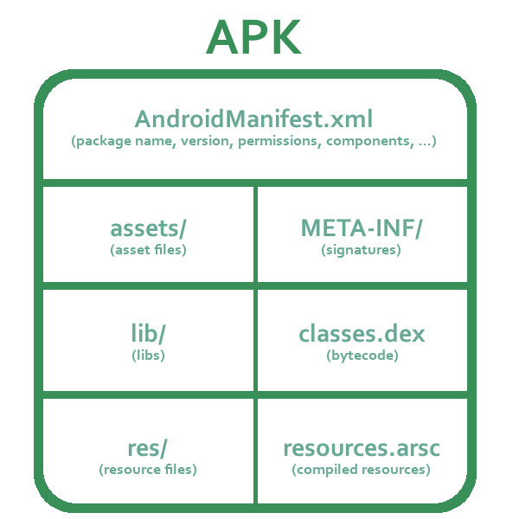

### What is Adapter in Android?

An adapter is used to create a child view to present the parent view items.

### Which types of flags are used to run an application on Android?

Following are two types of flags to run an application in Android:

* FLAG_ACTIVITY_NEW_TASK
* FLAG_ACTIVITY_CLEAR_TOP

### What is sleep mode in Android?

In sleep mode, CPU is slept and doesn't accept any commands from android device except Radio interface layer and alarm.

### Define Android Architecture?

Android architecture consists of 4 components:

1. Linux Kernal
2. Libraries
3. Android Framework
4. Android Applications

### What is the “UI thread”?

An Android app runs in its own process and can use multiple threads. The thread that the app will be executed upon, most of the time, is called the “main thread” or the “UI thread”.

### What is Instant Run?

Instant Run has the intention to increase the development speed of Android apps. Instead of rebuilding the whole app, Android is trying to patch the existing app on the Android device to reflect your changes.

### What is an Android manifest file?

Every Android app must have an AndroidManifest.xml file in its root directory. The AndroidManifest.xml file provides essential information about the application to the Android system, which the system must have before it can run any of the application’s code.

Background: It contains information about:

* the Java package of the application
* app components like activities, services, broadcast receivers and content providers
* necessary permissions

**4) What is dvm and JVM and what is the difference btn these two? what is the different architecture of it? Where does it lies in android architecture? tell me the steps**

>>**Dalvik Virtual machine (DVM) is Register Architecture, designed to run on low memory, uses its own byte code and runs .Dex file (Dalvik Executable File)**

Note: Dalvik was entirely replaced by ART in Android 5.0 Lollipop.

**>> No more DVM currently ART (Android Runtime) is used by android and which used AOT (ahead of time instead jit)**

ART performs the [translation](https://en.wikipedia.org/wiki/Translator_(computing)) of the application's [bytecode](https://en.wikipedia.org/wiki/Bytecode) into [native instructions](https://en.wikipedia.org/wiki/Native_instruction) that are later executed by the device's runtime environment.

ART improves the overall execution efficiency and reduces power consumption, which results in improved battery autonomy on [mobile devices](https://en.wikipedia.org/wiki/Mobile_device). At the same time, ART brings faster execution of applications, improved [memory allocation](https://en.wikipedia.org/wiki/Memory_allocation) and [garbage collection](https://en.wikipedia.org/wiki/Garbage_collection_(computer_science)) (GC) mechanisms, new applications [debugging](https://en.wikipedia.org/wiki/Debugging) features, and more accurate high-level profiling of applications.

Java Virtual Machine (JVM) is Stack Architecture, uses java byte code and runs .class file having JIT.

**Java  source code is compiled by the Java compiler into .class files. Then the dx (dexer) tool, part of the Android SDK processes the .class files into a proprietary file format called DEX that contains Dalvik bytecode.**

**DVM work ::Java code –compile-->>.class(it contain byte code)-->>.dex**

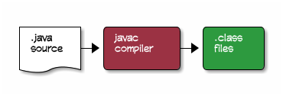

The .class files contain standard *Oracle JVM* Java byte-codes. But Android devices don’t use this byte-code format. Instead, Android has its own distinct byte-code format called *Dalvik*. Dalvik byte-codes, like *Oracle JVM* byte-codes, are machine-code instructions for a theoretical processor.

The compilation process needs to convert the .class files, and any .jar libraries into a single classes.dex file containing Dalvik byte-codes. This is done with the dx command:

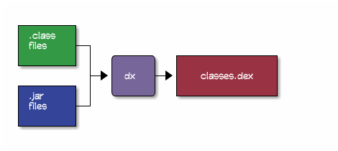

The dx command stitches all of the .class and .jar files together into a *single*classes.dex file written in Dalvik byte-code format.

**Difference between dvm & jvm**

1.    **Dalvik** is the process virtual machine (VM) in Google's Android operating system. It is the software that runs the apps on Android devices.

**2.    Dalvik is thus an integral part of Android, which is typically used on mobile devices such as mobile phones and tablet computers. Programs are commonly written in a dialect of Java and compiled to bytecode. Then they are converted from Java Virtual Machine-compatible .class files to Dalvik-compatible .dex (Dalvik Executable) files before installation on a device.**

3.    The compact Dalvik Executable format is designed to be suitable for systems that are constrained in terms of memory and processor speed.

4.    Dalvik is open-source software. It was originally written by Dan Bornstein, who named it after the fishing village of Dalvík in Eyjafjörður, Iceland, where some of his ancestors lived.

5.    A tool called dx is used to convert some (but not all) Java .class files into the .dex format. Multiple classes are included in a single .dex file.

6.      DVM is Register based which is designed to run on low memory, uses its own byte code and runs .Dex file .

7.    From Android 2.2 SDK Dalvik has got a Just in Time compiler

1. JVM is Stack based which uses java byte code and runs .class file having JIT.

**JVM vs DVM**

|  |  |  |
| --- | --- | --- |
|  | DVM | JVM |
| Architecture | Register | Stack |
| OS Support | Android | Multiple |
| Re- Tools | few | many |
| Executables | APK | JAR |
| Constant-Pool | Per Application | Per class |
| Memory | Less | More |

Dalvik is said to be a clean-room implementation rather than a development on top of a standard Java runtime, which would mean it does not inherit copyright-based license restrictions from either the standard-edition or open-source-edition Java runtimes. Dalvik is published under the Apache 2 license

.class vs dex

● In DEX all the classes of the application are packed into one file.

● All the classes in the same DEX file share field, method, etc if they are same.

● Classes from the same DEX file are loaded by the same class loader instance.

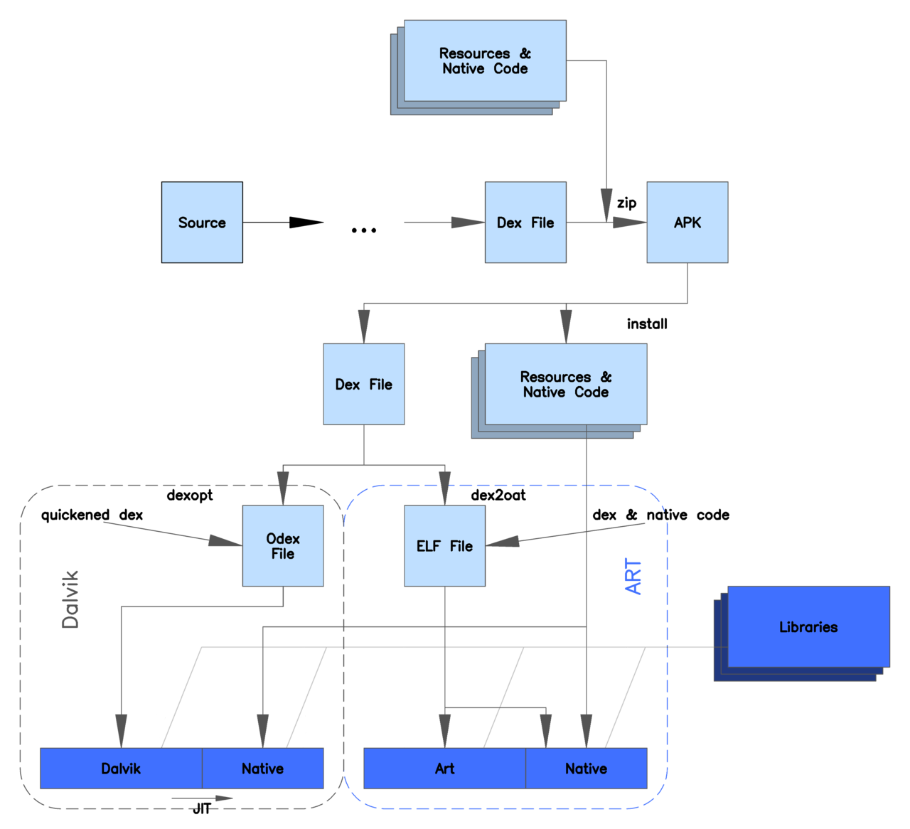

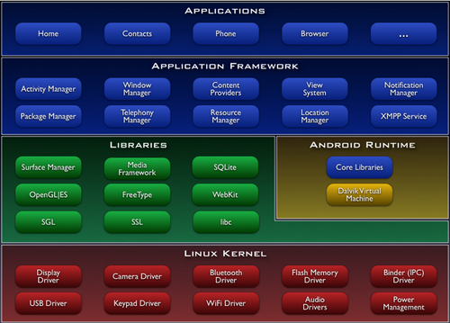

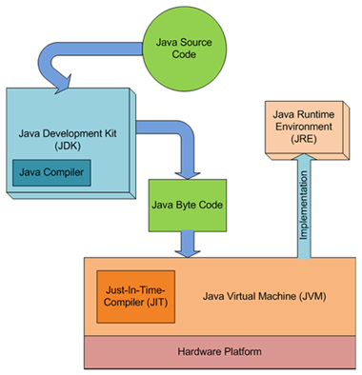

firstly java source code is converted into Bytecode file by the translator named “**Compiler**”. The byte code file gets name with .**class** extension and javac (java compiler) is the tool to compile the .java file.

Then,

java is a tool use to invoke Java Interpreter “**JVM**”. Now, the work of JVM starts. When JVM invoke,

**1.** a subprogram in JVM called **Class loader** (or system class loader) starts and load the bytecode into OS memory( or RAM).

**2.**another subprogram **Bytecode Verifier**verify and ensure that the code do not violate the security rules. That’s why the java program is much secured and virus free.

**3. T**hen last subprogram **Execution Engine**finally converts bytecodes into machine code. The name of that engine are in use today is **JIT Just In Compiler.**

**Java Source Code ----Converted by compiler to---→ >> bytecode (with extension of .class file and javac) --→ class loader of JVM loads it to OS (RAM) → Execution Engine JIT Just In Time Compiler finally converts bytecodes into machine code**

5) **What is is the difference btn thread and async task?**

>>

**In any higher programming language, there is concept of multi-tasking. Basically the user needs to run some portion of code without user interaction. A thread is generally developed for that. But in Android, multi-tasking can be done by any of the three methods Thread, Service and AsyncTask.**

**difference between Thread and AsyncTask.**

Thread  
A thread is a concurrent unit of execution. It has its own call stack. There are two methods to implement threads in applications.

1. One is providing a new class that extends Thread and overriding its run() method.
2. The other is providing a new Thread instance with a Runnable object during its creation.

A thread can be executed by calling its "start" method. You can set the "Priority" of a thread by calling its "setPriority(int)" method.  
  
A thread can be used if you have no affect in the UI part. For example, you are calling some web service or download some data, and after download, you are displaying it to your screen. Then you need to use a Handler with a Thread and this will make your application complicated to handle all the responses from Threads.  
  
A Handler allows you to send and process Message and Runnable objects associated with a thread's MessageQueue. Each thread has each message queue. (Like a To do List), and the thread will take each message and process it until the message queue is empty. So, when the Handler communicates, it just gives a message to the caller thread and it will wait to process.  
  
**If you use Java threads then you need to handle the following requirements in your own code:**

* **Synchronization with the main thread if you post back results to the user interface**
* **No default for canceling the thread**
* **No default thread pooling**
* **No default for handling configuration changes in Android**

AsyncTask  
  
AsyncTask enables proper and easy use of the UI thread. **This class allows performing background operations and publishing results on the UI thread without having to manipulate threads and/or handlers**. **An asynchronous task is defined by a computation that runs on a background thread and whose result is published on the UI thread.**  
  
AsyncTask will go through the following 4 stages:

**onPreExecute()**

Invoked on the UI thread before the task is executed

**doInbackground(Params..)**

Invoked on the background thread immediately after onPreExecute() finishes executing.

**onProgressUpdate(Progress..)**

Invoked on the UI thread after a call to publishProgress(Progress...).

**onPostExecute(Result)**

Invoked on the UI thread after the background computation finishes.

**Why should you use AsyncTask?**

**Easy to use for a UI Thread. (So, use it when the caller thread is a UI thread).**

**No need to manipulate Handlers.**

|  |  |  |  |  |
| --- | --- | --- | --- | --- |
|  | **Service** | **Thread** | **IntentService** | **AsyncTask** |
| **When to use ?** | Task with no UI, but shouldn't be too long. Use threads within service for long tasks. | - Long task in general.  - For tasks in parallel use Multiple threads (traditional mechanisms) | - Long task **usually** with no communication to main thread. **(Update)**- If communication is required, can use main thread handler or broadcast intents  - When callbacks are needed (Intent triggered tasks). | - Small task having to communicate with main thread.  - For tasks in parallel use multiple instances OR Executor |
| **Trigger** | Call to method onStartService() | Thread start() method | Intent | Call to method execute() |
| **Triggered From (thread)** | Any thread | Any Thread | Main Thread (Intent is received on main thread and then worker thread is spawed) | Main Thread |
| **Runs On (thread)** | Main Thread | Its own thread | Separate worker thread | Worker thread. However, Main thread methods may be invoked in between to publish progress. |
| **Limitations /** **Drawbacks** | May block main thread | - Manual thread management  - Code may become difficult to read | - Cannot run tasks in parallel.  - Multiple intents are queued on the same worker thread. | - one instance can only be executed once (hence cannot run in a loop)   - Must be created and executed from the Main thread |

Why should you use AsyncTask?

1. Easy to use for a UI Thread. (So, use it when the caller thread is a UI thread).
2. No need to manipulate Handlers.

Example

1. **private** **class** DownloadImageTask **extends** AsyncTask<String, Void, Bitmap> {
3. ImageView bmImage;
5. ProgressDialog pd;
7. Context mContext;
9. **public** DownloadImageTask(Context context,ImageView bmImage) {
11. **this**.bmImage = bmImage;
13. mContext = context;
15. }
17. **public** **void** onPreExecute() {
19. pd = ProgressDialog.show(mContext, "Downloading","Downloading..Please Wait", **true**);
21. }
23. **public** **void** onPostExecute(Bitmap result) {
25. pd.dismiss();
27. **if**(result!=**null**){
28. bmImage.setImageBitmap(result);
29. }
30. }
31. **protected** Bitmap doInBackground(String... urls) {
32. String urldisplay = urls[0];
33. Bitmap bitmap = **null**;
34. **try** {
35. InputStream in = **new** java.net.URL(urldisplay).openStream();
36. bitmap = BitmapFactory.decodeStream(in);
37. } **catch** (Exception e) {
38. Log.e("Error", e.getMessage());
39. e.printStackTrace();
40. }
41. **return** bitmap;
42. }
43. }

You can see that, before starting background work, the progress dialog is shown to the user and after completion of background work the progress dialog is dismissed in "onPostExecute". So you can do UI changes in the same class implementation without using Handler and message passing.  
  
To use this class, you need to write the following line:

1. **new** DownloadImageTask (Activity.**this**, sourceImageView).execute(url1);

Thread Handlers

Clearly one of the key rules of application development is never to perform time-consuming operations on the main thread of an application. The second, equally important rule is that the code within a separate thread must never, under any circumstances, directly update any aspect of the user interface. Any changes to the user interface must always be performed from within the main thread. The reason for this is that the Android UI toolkit is not thread-safe. Attempts to work with non thread-safe code from within multiple threads will typically result in intermittent problems and unpredictable application behavior.

In the event that the code executing in a thread needs to interact with the user interface, it must do so by synchronizing with the main UI thread. This is achieved by creating a handler within the main thread, which, in turn, receives messages from another thread and updates the user interface accordingly.

<http://www.techotopia.com/index.php/A_Basic_Overview_of_Android_Threads_and_Thread_handlers>

6) **Can we use thread instead of asynctask? what is the disadvantage of thread in android over async task?**

>>Yes

7) **I will give you a thread can you make it async task? if yes how? if no y?**

>> Yes

**8) tell the steps to remove async task and put a thread instead.**

9) Can i call one thread from asynctask(yes)? And can i call one asynctask from thread? can i call one asynctask from another asynctask? (Yes, but only inside onProgressUpdate() or onPostExecute() since these methods runs on the UI thread. Therefore, start the second AsyncTask on the UI thread by choosing one of the two methods listed above.)

10) **Have you used service?**

**>>****Services in Android is a component that runs in the background without any user interaction or interface. Unlike Activities services does not have any graphical interface. Services run invisibly performing long running tasks - doing Internet look ups, playing music, triggering notifications etc.,**

**Services run with a higher priority than inactive or invisible activities and therefore it is less likely that the Android system terminates them for resource management. The only reason Android will stop a Service prematurely is to provide additional resources for a foreground component usually an Activity. When this happens, your Service can be configured to restart automatically.**

**Creating a Service**

               Create a new class that extends Service. Below is the code snippet.

**import** **android.app.Service**;

**import** **android.content.Intent**;

**import** **android.os.IBinder**;

**public** **class** **MyService** **extends** Service {

**public** **void** **onCreate**() {

**super**.onCreate();

// This method is invoked when the service is called.

}

**public** IBinder **onBind**() {

**super**.onCreate();

// A client or activity is binded to service

}

}

**Services takes Two Forms**

**Started**

         A Service is started when a application component such as an activity invokes it by calling startService(). Once started, a service can run in the background indefinitely, even if the component that started it is destroyed

**Bound**

**A service is "bound" when an application component binds to it by calling bindService(). A bound service offers a client-server interface that allows components to interact with the service, send requests, get results, and even do so across processes with inter-process communication.**  
  
**Add the service to *AndroidManifest.xml***  
              Last but not the least, don't miss to add your service to android manifest file. If you don't add this service to manifest, you will not get any errors as well output.

**import** **android.os.Bundle**;

**import** **android.app.Activity**;

**import** **android.content.Intent**;

**import** **android.view.Menu**;

**import** **android.view.View**;

**public** **class** **MainActivity** **extends** Activity {

**@Override**

**protected** **void** **onCreate**(Bundle savedInstanceState) {

**super**.onCreate(savedInstanceState);

setContentView(R.layout.activity_main);

}

// Start the service

**public** **void** **startService**(View view) {

startService(**new** Intent(**this**, MyService.class));

}

// Stop the service

**public** **void** **stopService**(View view) {

stopService(**new** Intent(**this**, MyService.class));

}

**@Override**

**public** **boolean** **onCreateOptionsMenu**(Menu menu) {

getMenuInflater().inflate(R.menu.activity_main, menu);

**return** **true**;

}

}

**MyService.java**

**import** **android.app.Service**;

**import** **android.content.Intent**;

**import** **android.os.IBinder**;

**import** **android.widget.Toast**;

**public** **class** **MyService** **extends** Service {

**public** **MyService**() {

}

**@Override**

**public** IBinder **onBind**(Intent intent) {

**throw** **new** **UnsupportedOperationException**("Not yet implemented");

}

**@Override**

**public** **void** **onCreate**() {

Toast.makeText(**this**, "Service was Created", Toast.LENGTH_LONG).show();

}

**@Override**

**public** **void** **onStart**(Intent intent, **int** startId) {

// Perform your long running operations here.

Toast.makeText(**this**, "Service Started", Toast.LENGTH_LONG).show();

}

**@Override**

**public** **void** **onDestroy**() {

Toast.makeText(**this**, "Service Destroyed", Toast.LENGTH_LONG).show();

}

}

**AndroidManifest.xml**

<?xml version="1.0" encoding="utf-8"?>

<manifest xmlns:android="http://schemas.android.com/apk/res/android"

package="com.example.androidservice"

android:versionCode="1"

android:versionName="1.0" >

<uses-sdk

android:minSdkVersion="8"

android:targetSdkVersion="16" />

<application

android:allowBackup="true"

android:icon="@drawable/ic_launcher"

android:label="@string/app_name"

android:theme="@style/AppTheme" >

<activity

android:name="com.example.androidservice.MainActivity"

android:label="@string/app_name" >

<intent-filter>

<action android:name="android.intent.action.MAIN" />

<category android:name="android.intent.category.LAUNCHER" />

</intent-filter>

</activity>

**<service**

**android:name=".MyService"**

**android:enabled="true" />**

**</application>**

</manifest>

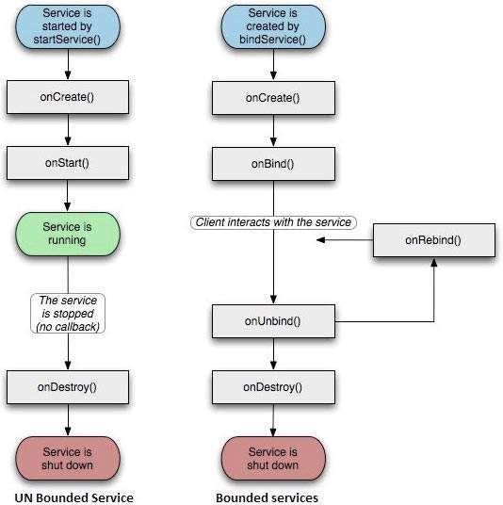

To create an service, you create a Java class that extends the Service base class or one of its existing subclasses. The **Service** base class defines various callback methods and the most important are given below. You don't need to implement all the callbacks methods. However, it's important that you understand each one and implement those that ensure your app behaves the way users expect.

|  |  |
| --- | --- |
| **Callback** | **Description** |
| onStartCommand() | The system calls this method when another component, such as an activity, requests that the service be started, by calling *startService()*. If you implement this method, it is your responsibility to stop the service when its work is done, by calling *stopSelf()* or *stopService()* methods. |
| onBind() | The system calls this method when another component wants to bind with the service by calling *bindService()*. If you implement this method, you must provide an interface that clients use to communicate with the service, by returning an***IBinder* object.** You must always implement this method, but if you don't want to allow binding, then you should return *null*. |
| onUnbind() | The system calls this method when all clients have disconnected from a particular interface published by the service. |
| onRebind() | The system calls this method when new clients have connected to the service, after it had previously been notified that all had disconnected in its *onUnbind(Intent)*. |
| onCreate() | The system calls this method when the service is first created using *onStartCommand()* or *onBind()*. This call is required to perform one-time set-up. |
| onDestroy() | The system calls this method when the service is no longer used and is being destroyed. Your service should implement this to clean up any resources such as threads, registered listeners, receivers, etc. |

public class LocalService extends Service {

    // Binder given to clients

    private final IBinder mBinder = new LocalBinder();

    // Random number generator

    private final Random mGenerator = new Random();

    /**

     * Class used for the client Binder.  Because we know this service always

     * runs in the same process as its clients, we don't need to deal with IPC.

     */

    public class LocalBinder extends Binder {

        LocalService getService() {

            // Return this instance of LocalService so clients can call public methods

            return LocalService.this;

        }

    }

    @Override

    public IBinder onBind(Intent intent) {

        return mBinder;

    }

    /** method for clients */

    public int getRandomNumber() {

      return mGenerator.nextInt(100);

    }

}

11) **have you used material design?**

>> You might have heard of android Material Design which was introduced in Android Lollipop version. In Material Design lot of new things were introduced like **Material Theme**, new **widgets**, **custom shadows**, **vector drawables** and custom **animations**. If you haven’t working on Material Design yet, this article will give you a good start.

In this tutorial we are going to learn the basic steps of Material Design development i.e writing the custom theme and implementing the navigation drawer using the RecyclerView.

--------------------------------------------------------------------------------

12) **Basic component of android.. name few of them.**

>>

|  |  |
| --- | --- |
| **Components** | **Description** |
| Activities | They dictate the UI and handle the user interaction to the smart phone screen |
| Services | They handle background processing associated with an application. |
| Broadcast Receivers | They handle communication between Android OS and applications. |
| Content Providers | They handle data and database management issues. |

|  |  |
| --- | --- |
| **Components** | **Description** |
| Fragments | Represents a portion of user interface in an Activity. |
| Views | UI elements that are drawn on-screen including buttons, lists forms etc. |
| Layouts | View hierarchies that control screen format and appearance of the views. |
| Intents | Messages wiring components together. |
| Resources | External elements, such as strings, constants and drawable pictures. |
| Manifest | Configuration file for the application. |

**13) What is activity.**

**14) Even if you have activity then also you need fragment, is it?**

>> Create an Activity only if it's absolutely absolutely required. With the backstack made available for committing bunch of fragment transactions, I try to create as minimum of Activities in my app as possible. Also, communicating between various fragments is much easier rather than sending data back and forth between activities.

Activity transitions are expensive, right? At least I believe so - since the old activity as to be destroyed/paused/stopped, pushed onto the stack and then the new activity has to be created/started/resumed.

15) What is the way to add screen in activity.

16) what is activity lifecycle?

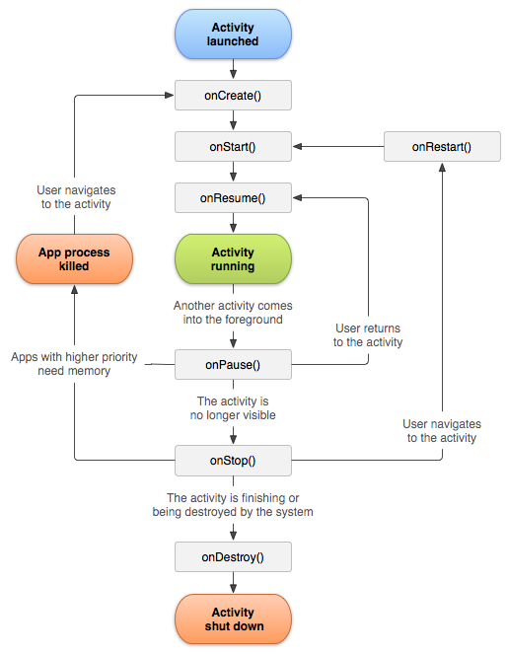

17) Tell me one scenario when activity onRestart will be called.

18) If we navigate from activity a to activity b what wil be the call of this lifecycle method?

19) What id the use of intent?

**20) Do you know about fragment?**

**21) How can we add fragment in a layout and its respective class?**

**>> We can add fragment in on create with layout infleater.**

public static class ExampleFragment extends Fragment {  
    @Override  
    public View onCreateView(LayoutInflater inflater, ViewGroup container,  
                             Bundle savedInstanceState) {  
        // Inflate the layout for this fragment  
        return inflater.inflate(R.layout.example_fragment, container, false);  
    }  
}

**22) how can we pass data with fragment?**

**>> Best way is to use bundle**

Fragment A:

Bundle b = new Bundle();

b.putString("Key", "YourValue");

b.putInt("YourKey", 1);

FragmentB fragB = new FragmentB();

fragB.setArguments(b);

getFragmentManager().beginTransaction().replace(R.id.your_container, fragB);

Fragment B:

Bundle b = this.getArguments();

if(b != null){

int i = b.getInt("YourKey");

String s =b.getString("Key");

}

**Other way also we can achieve it and those are.**

1.Use BroadCastReceiver (a little complicated)

2.Use SharePreference

3.save data into MyApplication extends Application

Other informations.

**step 1**.to send data from fragment to activity

Intent intent = new Intent(getActivity().getBaseContext(),

TargetActivity.class);

intent.putExtra("message", message);

getActivity().startActivity(intent);

**step 2**.to receive this data in Activity:

Intent intent = getIntent();

String message = intent.getStringExtra("message");

**step 3**. to send data from activity to another activity follow normal approach

Intent intent = new Intent(MainActivity.this,

TargetActivity.class);

intent.putExtra("message", message);

startActivity(intent);

**step 4** to receive this data in activity

Intent intent = getIntent();

String message = intent.getStringExtra("message");

**Step 5.** From Activity you can send data to Fragment with intent as:

Bundle bundle=new Bundle();

bundle.putString("message", "From Activity");

//set Fragmentclass Arguments

Fragmentclass fragobj=new Fragmentclass();

fragobj.setArguments(bundle);

and to receive in fragment in Fragment onCreateView method:

@Override

public View onCreateView(LayoutInflater inflater, ViewGroup container,

Bundle savedInstanceState) {

String strtext=getArguments().getString("message");

return inflater.inflate(R.layout.fragment, container, false);

}

**23) How will you achieve this.**

**you have a list fragment and details fragment and once you tap on the list fragment you go to the respective details fragment of it.(on the same screen)**

24) What is manifest file?

25) What is the use of min sdk , max sdk and target sdk?

26) What id backword compatibility in android.

27) If you are running the application in tablet or fone how do you check the device?

public static boolean isTablet(Context context) {

return (context.getResources().getConfiguration().screenLayout

& Configuration.SCREENLAYOUT_SIZE_MASK)

>= Configuration.SCREENLAYOUT_SIZE_LARGE;

}

**You can also try this**  
Add **boolean** parameter in resource file.  
in res/values/dimen.xml file add this line

<bool name="isTab">false</bool>

while in res/values-sw600dp/dimen.xml file add this line:

<bool name="isTab">true</bool>

then in your java file get this value:

if(getResources().getBoolean(R.bool.isTab)) {

System.out.println("tablet");

} else {

System.out.println("mobile");

}

28) Push notification... what all we need to do to receieve a message?(in android what we needto do?)

### Step 1: Add the Dependencies to configure GCM

groovy classpath 'com.google.gms:google-services:1.5.0'

### Step 2: Update the Manifest

Inside the project’s **AndroidManifest.xml** file, create and use a custom **C2D_MESSAGE** permission based on your project’s package name. Make sure that the protectionLevel of the permission is set to **signature**.

## Step 3. Get a Server API Key and a Sender ID

### Step 4. Create a Registration Service

### java public class RegistrationService extends IntentService { public RegistrationService() { super(“RegistrationService”); }

### Handle your stuff in onHandle.

### @Override

### protected void onHandleIntent(Intent intent) { } } `

### Step 5. Register the service in manifest.

29) methods of async task

>>**What is AsyncTask?**

               AsyncTask is an abstract class provided by Android which helps us to use the UI thread properly. This class allows us to perform long/background operations and show its result on the UI thread without having to manipulate threads.

**When-to-use-AsyncTask?**  
            Android implements single thread model and whenever an android application is launched, a thread is created. Assuming we are doing network operation on a button click in our application. On button click a request would be made to the server and response will be awaited. Due to single thread model of android, till the time response is awaited our screen is non-responsive. So we should avoid performing long running operations on the UI thread. This includes file and network access.

            To overcome this we can create new thread and implement run method to perform this network call, so UI remains responsive.

            But since Android follows single thread model and Android UI toolkit is not thread safe, so if there is a need to make some change to the UI based on the result of the operation performed, then this approach may lead some issues.

So the Android framework has given a very good pattern which is enveloped into AsyncTask.

***Note:****AsyncTask should ideally be used for operations that take few seconds. Some tasks keep the thread running for long time so in that case it is recommended to use java.util.concurrent package such as Executor, ThreadPoolExecutor and FutureTask.*

### AsyncTask has four steps:

1. **doInBackground:**Code performing long running operation goes in this method.  When onClick method is executed on click of button, it calls execute method which accepts parameters and automatically calls doInBackground method with the parameters passed.
2. **onPostExecute:**This method is called after doInBackground method completes processing. Result from doInBackground is passed to this method.
3. **onPreExecute:**This method is called before doInBackground method is called.
4. **onProgressUpdate:** This method is invoked by calling publishProgress anytime from doInBackground call this method.

The task can be cancelled by invoking cancel(boolean) method. This will cause subsequent calls to **isCancelled()**to return true. After invoking this method, **onCancelled(Object)**method is called instead of onPostExecute() after doInBackground() returns.

**package** com.example.asynctaskdemo;

**import** **android.app.Activity**;

**import** **android.os.AsyncTask**;

**import** **android.os.Bundle**;

**import** **android.view.Menu**;

**import** **android.view.View**;

**import** **android.widget.Button**;

**import** **android.widget.EditText**;

**import** **android.widget.TextView**;

/**

* @author Prabu

* AsyncTask exmple

*

*/

**public** **class** **MainActivity** **extends** Activity {

**private** Button button;

**private** EditText time;

**private** TextView finalResult;

**@Override**

**protected** **void** **onCreate**(Bundle savedInstanceState) {

**super**.onCreate(savedInstanceState);

setContentView(R.layout.activity_main);

time = (EditText) findViewById(R.id.et_time);

button = (Button) findViewById(R.id.btn_do_it);

finalResult = (TextView) findViewById(R.id.tv_result);

button.setOnClickListener(**new** View.OnClickListener() {

**@Override**

**public** **void** **onClick**(View v) {

AsyncTaskRunner runner = **new** AsyncTaskRunner();

String sleepTime = time.getText().toString();

runner.execute(sleepTime);

}

});

}

**@Override**

**public** **boolean** **onCreateOptionsMenu**(Menu menu) {

// Inflate the menu; this adds items to the action bar if it is present.

getMenuInflater().inflate(R.menu.activity_main, menu);

**return** **true**;

}

/**

* @author Prabu

* Private class which runs the long operation. ( Sleeping for some time )

*/

**private** **class** **AsyncTaskRunner** **extends** AsyncTask<String, String, String> {

**private** String resp;

**@Override**

**protected** String **doInBackground**(String... params) {

publishProgress("Sleeping..."); // Calls onProgressUpdate()

**try** {

// Do your long operations here and return the result

**int** time = Integer.parseInt(params[**0**]);

// Sleeping for given time period

Thread.sleep(time);

resp = "Slept for " + time + " milliseconds";

} **catch** (InterruptedException e) {

e.printStackTrace();

resp = e.getMessage();

} **catch** (Exception e) {

e.printStackTrace();

resp = e.getMessage();

}

**return** resp;

}

/*

* (non-Javadoc)

*

* @see android.os.AsyncTask#onPostExecute(java.lang.Object)

*/

**@Override**

**protected** **void** **onPostExecute**(String result) {

// execution of result of Long time consuming operation

finalResult.setText(result);

}

/*

* (non-Javadoc)

*

* @see android.os.AsyncTask#onPreExecute()

*/

**@Override**

**protected** **void** **onPreExecute**() {

// Things to be done before execution of long running operation. For

// example showing ProgessDialog

}

/*

* (non-Javadoc)

*

* @see android.os.AsyncTask#onProgressUpdate(Progress[])

*/

**@Override**

**protected** **void** **onProgressUpdate**(String... text) {

finalResult.setText(text[**0**]);

// Things to be done while execution of long running operation is in

// progress. For example updating ProgessDialog

}

}

}

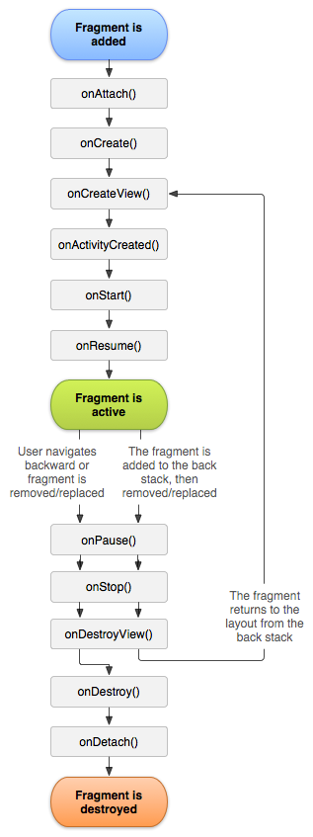

Fragment

Here is the list of methods which you can to override in your fragment class −

* **onAttach()**The fragment instance is associated with an activity instance.The fragment and the activity is not fully initialized. Typically you get in this method a reference to the activity which uses the fragment for further initialization work.
* **onCreate()** The system calls this method when creating the fragment. You should initialize essential components of the fragment that you want to retain when the fragment is paused or stopped, then resumed.
* **onCreateView()** The system calls this callback when it's time for the fragment to draw its user interface for the first time. To draw a UI for your fragment, you must return a **View** component from this method that is the root of your fragment's layout. You can return null if the fragment does not provide a UI.
* **onActivityCreated()**The onActivityCreated() is called after the onCreateView() method when the host activity is created. Activity and fragment instance have been created as well as the view hierarchy of the activity. At this point, view can be accessed with the findViewById() method. example. In this method you can instantiate objects which require a Context object
* **onStart()**The onStart() method is called once the fragment gets visible.
* **onResume()**Fragment becomes active.
* **onPause()** The system calls this method as the first indication that the user is leaving the fragment. This is usually where you should commit any changes that should be persisted beyond the current user session.
* **onStop()**Fragment going to be stopped by calling onStop()
* **onDestroyView()**Fragment view will destroy after call this method
* **onDestroy()**onDestroy() called to do final clean up of the fragment's state but Not guaranteed to be called by the Android platform.

Sample code https://www.learn2crack.com/2014/05/android-working-with-fragments.html

**Content provider**

>>http://www.compiletimeerror.com/2013/12/content-provider-in-android.html#.Vsi0SR94uAM

A content provider presents data to external applications as one or more tables that are similar to the tables found in a relational database.

Content providers are one of the primary building blocks of Android applications, providing content to applications. They encapsulate data and provide it to applications through the **single**[**ContentResolver**](https://developer.android.com/reference/android/content/ContentResolver.html)**interface**. A content provider is only required if you need to share data between multiple applications. For example, the contacts data is used by multiple applications and must be stored in a content provider. If you don't need to share data amongst multiple applications you can use a database directly via [SQLiteDatabase](https://developer.android.com/reference/android/database/sqlite/SQLiteDatabase.html).

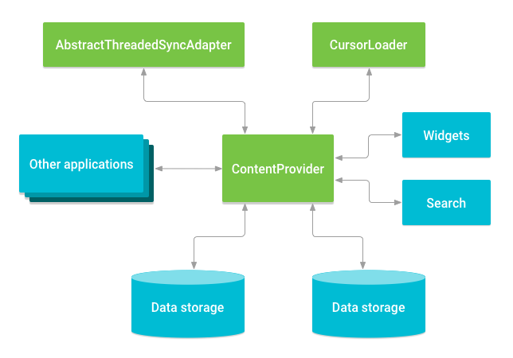

%%%%%%%%%%%%%%%%%%%%%%%%%%%%%%%%%%%%%%%%%%%%%%%%%%%%%%%%%%%%%%%%%%% %%%%%%%%%%%%%%%%%%%%%%%%%%%%%%%%%%%%%%%%%%%%%%%%%%%%%%%%%%%%%%%%%%%%%%%%%%%%%%%%%%%%--from office-----%%%%%%%%%%%%%%%%%%%%%%%%%%%%%%%%%%%%%%%%%%%%%%%%%%%%%%%%%%%%%%%%%%%%%%%%%%%%%%%%%%%%%%%%%%%%%%%%%%%%%%%%%%%%%%%%%%%%%%%%%%%%%%%%%%%%%%%%%%%%%%%%%%%%%%%%%%%%%%%%%%%%%%%%%%%%%%%%

**Configuration.java**

>> here all the configuration is being declared like

-- which server needs to use whether QA,QA+1, pilot or production.

--  keepAliveSessionActive

-- Log enable or not.

-- If we need to add any new module then its need to be added here in this class.

-- Here we need to give the entry point of another module.

??? - y are they FLAG_CLEAR_HISTORY using again & again

>> BaseContainer.java.

-- wr is the setContant view??

**************

-For any reusable component we can extend CustomVMC. CustomVMC is an abstract class where we can declare some methods.

-CustomVMC extends baseVMC

-base vmc is extended by all VMC classes. It will register and unregister the

 VMC to SDKEventBus and listens for ShellEvent. To listen the event, implement

  onEvent(ShellEvent) method. Whenever ShellEvent is posted to EventBus, Vmc's

  onEvent method will be invoked.

When VMC is inside an Activity that is not visible anymore, by default the VMC stops listening to events.

As soon as the Activity becomes visible again, VMC starts listening to events again.

If you need that VMC always listen to events, even when the Activity is not visible, you need to explicitelly call this method (alwaysListen) with the argument TRUE.

>>>**SDKEventBus is a medium for module to module communication. All module should**

**\* post ShellEvent this SDKEventBus. In turn, it will notify the ENE about the**

**\* event.**

###################################

/**

 * **Core Hook class which maintains all the instances of the Hooks present Shell.**

 *

 * Developer can get the various Hooks by calling Hook.getInstance().get&ltHookName&gt.

 *

 * Developer should set all the Hooks in LauncherApplication like below.

 * @deprecated Since version 3.1.3.20. Use {@link com.bnppf.ssc.imb.sf.shell.sdk.hook.HookFactory} instead.

 */***********************************************

**DSLManager.java it is a data sharing layer.**

## What are the functionality shell has given? what you have used in your project.

#### How to configure sonarquebe & jenkins

#### Design pattern of android

**A design pattern is just a convenient way of reusing object oriented code between projects and programmers.**

**Design pattern devides into 3 types.**

-- creation @ create objects for you rather than you are having to instantiate objects directly. Program gains more flexibility on which objects needs to be created for given use case.

-- Structural @ Help you to compose groups of objects  in to larger structure such as complex user interface and accounting data.

-- Behavioral pattern @ help you to define the communication between objects in your system and how the flow will controll in a complex progam.

**The most common design pattern in Android :: MVC, KMVP , MVVM( Model view-view model)**

http://www.slideshare.net/jkumarr/design-pattern-in-android

|  |  |  |  |  |  |  |  |  |  |  |  |  |  |  |  |  |  |  |  |  |  |  |  |  |  |  |  |  |  |  |  |  |  |  |  |  |  |  |  |  |
| --- | --- | --- | --- | --- | --- | --- | --- | --- | --- | --- | --- | --- | --- | --- | --- | --- | --- | --- | --- | --- | --- | --- | --- | --- | --- | --- | --- | --- | --- | --- | --- | --- | --- | --- | --- | --- | --- | --- | --- | --- |
| accepted | I tried using both the Model-View-Control and Model-View-Presenter design patterns for doing android development. My findings are Model-View-Control works fine, but there is a couple of "issues". It all comes down to how you perceive android Activity class. Is it a controller, or is it a view?  The actual Activity class doesn't extend android's View class, but it does, however, handle displaying a window to the user and also handle the events of that window (onCreate, onPause etc).  This means, that when you are using a MVC pattern, your controller will actually be a pseudo View-Controller. Since it is handling displaying a window to the user, with the additional view components you have added to it with setContentView, and also handling events for atleast the various activity life cycle events.  In MVC, the controller is supposed to be the main entry point. Which is a bit debatable if this is the case when applying it to android development, since the activity is the natural entry point of most applications.  Because of this, i personall find that the **Model-View-Presenter** pattern is a perfect fit for android development. Since the Views role in this pattern are:   * serving as a entry point * rendering components * routing user events to the presenter   This allows you to implement your model like so:  **View** - this contains your UI components, and handles events for them.  **Presenter** - this will handle communication between your model and your view, look at it as a gateway to your model. Meaning, if you have a complex domain model representing, God know what, and your view only needs a very small subset of this model, the presenters job is to query the model and then update the view. For example, if you have a model containing a paragraph of text, a headline and a word-count. But in a given view, you only need to display the headline in the view. Then the presenter will read the data needed from the model, and update the view accordingly.  **Model** - this should basically be your full domain model, hopefully it will help making your domain model more "tight" as well, since you wont need special methods to deal with cases as mentioned above.  By decoupling the model from the View all together (through use of the presenter), it also becomes much more intuitive to test your model. You can have unit test for your domain model, and unit test for your presenters.  Try it out, I personally find it a great fit for android development.  http://www.slideshare.net/PedroVicenteGmezSnch/software-design-patterns-on-android  Android design principle :: Let me make it mine, Simplefy my life, keep it brief, I should always know where i am, Never loose my stuff, It should look the same it should act the same, Only interrupt me if its required, Make important things fast,  ** Application branding , cards UI, Navigation draw, Action bar, Tabs,  >>>>>>>>>>>>>>>>>>>>>>>>>>>>>>>>>>>>>>>>>>>>>>>>>>>>>>>>>>  Multiple screen design   * A set of six generalized **densities**:   + *ldpi* (low) ~120dpi   + *mdpi* (medium) ~160dpi   + *hdpi* (high) ~240dpi   + *xhdpi* (extra-high) ~320dpi   + *xxhdpi* (extra-extra-high) ~480dpi   + *xxxhdpi* (extra-extra-extra-high) ~640dpi   Each genera  **As you design your UI for different screen sizes, you'll discover that each design requires a minimum amount of space. So, each generalized screen size above has an associated minimum resolution that's defined by the system. These minimum sizes are in "dp" units—the same units you should use when defining your layouts—which allows the system to avoid worrying about changes in screen density.**   * *xlarge* screens are at least 960dp x 720dp * *large* screens are at least 640dp x 480dp * *normal* screens are at least 470dp x 320dp * *small* screens are at least 426dp x 320dp   **How to Support Multiple Screens**  **Explicitly declare in the manifest which screen sizes your application supports**  By declaring which screen sizes your application supports, you can ensure that only devices with the screens you support can download your application. Declaring support for different screen sizes can also affect how the system draws your application on larger screens—specifically, whether your application runs in screen compatibility mode.  To declare the screen sizes your application supports, you should include the <supports-screens> element in your manifest file.  **Provide different bitmap drawables for different screen densities**  The [configuration qualifiers](http://developer.android.com/guide/practices/screens_support.html#_blank) (described in detail below) that you can use for density-specific resources areldpi (low), mdpi (medium), hdpi (high), xhdpi extra-high), xxhdpi (extra-extra-high), and xxxhdpi(extra-extra-extra-high). For example, bitmaps for high-density screens should go in drawable-hdpi/   |  |  |  | | --- | --- | --- | | Screen characteristic | Qualifier | Description | | Size | small | Resources for *small* size screens. | | normal | Resources for *normal* size screens. (This is the baseline size.) | | large | Resources for *large* size screens. | | xlarge | Resources for *extra-large* size screens. | | Density | ldpi | Resources for low-density (*ldpi*) screens (~120dpi). | | mdpi | Resources for medium-density (*mdpi*) screens (~160dpi). (This is the baseline density.) | | hdpi | Resources for high-density (*hdpi*) screens (~240dpi). | | xhdpi | Resources for extra-high-density (*xhdpi*) screens (~320dpi). | | xxhdpi | Resources for extra-extra-high-density (*xxhdpi*) screens (~480dpi). | | xxxhdpi | Resources for extra-extra-extra-high-density (*xxxhdpi*) uses (~640dpi). Use this for the launcher icon only, see [note](http://developer.android.com/guide/practices/screens_support.html#_blank) above. | | nodpi | Resources for all densities. These are density-independent resources. The system does not scale resources tagged with this qualifier, regardless of the current screen's density. | | tvdpi | Resources for screens somewhere between mdpi and hdpi; approximately 213dpi. This is not considered a "primary" density group. It is mostly intended for televisions and most apps shouldn't need it—providing mdpi and hdpi resources is sufficient for most apps and the system will scale them as appropriate. If you find it necessary to provide tvdpi resources, you should size them at a factor of 1.33*mdpi. For example, a 100px x 100px image for mdpi screens should be 133px x 133px for tvdpi. | | Orientation | land | Resources for screens in the landscape orientation (wide aspect ratio). | | port | Resources for screens in the portrait orientation (tall aspect ratio). | | Aspect ratio | long | Resources for screens that have a significantly taller or wider aspect ratio (when in portrait or landscape orientation, respectively) than the baseline screen configuration. | | notlong | Resources for use screens that have an aspect ratio that is similar to the baseline screen configuration. |   Configuration examples  To help you target some of your designs for different types of devices, here are some numbers for typical screen widths:   * **320dp: a typical phone screen (240x320 ldpi, 320x480 mdpi, 480x800 hdpi, etc).** * **480dp: a tweener tablet like the Streak (480x800 mdpi).** * **600dp: a 7” tablet (600x1024 mdpi).** * **720dp: a 10” tablet (720x1280 mdpi, 800x1280 mdpi, etc).**     <manifest ... >  **<supports-screens android:requiresSmallestWidthDp="600" />**      ...  </manifest>  <supports-screens  android:anyDensity=*"true"*  android:largeScreens=*"true"*  android:normalScreens=*"true"*  android:resizeable=*"true"*  android:smallScreens=*"true"*  android:xlargeScreens=*"true"* />  **Best Practices**  Here is a quick checklist about how you can ensure that your application displays properly on different screens:   1. **Use wrap_content, fill_parent, or dp units when specifying dimensions in an XML layout file** 2. **Do not use hard coded pixel values in your application code** 3. **Do not use AbsoluteLayout (it's deprecated)** 4. **Supply alternative bitmap drawables for different screen densities**   The following sections provide more details. |

Automation

### [**Robotium Android Testing Tool**](http://www.softwaretestinghelp.com/robotium-tutorial-android-application-ui-testing-tool/)

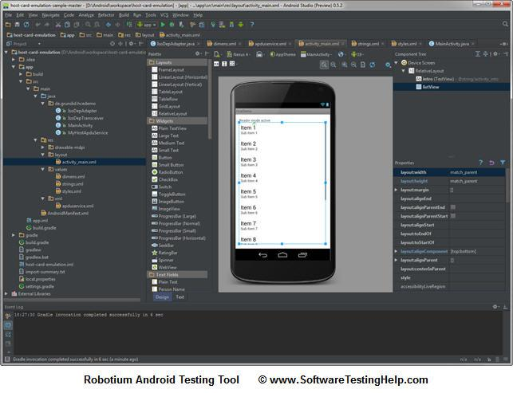

Software developers often describe it as Selenium for Android. **Tests created by Robotium are written in Java. In fact, Robotium is a library for unit tests.**

But it takes much time and efforts to create tests by means of Robotium, as one must work with the program source code in order to automate tests. The tool is also unsuitable for interaction with system software; it cannot lock and unlock a smartphone or a tablet. There is no Record and Play function in Robotium, and **it does not provide screenshots.**

### **#2. MonkeyRunner Android App Testing**

MonkeyRunner is one of popular Android Testing tools used for automating of functional tests for Android software.

This tool is more low-level than Robotium is. One does not have to deal with the source code in order to automate tests. The tests are written in Python, one may use a recording tool for creating tests.

MonkeyRunner can run tests on real devices connected to a PC or emulators. The tool has an API what allows it to control a smartphone, a tablet or an emulator from outside of Android code.

**Significant disadvantage of the mobile app testing tool is that it is necessary to write scripts for each device. Another problem of MonkeyRunner is that the tests require adjustments each time when user interface of the tested program is changed.**

### **#3. Ranorex Android Application Testing Tool *******************************************************VVI**

(Click to enlarge image)

Ranorex is a good tool for tests automation not only for the latest, but also for early versions and sub-versions of Android, beginning from Android 2.2.

ne of Ranorex advantages is its detailed reports with screenshots. It can connect a smartphone or a tablet to Internet via WiFi.

An automated test engineer can elaborate data-driven tests, excluding XML data format, by means of this Android tool. Ranorex Studio enables an automated test engineer to create tests easily, just clicking the mouse. It allows elaborating additional program modules. The modules may be utilized during late development cycles for more complex test scenarios.

It is a commercial mobile application tool; its license price is 1990 EUR. Ranorex searches elements rather slowly; it takes up to 30 seconds to perform such an operation. One must instrument APK files for Ranorex. Otherwise it is impossible to automate tests by means of this tool, as it works only with instrumented APK files.

------------

### **#4. Appium Android Automation Framework**

(Click to enlarge image)

It’s a framework for creation automated tests for iOS and Android. It is a free tool. It supports Android versions from 2.3 and later. Appium utilizes WebDriver interface for tests running. It supports many programming languages, such as Java, C#, Ruby and other hich are in the WebDriver library.

It can control Safari and Chrome on mobile devices. This allows to test mobile web sites using Appium and these browsers.

**But some automated test engineers complain that it provides poor, insufficient reports. Also its weakness is reduced XPath support on mobile devices.**

UI Automator frame work

http://code.tutsplus.com/tutorials/automating-user-interface-testing-on-android--cms-23969

## Introduction

Android's Testing Support library includes the UI Automator framework, which can be used to perform automated black-box testing on Android apps. Introduced in API Level 18, the framework allows developers to simulate user actions on the widgets that constitute an app's user interface.

In this tutorial, I am going to show you how to use the framework to create and run a basic user interface test for the default Calculator app.

## Prerequisites

To follow along, you need:

* the latest build of Android Studio
* a device or emulator that runs Android 4.3 or higher
* a basic understanding of JUnit

## 1. Installing Dependencies

To use the UI Automator framework in your project, edit the build.gradle file in your project's app directory, adding the following dependencies:

|  |  |
| --- | --- |
| 1  2  3 | androidTestCompile 'com.android.support.test:runner:0.2'  androidTestCompile 'com.android.support.test:rules:0.2'  androidTestCompile 'com.android.support.test.uiautomator:uiautomator-v18:2.1.0' |

The Sync Now button should be on the screen now. When you click it, you should see an error that looks like this:

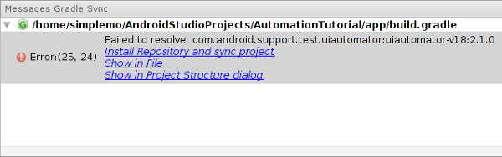

Click the Install Repository and sync project link to install the Android Support Repository.

If you are using the appcompat-v7 library and its version is 22.1.1, you need to add the following dependency to ensure that both the app and the test app are using the same version of com.android.support:support-annotations:

|  |  |
| --- | --- |
| 1 | androidTestCompile 'com.android.support:support-annotations:22.1.1' |

Next, due to a bug in Android Studio, you need to exclude a file named LICENSE.txtusing packagingOptions. Failing to do so will lead to the following error when you try to run a test:

|  |  |
| --- | --- |
| 1  2  3  4  5 | Execution failed for task ':app:packageDebugAndroidTest'.  Duplicate files copied in APK LICENSE.txt    File 1: ~/.gradle/caches/modules-2/files-2.1/org.hamcrest/hamcrest-core/1.1/860340562250678d1a344907ac75754e259cdb14/hamcrest-core-1.1.jar  File 2: ~/.gradle/caches/modules-2/files-2.1/junit/junit-dep/4.10/64417b3bafdecd366afa514bd5beeae6c1f85ece/junit-dep-4.10.jar |

Add the following snippet at the bottom of your build.gradle file:

|  |  |
| --- | --- |
| 1  2  3  4  5 | android {      packagingOptions {          exclude 'LICENSE.txt'      }  } |

## 2. Create a Test Class

Create a new test class, CalculatorTester, by creating a file namedCalculatorTester.java inside the androidTest directory. To create a UI Automator test case, your class must extend InstrumentationTestCase.

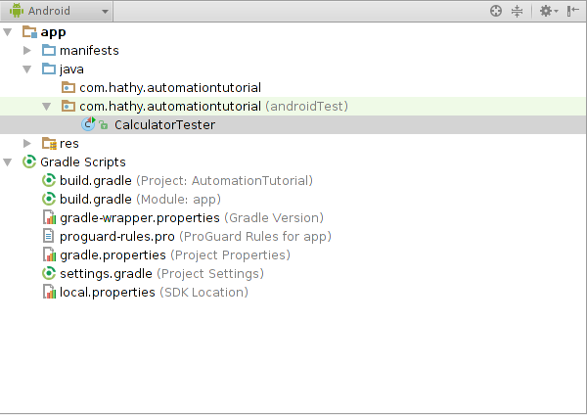

Press Alt+Insert and then click SetUp Method to override the setUp method.

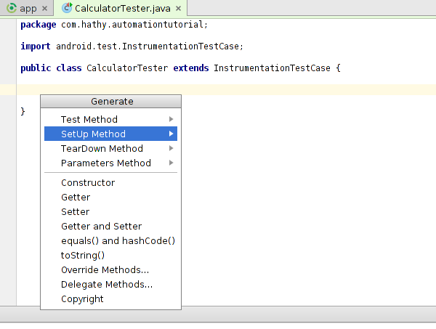

Press Alt+Insert again and click Test Method to generate a new test method. Name this method testAdd. The CalculatorTester class should now look like this:

|  |  |
| --- | --- |
| 01  02  03  04  05  06  07  08  09  10  11 | **public** **class** CalculatorTester **extends** InstrumentationTestCase{        @Override  **public** **void** setUp() **throws** Exception {        }    **public** **void** testAdd() **throws** Exception {        }  } |

## 3. Inspect the Launcher's User Interface

Connect your Android device to your computer and press the home button on your device to navigate to the home screen.

Go back to your computer and use your a file explorer or terminal to browse to the directory where you installed the Android SDK. Next, enter the tools directory inside it and launch uiautomatorviewer. This will launch UI Automater Viewer. You should be presented with a screen that looks like this:

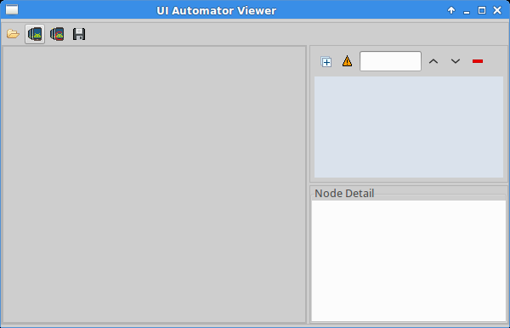

Click the button that looks like a phone to capture a screenshot of your Android device. Note that the screenshot you just captured is interactive. Click the Apps icon at the bottom. In the Node Detail section on the right, you're now able to see various details of your selection as shown below.

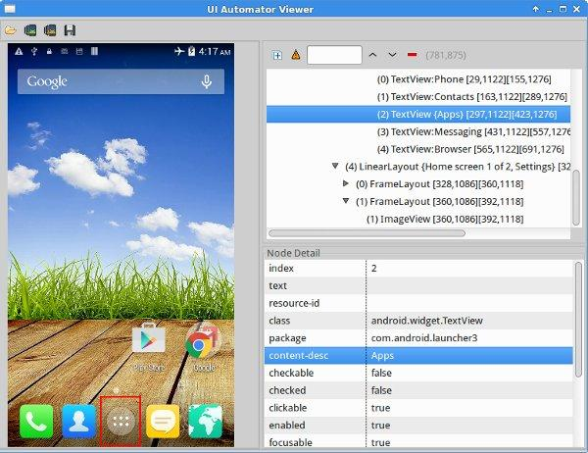

To interact with items on the screen, the UI Automator testing framework needs to be able to uniquely identify them. In this tutorial, you will be using either the text, thecontent-desc, or the class of the item to uniquely identify it.

As you can see, the Apps icon doesn't have any text, but it does have acontent-desc. Make a note of its value, because you will be using it in the next step.

Pick your Android device up and touch the Apps icon to navigate to the screen that shows the apps installed on the device. Head back to UI Automater Viewer and capture another screenshot. Since you will be writing a test for the Calculator app, click its icon to look at its details.

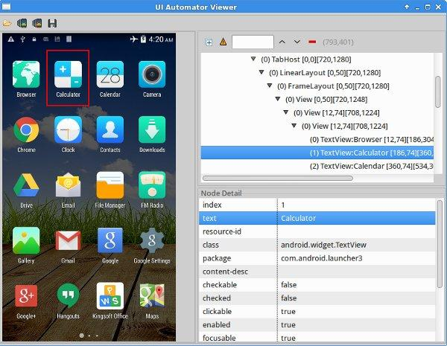

This time the content-desc is empty, but the text contains the value Calculator. Make a note of this as well.

If your Android device is running a different launcher or a different version of Android, the screens and the node details will be different. This also means that you will have to make some changes in your code to match the operating system.

## 4. Prepare the Test Environment

Return to Android Studio to add code to the setUp method. As its name suggests, the setUp method should be used to prepare your test environment. In other words, this is where you specify what needs to be done before running the actual test.

You will now be writing code to simulate what you did on your Android device in the previous step:

1. Press the home button to go to the home screen.
2. Press the Apps icon to view all apps.
3. Launch the Calculator app by tapping its icon.

In your class, declare a field of type UiDevice and name it device. This field represents your Android device and you will be using it to simulate user interaction.

|  |  |
| --- | --- |
| 1 | **private** UiDevice device; |

In the setUp method, initialize device by invoking the UiDevice.getInstancemethod, passing in a Instrumentation instance as shown below.

|  |  |
| --- | --- |
| 1 | device = UiDevice.getInstance(getInstrumentation()); |

To simulate pressing the home button of the device, invoke the pressHome method.

|  |  |
| --- | --- |
| 1 | device.pressHome(); |

Next, you need to simulate a click event on the Apps icon. You can't do this immediately though, because the Android device will need a moment to navigate to the home screen. Trying to click the Apps icon before it is visible on the screen will cause a runtime exception.

To wait for something to happen, you need to call the wait method on the UiDevice instance. To wait for the Apps icon to show up on the screen, use the Until.hasObject method.

To identify the Apps icon, use the By.desc method and pass the value Apps to it. You also need to specify the maximum duration of the wait in milliseconds. Set it to 3000. This results in the following code block:

|  |  |
| --- | --- |
| 1  2 | // Wait for the Apps icon to show up on the screen  device.wait(Until.hasObject(By.desc("Apps")), 3000); |

To get a reference to the Apps icon, use the findObject method. Once you have a reference to the Apps icon, invoke the click method to simulate a click.

|  |  |
| --- | --- |
| 1  2 | UiObject2 appsButton = device.findObject(By.desc("Apps"));  appsButton.click(); |

Like before, we need to wait a moment for the Calculator icon to show up on the screen. In the previous step, you saw that the Calculator icon can be uniquely identified by its text field. We invoke the By.text method to find the icon, passing in Calculator.

|  |  |
| --- | --- |
| 1  2 | // Wait for the Calculator icon to show up on the screen  device.wait(Until.hasObject(By.text("Calculator")), 3000); |

Use the findObject and click methods to obtain a reference to the Calculator icon and simulator a click.

|  |  |
| --- | --- |
| 1  2 | UiObject2 calculatorApp = device.findObject(By.text("Calculator"));  calculatorApp.click(); |

## 5. Inspect the Calculator's User Interface

Launch the Calculator app on your Android device and use UI Automater Viewer to inspect it. After capturing a screenshot, click the buttons to see how you can uniquely identify them.

For this test case, you will be making the calculator calculate the value of 9+9= and check if it shows 18 as the result. This means that you need to know how to identify the buttons with the labels 9, +, and =.

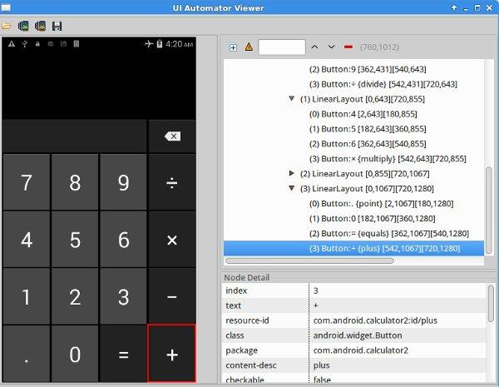

On my device, here's what I gathered from the inspection:

* The buttons containing the digits have matching text values.
* The buttons containing the + and = symbols have the content-desc values set to plus and equals respectively.
* The result is shown in an EditText widget.

Note that these values might be different on your device if you are using a different version of the Calculator app.

## 6. Create the Test

In the previous steps, you already learned that you can use the findObjectmethod along with either By.text or By.desc to get a reference to any object on the screen. You also know that you have to use the click method to simulate a click on the object. The following code uses these methods to perform the calculation 9+9=. Add it to the testAdd method of the CalculatorTester class.

|  |  |
| --- | --- |
| 01  02  03  04  05  06  07  08  09  10  11  12  13  14  15  16  17 | // Wait till the Calculator's buttons are on the screen  device.wait(Until.hasObject(By.text("9")), 3000);    // Select the button for 9  UiObject2 buttonNine = device.findObject(By.text("9"));  buttonNine.click();    // Select the button for +  UiObject2 buttonPlus = device.findObject(By.desc("plus"));  buttonPlus.click();    // Press 9 again as we are calculating 9+9  buttonNine.click();    // Select the button for =  UiObject2 buttonEquals = device.findObject(By.desc("equals"));  buttonEquals.click(); |

At this point, you have to wait for the result. However, you can't useUntil.hasObject here because the EditText containing the result is already on the screen. Instead, you have to use the waitForIdle method to wait for the calculation to complete. Again, the maximum duration of the wait can be 3000 ms.

|  |  |
| --- | --- |
| 1 | device.waitForIdle(3000); |

Get a reference to the EditText object using the findObject and By.clazzmethods. Once you have the reference, call the getText method to determine the result of the calculation.

|  |  |
| --- | --- |
| 1  2 | UiObject2 resultText = device.findObject(By.clazz("android.widget.EditText"));  String result = resultText.getText(); |

Finally, use assertTrue to verify that the result is equal to 18.

|  |  |
| --- | --- |
| 1 | assertTrue(result.equals("18")); |

Your test is now complete.

Wt kinda api u hv used so far

> googlemao, facebook,tweeter, Gson,xing @barcode scanning

Wt r d 3rd parties api

>> comscore(analytics).

**SQLITE**

CREATE TABLE database_name.table_name(

column1 datatype PRIMARY KEY(one or more columns),

column2 datatype,

column3 datatype,

.....

columnN datatype,

);

SQLite is a opensource SQL database that stores data to a text file on a device. Android comes in with built in SQLite database implementation.

SQLite supports all the relational database features. In order to access this database, you don't need to establish any kind of connections for it like JDBC,ODBC e.t.c

## Database - Package

**The main package is android.database.sqlite that contains the classes to manage your own databases**

## Database - Creation

In order to create a database you just need to call this method openOrCreateDatabase with your database name and mode as a parameter. It returns an instance of SQLite database which you have to receive in your own object.Its syntax is given below

SQLiteDatabase mydatabase = openOrCreateDatabase("your database name",MODE_PRIVATE,null);

Apart from this , there are other functions available in the database package , that does this job. They are listed below

|  |  |
| --- | --- |
| **Sr.No** | **Method & Description** |
| 1 | **openDatabase(String path, SQLiteDatabase.CursorFactory factory, int flags, DatabaseErrorHandler errorHandler)**  This method only opens the existing database with the appropriate flag mode. The common flags mode could be OPEN_READWRITE OPEN_READONLY |
| 2 | **openDatabase(String path, SQLiteDatabase.CursorFactory factory, int flags)**  It is similar to the above method as it also opens the existing database but it does not define any handler to handle the errors of databases |
| 3 | **openOrCreateDatabase(String path, SQLiteDatabase.CursorFactory factory)**  It not only opens but create the database if it not exists. This method is equivalent to openDatabase method |
| 4 | **openOrCreateDatabase(File file, SQLiteDatabase.CursorFactory factory)**  This method is similar to above method but it takes the File object as a path rather then a string. It is equivalent to file.getPath() |

**Create a Database Using a SQL Helper**

Once you have defined how your database looks, you should implement methods that create and maintain the database and tables. Here are some typical statements that create and delete a table:

private static final String TEXT_TYPE = " TEXT";

private static final String COMMA_SEP = ",";

private static final String SQL_CREATE_ENTRIES =

    "CREATE TABLE " + FeedEntry.TABLE_NAME + " (" +

    FeedEntry._ID + " INTEGER PRIMARY KEY," +

    FeedEntry.COLUMN_NAME_ENTRY_ID + TEXT_TYPE + COMMA_SEP +

    FeedEntry.COLUMN_NAME_TITLE + TEXT_TYPE + COMMA_SEP +

    ... // Any other options for the CREATE command

    " )";

private static final String SQL_DELETE_ENTRIES =

    "DROP TABLE IF EXISTS " + FeedEntry.TABLE_NAME;

**A useful set of APIs is available in the**[**SQLiteOpenHelper**](http://developer.android.com/reference/android/database/sqlite/SQLiteOpenHelper.html)**class**. When you use this class to obtain references to your database, the system performs the potentially long-running operations of creating and updating the database only when needed and *not during app startup*. All you need to do is call [getWritableDatabase()](http://developer.android.com/reference/android/database/sqlite/SQLiteOpenHelper.html#getWritableDatabase()) or[getReadableDatabase()](http://developer.android.com/reference/android/database/sqlite/SQLiteOpenHelper.html#getReadableDatabase()).

**Note: Because they can be long-running, be sure that you call**[**getWritableDatabase()**](http://developer.android.com/reference/android/database/sqlite/SQLiteOpenHelper.html#getWritableDatabase())**or**[**getReadableDatabase()**](http://developer.android.com/reference/android/database/sqlite/SQLiteOpenHelper.html#getReadableDatabase())**in a background thread, such as with**[**AsyncTask**](http://developer.android.com/reference/android/os/AsyncTask.html)**or**[**IntentService**](http://developer.android.com/reference/android/app/IntentService.html)**.**

To use [SQLiteOpenHelper](http://developer.android.com/reference/android/database/sqlite/SQLiteOpenHelper.html), create a subclass that overrides the [onCreate()](http://developer.android.com/reference/android/database/sqlite/SQLiteOpenHelper.html#onCreate(android.database.sqlite.SQLiteDatabase)), [onUpgrade()](http://developer.android.com/reference/android/database/sqlite/SQLiteOpenHelper.html#onUpgrade(android.database.sqlite.SQLiteDatabase,%20int,%20int)) and[onOpen()](http://developer.android.com/reference/android/database/sqlite/SQLiteOpenHelper.html#onOpen(android.database.sqlite.SQLiteDatabase)) callback methods. You may also want to implement [onDowngrade()](http://developer.android.com/reference/android/database/sqlite/SQLiteOpenHelper.html#onDowngrade(android.database.sqlite.SQLiteDatabase,%20int,%20int)), but it's not required.

For example, here's an implementation of [SQLiteOpenHelper](http://developer.android.com/reference/android/database/sqlite/SQLiteOpenHelper.html) that uses some of the commands shown above:

public class FeedReaderDbHelper extends SQLiteOpenHelper {

    // If you change the database schema, you must increment the database version.

    public static final int DATABASE_VERSION = 1;

    public static final String DATABASE_NAME = "FeedReader.db";

    public FeedReaderDbHelper(Context context) {

        super(context, DATABASE_NAME, null, DATABASE_VERSION);

    }

    public void onCreate(SQLiteDatabase db) {

        db.execSQL(SQL_CREATE_ENTRIES);

    }

    public void onUpgrade(SQLiteDatabase db, int oldVersion, int newVersion) {

        // This database is only a cache for online data, so its upgrade policy is

        // to simply to discard the data and start over

        db.execSQL(SQL_DELETE_ENTRIES);

        onCreate(db);

    }

    public void onDowngrade(SQLiteDatabase db, int oldVersion, int newVersion) {

        onUpgrade(db, oldVersion, newVersion);

    }

}

**To access your database, instantiate your subclass of**[**SQLiteOpenHelper**](http://developer.android.com/reference/android/database/sqlite/SQLiteOpenHelper.html)**:**

FeedReaderDbHelper mDbHelper = new FeedReaderDbHelper(getContext());

nsert data into the database by passing a [ContentValues](http://developer.android.com/reference/android/content/ContentValues.html) object to the [insert()](http://developer.android.com/reference/android/database/sqlite/SQLiteDatabase.html#insert(java.lang.String,%20java.lang.String,%20android.content.ContentValues)) method:

// Gets the data repository in write mode

SQLiteDatabase db = mDbHelper.getWritableDatabase();

// Create a new map of values, where column names are the keys

ContentValues values = new ContentValues();

values.put(FeedEntry.COLUMN_NAME_ENTRY_ID, id);

values.put(FeedEntry.COLUMN_NAME_TITLE, title);

values.put(FeedEntry.COLUMN_NAME_CONTENT, content);

// Insert the new row, returning the primary key value of the new row

long newRowId;

newRowId = db.insert(

         FeedEntry.TABLE_NAME,

         FeedEntry.COLUMN_NAME_NULLABLE,

         values);

The first argument for [insert()](http://developer.android.com/reference/android/database/sqlite/SQLiteDatabase.html#insert(java.lang.String,%20java.lang.String,%20android.content.ContentValues)) is simply the table name. The second argument provides the name of a column in which the framework can insert NULL in the event that the [ContentValues](http://developer.android.com/reference/android/content/ContentValues.html) is empty (if you instead set this to "null", then the framework will not insert a row when there are no values).

## Read Information from a Database

To read from a database, use the [query()](http://developer.android.com/reference/android/database/sqlite/SQLiteDatabase.html#query(boolean,%20java.lang.String,%20java.lang.String%5B%5D,%20java.lang.String,%20java.lang.String%5B%5D,%20java.lang.String,%20java.lang.String,%20java.lang.String,%20java.lang.String)) method, passing it your selection criteria and desired columns. The method combines elements of [insert()](http://developer.android.com/reference/android/database/sqlite/SQLiteDatabase.html#insert(java.lang.String,%20java.lang.String,%20android.content.ContentValues)) and [update()](http://developer.android.com/reference/android/database/sqlite/SQLiteDatabase.html#update(java.lang.String,%20android.content.ContentValues,%20java.lang.String,%20java.lang.String%5B%5D)), except the column list defines the data you want to fetch, rather than the data to insert. The results of the query are returned to you in a [Cursor](http://developer.android.com/reference/android/database/Cursor.html) object.

SQLiteDatabase db = mDbHelper.getReadableDatabase();

// Define a *projection* that specifies which columns from the database

// you will actually use after this query.

String[] projection = {

    FeedEntry._ID,

    FeedEntry.COLUMN_NAME_TITLE,

    FeedEntry.COLUMN_NAME_UPDATED,

    ...

    };

// How you want the results sorted in the resulting Cursor

String sortOrder =

    FeedEntry.COLUMN_NAME_UPDATED + " DESC";

Cursor c = db.query(

    FeedEntry.TABLE_NAME,  // The table to query

    projection,                               // The columns to return

    selection,                                // The columns for the WHERE clause

    selectionArgs,                            // The values for the WHERE clause

    null,                                     // don't group the rows

    null,                                     // don't filter by row groups

    sortOrder                                 // The sort order

    );

**Delete Information from a Database**

To delete rows from a table, you need to provide selection criteria that identify the rows. The database API provides a mechanism for creating selection criteria that protects against SQL injection. The mechanism divides the selection specification into a selection clause and selection arguments. The clause defines the columns to look at, and also allows you to combine column tests. The arguments are values to test against that are bound into the clause. Because the result isn't handled the same as a regular SQL statement, it is immune to SQL injection.

// Define 'where' part of query.

String selection = FeedEntry.COLUMN_NAME_ENTRY_ID + " LIKE ?";

// Specify arguments in placeholder order.

String[] selectionArgs = { String.valueOf(rowId) };

// Issue SQL statement.

db.delete(table_name, selection, selectionArgs);

## Update a Database

When you need to modify a subset of your database values, use the [update()](http://developer.android.com/reference/android/database/sqlite/SQLiteDatabase.html#update(java.lang.String,%20android.content.ContentValues,%20java.lang.String,%20java.lang.String%5B%5D)) method.

Updating the table combines the content values syntax of [insert()](http://developer.android.com/reference/android/database/sqlite/SQLiteDatabase.html#insert(java.lang.String,%20java.lang.String,%20android.content.ContentValues)) with the where syntax of [delete()](http://developer.android.com/reference/android/database/sqlite/SQLiteDatabase.html#delete(java.lang.String,%20java.lang.String,%20java.lang.String%5B%5D)).

SQLiteDatabase db = mDbHelper.getReadableDatabase();

// New value for one column

ContentValues values = new ContentValues();

values.put(FeedEntry.COLUMN_NAME_TITLE, title);

// Which row to update, based on the ID

String selection = FeedEntry.COLUMN_NAME_ENTRY_ID + " LIKE ?";

String[] selectionArgs = { String.valueOf(rowId) };

int count = db.update(

    FeedReaderDbHelper.FeedEntry.TABLE_NAME,

    values,

    selection,

    selectionArgs);

**WEBSERVICE CALL**

<http://androidexample.com/Restful_Webservice_Call_And_Get_And_Parse_JSON_Data-_Android_Example/index.php?view=article_discription&aid=101&aaid=123>

Gradle

Gradle's ability to manage dependencies isn't limited to external libraries. As your project grows in size and complexity, you'll want to organize the code into modules with clearly defined responsibilities. Gradle provides powerful support for defining and organizing multiproject builds, as well as modeling dependencies between projects.

Gradle combines good parts of both tools and builds on top of them with DSL and other improvements. It has Ant’s power and flexibility with Maven’s life-cycle and ease of use. The end result is a tool that was released in 2012 and gained a lot of attention in a short period of time. For example, Google adopted Gradle as the default build tool for the Android OS.

Gradle does not use XML. Instead, it had its own DSL based on [Groovy](http://groovy.codehaus.org/) (one of JVM languages). As a result, Gradle build scripts tend to be much shorter and clearer than those written for Ant or Maven. The amount of boilerplate code is much smaller with Gradle since its DSL is designed to solve a specific problem: move software through its life cycle, from compilation through static analysis and testing until packaging and deployment.

Initially, Gradle used [Apache Ivy](http://ant.apache.org/ivy/) for its dependency management. Later own it moved to its own native dependency resolution engine.

Gradle effort can be summed as “convention is good and so is flexibility”.

[[build.gradle](https://github.com/vfarcic/JavaBuildTools/blob/master/build.gradle)]

|  |  |
| --- | --- |
| 1  2  3  4  5  6  7  8  9  10  11  12  13  14  15 | apply plugin: 'java'  apply plugin: 'checkstyle'  apply plugin: 'findbugs'  apply plugin: 'pmd'    version = '1.0'    repositories {      mavenCentral()  }    dependencies {      testCompile group: 'junit', name: 'junit', version: '4.11'      testCompile group: 'org.hamcrest', name: 'hamcrest-all', version: '1.3'  } |

Not only that the Gradle code is much shorter and, to those familiar with Gradle, easier to understand than Maven, but it actually introduces many useful tasks not covered with the Maven code we just wrote. To get the list of all tasks that Gradle can run with the current configuration, please execute the following.

|  |  |
| --- | --- |
| 1 | gradle tasks --all |

Karya technologies

**Xamarin cross platform**

**Beacon**

**webservice call**

### Rest vs SOAP

|  |  |
| --- | --- |
| REST | SOAP |
| REST stands for REpresentational State Transfer | SOAP stands for Simple Object Access Protocol |
| REST is not XML protocol based | SOAP is a XML based messaging protocol |
| REST doesn’t have any specification | SOAP has specifications like WSDL etc |
| REST doesn’t enforce message format as XML or JSON | SOAP enforces message format as XML |
| Light weight – due to the usage of JSON | Heavy weight – due to the usage of XML |
| Easy to parse the response | Bit difficult to parse the response |